A HISTORY OF THE CONGREGATIONAL CHRISTIAN CHURCH OF SAMOA IN TAFAGAMANU AND SAVAIA FROM ITS COMMENCEMENT IN 1938 TO ITS CURRENT STATE -
BLOOD IS THICKER THAN WATER, BUT SERVICE IS THICKER THAN BLOOD

A Thesis Presented to the
Faculty of the Malua Theological College
Apia, Samoa
In Partial Fulfilment of the
Requirements for the Degree
Master of Theology

by
Rev. To’osavili Uini II Atimalala Tu’a.
October 2022

Consent Form for the Retention and use of the Thesis

I, To’osavili…………..
agree that the thesis be accessible for the purpose of study and research in accordance with the normal conditions established by the Malua College Librarian for the care, loan and reproduction of the thesis.

Signature: ______________________ Date: ______________________

Declaration of Authorship of Thesis
I, To’osavili…………….
hereby declare that this submission is my own work and that, to the best of my knowledge, it contains no material previously published or written by another person nor material which to a substantial extent has been accepted for the award of any other degree or diploma at Malua Theological College or any other educational institution, except where due acknowledgement is made in this thesis. Any contribution made to the research by colleagues with whom I have worked at Malua Theological College or elsewhere during my candidature is fully acknowledged.

Signature: ______________________ Date: ______________________

ABSTRACT
This thesis is an effort to analyse the missing historical links and lapses of our church the CCCS Tafagamanu especially the unknown service or tautua offered by the people of Tafagamanu in the early years of the church to the present days. This is through the implementation of appropriate and relevant sources to provide available evidence to fill gaps in the history of CCCS Tafagamanu. Our church in Tafagamanu had been established since its inception with the village of Savaia until was separated in …Much of that history have been lost. Hence the importance of this attempt.
In addition, the values of their histories are of course what the present generations are indebted to. This idea arises the need for their past endeavours to be acknowledged for educating today and providing stability for the future. Therefore, a true aspiration enforces our line of work to initiate this project not just for the sake of historical recordings but the unknown tautua offered by our fore parents.

DECLARATION
I declare that this work has not been used without due acknowledgment of any material that has been previously submitted for a degree or diploma in another institution. I also declare that the work has not used any material, heard or read, without proper acknowledgment of the source.

Signed: _______________________
Date: _______________________

DEDICATION
I dedicate this project
to my wife Epenesa Tangatauli Tu’a,
to my children Marino Lorenese, Mafutaga Michani Olivetti and Tafaāta’ōmanū Azariah Benjamin,
to my families,
to the people of Tafagamanu and Savaia,

In Loving Memory of my Late Mother Avau To’o
04th July 1949 to 06th September 2021

CONTENTS
Consent Form for the Retention and use of the Thesis ii
Declaration of Authorship of Thesis iii
ABSTRACT iv
DECLARATION v
DEDICATION vi
ACKNOWLEDGEMENTS xii
List of Abbreviations xiii
INTRODUCTION 1
CHAPTER ONE 5
REASONS FOR WRITING THIS HISTORY AND THE FAIFEAU PERSPECTIEVE IN WRITING THIS HISTORY 5
1. INTRODUCTION 5
2. REASONS FOR THIS STUDY 5
3. FAIFEAU PERSPECTIVE IN PUTTING TOGETHER THIS HISTORY AND ANALYZING THE HISTORY OF THE CHURCH IN TAFAGAMANU 6
3.1 Faifeau Perspective – Tautua: Samoan Perspective 10
3.1.1 A Common Definition of Tautua 10
3.1.2 Samoan Cultural Types of Tautua/Services 14
3.2 A BIBLICAL AND THEOLOGICAL MEANING OF TAUTUA (SERVANT): DIAKONOS AND DOULOS 17
3.2.1. diakonos 17
3.2.2 Doulos 20
3.3 Tafagamanu the Servant 21
3.4. Significance of this history to the people of Tafagamanu and Savaia 28
3.4.1. The Past Teaches Today 28
3.4.2. Mistakes 28
3.5. Conclusion 28
CHAPTER 2 30
THE BEGINNING OF THE CHURCH IN TAFAGAMANU AND ITS DEVELOPMENT 30
1. INTRODUCTION 30
2. ORIGINS AND BEGINNING 30
2.1 VAIOLA: THE ORIGINAL LAND 31
2.1.1 Offering of Land to the Church 31
3. Clause one of the original Deed 39
3.1. The Recent Plan View of Vaiola’s Legal Map. 41
3.2. The First Church in Lefaga and Faleaseela 43
3.2.1. Any Other Church Denomination in Lefaga? 43
3.3. The Date of Arrival (Church in Tafagamanu) 44
4. Tradition 1. 45
4.1. The Significant Contribution of the name Malia 46
4.2. Faumuina Tupuse 47
4.3. Reason why Eli Jennings moved to Tafagamanu. 48
4.3.1 White Man’s Influence 48
5. Lefaga including Savaia and Tafagamanu lands in Mortgage 49
5.1. Mortgage and the Church 50
6. Tradition 2 52
6.1. Reflection on what happened at Mulitapuili in 1865 53
6.2. Judges 14: 14 54
7. Progress of the Church in Lefaga and Faleaseela 54
7.1. CCCS Matautu’s Official Deed: signed on the 3rd of July, 1889. 56
8. SUMMARY: Evaluation on the presented Traditions 58
8.1. Church’s Arrival Date (Officially was 1838) 58
8.2 Missionaries Involved 59
8.3. Natives involved in the beginning 59
8.3.1. Those who signed and witnessed the 1880 deed. 60
9. London Missionary Society Program: 60
10. List of LMS Missionaries and Samoan Pastors from 1838 to 1879 60
11. Pastors from 1880 to 2022 61
12. Summary 62
12.1. The Official Claim 63
CHAPTER 3 64
THE SHIFT OF THE CHURCH 64
1. INTRODUCTION 64
1.1. Reasons for the Shift of the Church from Vaiola to Niue 64
1.1.1. Population Growth 64
1.1.2. The Church was too close to the sea 65
2. 1875 to 1879: 65
2.1. These are some of the remains of the church building that was built between 1875 and 1879 (THE THIRD CHURCH BUILDING) 66
3. The Second Shift of the church in 1915 67
3.1. The Death of James Charles Curry 67
4. Falesa/ Church Houses and Buildings that were built and where they were built 69
5. Biblical Reflections 71
5.1. 1 Corinthians 13: 14. 71
5.2. Exodus 3: 6. 72
6. Pastors from 1880 to 2008 before the Separation 74
7. LAND OFFERING NIUE 75
7.1. The English Translation of the deed 76
7.2. Land Description: 76
8. Summary 79
CHAPTER 4 81
THE SPLIT OF THE CHURCH IN 2009 81
1. INTRODUCTION 81
2. Reasons that contributed to the Split of the two Villages 82
2.1. 1980: The two villages separated not the church 82
3. Tafagamanu and Savaia o Nu’u Mavae or traditional villages 83
3.1. The Salutations (Faalupega) of Tafagamanu and Savaia 83
4. 2008 to 2009: The Separation and the birth of two New Churches 84
4.1. The Tuala Peniamina Tuala Dairy 84
5. The Cause of Separation 85
5.1. Beginning of the Separation 86
5.1.1. Sunday 19th October 2008 86
5.1.2. The Plan for a New Church in Tafagamanu 87
5.1.3. Some wanted to return to Savaia 88
6. Saturday 20th December 2008 89
6.1. Meeting with the CCCS Board 89
7. The Unofficial Opening of the Church 89
7.1. People who attended the ceremony based on Family Names (Matafale). 90
7.2. Villagers and Chiefs who participated (Non CCCS members) 90
8. The Official Opening 91
8.1. Pastors from the Pulega who were present 92
8.2. People from the district who participated 92
9. Founding Families of the Church 93
10. Summary of Tuala’s Diary 93
11. Savaia’s Side of the Story 95
12. Evaluation of the two Stories (Faifeau’s perspective) 95
13. The Land called OLI 95
13.1. The Official Map OLI 96
13.2. Rewriting what is written on the Map 98
14. Meaning of the name OLI 99
15. Our Testimony 100
15.2. Saturday 6th of August, 2011 102
16. The Trip to Sydney Australia in 2013 103
16.1. Alo ma Tamafanau o Tafagamau i Sini 104
17. Let the Construction Begin: March in 2014 106
18. MALUMALU O MATAGOFIE 108
18.1. The Openning Ceremony: 109
19. Summary 110
CHAPTER FIVE 111
1. Summary 111
1.1 Progress of the Church in Tafagamanu and Savaia. 111
1.1.1 Tafagamanu 111
1.1.2 Savaia 111
2. Churches that were derived from the original church in Tafagamanu and Savaia 112
2.1. CCCS/EFKS Savaia and Tafagamanu Uta. (Located in Savaia) 112
2.1.1. Interview with Professor Fui Asofou So’o 112
2.1.2. A history of CCCS Savaia and Tafagamanu Uta 113
2.1.3. Rev. Keneti Leaupepetele and wife Faaleleiga 114
2.1.4. List of Church Ministers in Savaia and Tafagamanu Uta 115
2.2 Methodist Church in Tafagamanu 116
2.2.1. A History of the Methodist Church Samoa in Tafagamanu 116
2.2.2. Nature of the Work in Savaia 117
2.2.3. The Establishment of the Church 119
2.2.4. List of Resident Church Ministers 120
2.2.5. The Founding Families of the Church 121
2.2.6. Families of the Church in 2022 121
2.3. Pentecostal Church of Samoa in Savaia. 122
2.3.1. List of resident pastors of the Church. 122
3. CHURCHES LEFAGA AND FALEASEELA 123
3.1. TANUMALALA 123
3.2. FALEASEELA 123
3.3. SAFA’ATO’A 123
3.4. TAFAGAMANU 123
3.5. SAVAIA 123
3.6. GAGAIFOLEVAO 123
3.7. MATAUTU 124
4. There are twenty two (22) established churches in Lefaga and Faleaseela 124
5. Summary 125
5.1. Tautua Eleele (Service through Land) 125
5.2. Tautua Tagata (Service as Human Sacrifices) 127
5.2.1. CCCS Pastors from Tafagamanu and Savaia offered as sacrifices since the beginning of the Church in the village 127
6. God’s Kingdom: Hope, Peace and Properity 134
7. Concluding Remarks 134
APPENDIX ONE 136
APPENDIX TWO 136
GLOSSARY 138
BIBLIOGRAPHY 139

ACKNOWLEDGEMENTS
First and foremost, I give the greatest praise and honor to our Lord and God for giving me the strength to complete this thesis. It was a very challenging project but God never left my side during this work.
My genuine and deepest thanks to my supervisor, Rev. Dr. Vaitusi Lealaiauloto Nofoaiga for helping me with this paper. You fully shared your wisdom on making this project relevant and reliable. Thank you for your accurate visions presented through your productive remarks and inspirations that massively helped me persevere in completing this thesis. Faafetai tele.
I am fully appreciative for the full support provived by Afioga Fonoti Samagape’a Tivasa Namulau’ulu and the TESFAC Research & Consultancy Services. You have delivered solid evidence for this thesis. These facts were never thought to be existed but you unveiled them for the sake of our people’s history. Faafetai tele lava i lau afioga ma le aufaigaluega.
To my wife and kids, I owe you more than you know. Thank you, thank you very much for your silent support and your prayers. You have encouraged and pushed me throughout this work, especially when things seemed impossible. Thank you and I appreciate you.
I would also like to thank all our families and friends for your support. Last but not least, I would also like to thank the people of Tafagamanu and Savaia who helped me with this paper. I am deeply indebted of your endless contribution through interviews. To our people of Tafagamanu and Savaia in Samoa and abroad, this is for you. Faafetai, faafetai lava.

Faamanuia mai le Atua i lenei Galuega

List of Abbreviations
EFKS Ekalesia Fa’apotopotoga Kerisiano Samoa
CCCS Congregational Christian Church Samoa
LMS London Missionary Society

INTRODUCTION
If a generation’s service to an assigned cause becomes a lost history, lapses may occur, and relative truth is lost. Therefore, this study is an attempt to convey and play witness through the enforcement of any appropriate historical claims from any necessary source to apply an available seal to any historical openings. Our church in Tafagamanu and Savaia, for instance, has lost most of its history due to various reasons that will be presented. Nevertheless, the ethicality of the past has the right to be acknowledged and used since the past itself is founded learning mechanisms for today, and will indeed become the basis of tomorrow.
For that reason, gathering the historical information on our church’s groundwork arises greater awareness due to biased-based beliefs that were passed down from generation to generation through oral traditions. For instance, carrying a Samoan family name is not a consented tradition that anyone can write about or use in any sort if it is not in the best interest as a whole. For each family’s or village’s history is the truth to them. Nevertheless, this common oral tradition became the only practical knowledge required and available throughout history. However, the procurement and divulging of this available knowledge is learned by participation, imitation, and observation.
Hence, this tradition and its development are due to respect and honour set by a traditional fixed mentality. After all, it is diverse normality built and pinned within every Samoan. As a parish and resident minister in the village, history will be presented from my point of view using theological views and interpretations, with uttermost regard and respect for the more extraordinary efforts and contributions offered to the LMS church, by the people of Tafagamanu and Savaia in the past. To revive this history, this thesis will cater a compilation of important reasons why this thesis needed to be written in the first place and, of course, a document on embracing Tafagamanu and Savaia’s ancestors’ services or the Samoan word tautua to the church and to put in account the contributions of all who helped proclaimed the gospel in this part of Samoa despite the opposing natures of the spreading the gospel.
This research presents the service of history to the London Missionary Society and the Congregational Christian Church of Samoa (CCCS) from the local sources, like the contribution of various parishes in Samoa and abroad, such as our own (CCCS/EFKS Tafagamanu). From the perspective of a CCCS parish/resident minister, the service given and offered to the church (LMS/EFKS) by the people of the past is to be embraced and acknowledged. Presenting a history of our parish in Tafagamanu is the focal interest of this thesis. However, the lack of historical information about our parish’s contribution to the origins and development of the church in our district (Lefaga and Faleaseela) and the mother church raises crucial concerns. There are many oral traditions concerning the origin and development of the church, but presenting and supporting valuable evidence and information is, of course, the main target of this thesis. This study also allows me to fulfil my interest in reading and to interpret history from a parish minister’s context. Therefore, in writing this thesis, I will attempt five things. First, I will enlighten the readers of this study on why I chose to write this history. In doing so, I will explore the hidden efforts and contributions of the people in the past concerning the services offered to the LMS missionaries and the church. Secondly, this study will give an explanation of the significance of this history not just to our people in specific ways but to the mother church as well. Thirdly, geographically speaking, this research focuses on the transition of the church from its original place, as mentioned above, to its new location. Reasons for the church's split in 2009 will be my fourth focus. Finally, a composition of the four approaches will be compiled, corresponding with the comparison of the development of the church and its values and flaws, and how it contributes today.
To accomplish the above, the thesis is structured as follows. Chapter one will give a general overview of the fundamental reasons why I chose to write this paper. Reasons that highlight the sole historical truth of what took place in and during the commencement of the church in Tafagamanu and Savaia. Chapter two will delve into the cultural, political, and religious influence on the church and its significance to its development in time. An investigation of the arrival of the church will be conducted. Throughout this research, an offering of land made by particular families of Tafagamanu will also be investigated. Chapter three explores and reports on the geographical transition of the church from its original place to another and the reasons behind it. This transition or shift of the church assuredly came across several lapses that need to be exploited and divulged since, and more likely, those lapses might have stolen some particular truths of history within the services and contributions given by people to the church as a whole. Furthermore, an investigation will be conducted on how rapid the church’s development came to be and its outcome. Lastly, in this chapter, a report on brief report on the lead-up to the split of the two villages. Chapter four, will report on the separation of the church of Savaia and Tafagamanu. Within this chapter, possible standards set by the origins and developments of the church throughout the past will be revealed as well, which on the other were beneficial to others. However, others might not have that courtesy. An overview will be presented concerning the growth of the Church in Tafagamanu and Savaia and its contribution to the development of the church in the district of Lefaga and Faleaseela. Chapter five will serve as the conclusion of this thesis. Each chapter will present a conclusion of its own. These conclusions will be compiled in this chapter with my interpretation from a parish minister’s perspective. A Christian perspective will help to make meaning to the offered history. It is not in the interest of this thesis to be fully immersed in an all-detailed survey as far as history is concerned. However, a gathering of historical information is warranted to highlight how our church history (Tafagamanu Parish) is read and understood in the church history as a whole.

CHAPTER ONE

REASONS FOR WRITING THIS HISTORY AND THE FAIFEAU PERSPECTIEVE IN WRITING THIS HISTORY

1. INTRODUCTION
This chapter will be divided into two sections. First, I will discuss the reasons that evoked my interest to pursue this research. It is from an inspiration of witnessing a service to God done by the people of Tafagamanu and hearing their stories about the oral history passed on by their ancestors and parents about the arrival of the LMS church in their village. Second, the chapter will explain the Faifeau perspective behind collecting, analyzing, and evaluating that history.

2. REASONS FOR THIS STUDY
The following reasons show why I have decided to do this research. It is important to my ministry as a church minister of the Congregational Christian Church of Tafagamanu. First, the stories shared by our church members, the members of the Congregational Christian Church of Tafagamanu, tell a history of the church's arrival in Tafagamanu. This account has historical and theological significance for the people of Tafagamanu. It is a history that needs to be written and recorded for the present generation and the coming generations of Tafagamanu. Hence, I wanted to do this study. Second, as a church minister, I feel that I have a responsibility to do something about the history of the arrival of the church in Tafagamanu and its continuation beyond Tafagamanu, which according to the oral history of the village of Tafagamanu, had an impact on the establishment of other churches in the district of Lefaga. It is to show the important historical connection of Tafagamanu as a village and a church to other villages and churches of Lefaga. Third, I consider this research as a ministry or an undertaking of my role as a church minister in proclaiming the Gospel by looking back at the God-given gifts to the people of Tafagamanu that need to be remembered and treasured by the present generation. It is to inspire the new generation to continue the great work of their fore-parents. The influence of the outside world’s cultures and social media, and modern technology affect how the new generation thinks about living life to God. However, reminding them of their important history about their lands, place, space, and inheritance surely will give them something close and dear to their hearts to embrace. Hopefully, it will inspire some of them to pursue offering their lives to be servants of God in the work of becoming and being church ministers or faifeau. Fourth, a history exhibits a sense of belonging for a particular group of people to a particular place and space. It situates a group of people in a place they call home. Knowing this sense of belonging brings inspiration to continue on the good work done by their fore-parents that made their home land a special place. Fifth, I consider starting the Master of Theology program at Malua as an opportunity to continue learning more about God. Researching history is one way of doing that. I am very humbled by this chance to continue learning more about God's love in and through the history of our people – the people of Tafagamanu.

3. FAIFEAU PERSPECTIVE IN PUTTING TOGETHER THIS HISTORY AND ANALYZING THE HISTORY OF THE CHURCH IN TAFAGAMANU
How to write history is essential for it embraces the feeling of realization and recognition of the importance of the events of the past to the present and the future. This part of describing how the history presented in this study is put together and analysed is an essential part of this work. There are various ways of writing history or historiographies. For example, in Malama Meleisea’s writing of the history of Samoa from the time of the arrival of the missionaries, traders, and whalers into Samoa in the 17th century and 18th century to the 20th century, a progressive perspective. It is the idea of looking at the history of the coming and the arrival of the foreigners into Samoa with a purpose such as the purpose of colonization. Meleisea’s perspective of the history of Samoa about the foreigners challenged the history writing of people like J. W. Davidson that always blamed the Samoan people for the problems occurred in the relationship between the Samoan people and the Europeans living in Samoa in the 1800s and 1900s.
Oka Fauolo’s writing of the EFKS church history presents another approach to history writing in Samoa. It considers the events that happened in the past, such as the coming and the arrival of the missionaries with the Gospel into Samoa, as not a progressive mission but a plan of God. Fauolo’s perspective is influenced by his role as a Toeaina and Faifeau of the church. It is an example of history writing from the Christian perspective, as explained by David Bebbington. According to Bebbington:
“The earliest Christians…continued to believe in divine intervention, to conceive of the historical process as a straight line and to see the panorama of world events as moving towards a goal.”
This study follows Toeaina Malolo Oka Fauolo’s perspective of the work of the missionaries and the spread of the Gospel in Samoa. It is part of God’s plan for his people in Samoa.
It is important to regard history as a field of study that relates to other disciplines, such as Biblical and Theological studies. Daniel Brauer, in his explanation of history writing in today's world of globalization, says:
“…history is an essentially interdisciplinary field whose boundaries are hard to find. Its repertoire of concepts not only has to do with the detailed and documented empirical reconstruction of what happened – it also has an interdependent relationship with other social disciplines concerning the topics involved in each case, so that any innovations in the theories of those disciplines have an impact on historical narratives (just as historical reconstructions can help to test and reconfigure them). On the other hand, historiography itself is also situated in a historical context, which it tries to understand simultaneously with shaping its concepts.”

This study agrees with the above comments of Brauer, where he talks about history as an interdisciplinary field. History in itself is made up of different relationships such as social, cultural, political, and religious. These diverse and various relationships influenced the historical narratives. This is the thinking that goes together with seeing church history as God’s plan behind the putting of the history and its analysis presented in this study. The history described in this thesis is the history of the Congregational Christian Church Tafagamanu, which is comprised of the church's relationship to the village, people, and families of Tafagamanu. It is also a history that has connections to other churches and villages of the Lefaga district.
The history is church history. Therefore, it has a biblical and theological connection to the ecclesiastical global and local tasks of spreading the Gospel or the discipleship work of the global church to the local places and spaces. In this sense, the biblical and theological meaning of discipleship is brought in to make more sense of the function of the acceptance of the church and its growth in Tafagamanu. This history also considers necessary the impact of the Samoan culture in broadening the meaning and the practicing of the Gospel as proclaimed by the church. It feels the Samoan customs and values in the acceptance, the start, and the continuation of the church in Tafagamanu, such as the matai system. As a writer of this history, the current faifeau of the Tafagamanu church, I regard myself as part of this history. I look at myself as a servant of God who is willing to assert the consideration of the history of the Tafagamanu church as proof and evidence of the great love of God for Tafagamanu from the beginning to now. Thus, the history of the Tafagamanu church shown in this study is the history of the love of God for the people of Tafagamanu. Hence, the perspective that put together this history and its analysis is an integration of the work of the missionaries, the work of the people of Tafagamanu in that history, the Samoan culture, and the biblical and theological thoughts that interpreted the love of God behind that history.
The Faifeau perspective utilized in writing this history is based on the word tautua. Tautua is a servant serving their family, village, and church. That service is also called tautua. The understanding of what tautua is in today’s Samoan world reflects the integration of the Samoan and Christian understanding of serving God in and through our families, villages, and churches. Thus, tautua is defined as a Samoan value and also a Christian undertaking. Hence, defining and discussing the perspective of tautua used in writing the history presented herein is twofold. First, tautua will be explained from its social and cultural meaning and practice in our Samoan social and cultural world. Second, tautua will be discussed from the point of view of serving God as portrayed and explained in the New Testament, emphasizing examples from Jesus’ ministry and Paul’s understanding of serving God as expressed and depicted in the Greek words: daikonos and doulos.

3.1 Faifeau Perspective – Tautua: Samoan Perspective
I have witnessed the people of the Tafagamanu village and church working hard in their daily activities in the village, fulfilling their service to God in and through their families, village, and church. I also hope to do the same through the work I am doing with the people of Tafagamanu. In this way, tautua, therefore, is simply about serving God through the family, the village, and the church. There are different and various types of tautua that designate an excellent service and not a good service that I will elaborate upon.

3.1.1 A Common Definition of Tautua
The Samoan word Tautua means Service. This is the most common translation of the word. It is a very complex term, for it is more to it than its literal translation and meaning. This is due to various contextual usage of the word. Tautua is made of two words, tau, and tua. Tau means to fight or to make war, while tua means at the back or behind. Therefore, tautua means to fight/make war from behind. Furthermore, according to Nofoaiga, there is more about the meaning of the concept of tautua as a verb and as a noun accentuating the implications of the two words (tau and tua) that make up the concept tautua. The syllable tau as a verb means to relate to (or being connected to); to reach (achieve); to fight, read or count.
Tautua as an undertaking that considers meaningful a connection or a relationship to someone else in a family or village signifies the more profound nature of service. It has always been a part of our lives. There are various ways to be connected to service. It might be through serving family (blood-related); through our jobs and occupation (calling) due to our expertise and intellects, and through communal connections (friendship), or by spiritual connections. This means that everyone relates or connects to the service, even to oneself. Thus, in a Samoan family, a village, and a community, everyone relates to one another in and through serving each other. In other words, Tautua is a relational role and responsibility of any Samoan to their family and village.
Tautua, as reaching out, expresses the importance of doing something good for the other family and village members. It is considered an achievement and an accomplishment got for the benefit of all members. In other words, tautua is a service to be carried out to get its end, achieving the purpose and goal of the service. This goal is to meet the need of the person served. However, not all goals can be reached due to various but understandable circumstances. Sometimes a more profound feeling of being shamed results from falling short of achieving the set goal. This is a challenge of becoming and being a tautua when faced with obstacles that hinder the efforts of trying to reach out to those in need. So, tautua is not a smooth undertaking. It is a role and responsibility that encounters problems along the way.
Tautua, as a fight and war, is not about violent confrontations with other members of the family and community. It is about having the strong will and courage to withstand the pain and suffering of carrying out the actual task of tautua. It is a personal fight to stand up against the labor of long hours of hard work on working the lands and fishing the sea to provide food for the family and village. It is a personal fight to have the confidence and the courage to speak on behalf of the family in village meetings. It is a personal fight to take upon oneself any blame by other family members and villagers to keep the peace within the family and village. Thus, tautua is not an easy task. It is a responsibility full of challenges. Hence, this definition is not the literal usage of the word fight as it stands typically, but what it represents is the overall mood within the context of tau which carries the message on how deep and grave the standards of tau is, and its cultural contribution to the broader meaning of the word Tautua.
Exclusively, when the uttermost commitment on the act of serving is required. This commitment resembles with whole-heartedness and positive will to utilize service as the tautua’s battle ground. Tautua as a task that considers important counting and reading how things in the world happen is a definition that presents a complex metaphorical comparison. In the context of tau in terms of reading, one has to be intelligent in order to read different situations to come up with relevant solutions so that the service given is up-standing and meet the necessary levels of service required. This definition exhibits the tautua who has good wisdom in knowing what to do when things happen in the family and village. He/she is a kind of Tautua who knows how to deal with the reality of life in accordance with the situations his/her family and village are in. Thus, tautua needs to be smart in serving the family according to the resources available in a particular place at a particular time.
Tautua in the outside kitchen is further described by the syllable tua which literally means at the back or from behind. It reveals where the role tautua is to be carried out. It is from the back or from behind not in front. Metaphorically, it means humbleness and humility is the attitude of a Tautua. Similarly to a common saying, “Behind a great man, is a greater woman.” The service performed behind the scene reveals humbleness and not boastful. The kind of service that does not seek for glory or fame.
The use of the word tautua as a verb is referred to an act or acts of serving offered and performed by an individual or many people accordingly. These services offered are believed to be operated from not just under one criteria of serving, but due to a compilation of various conditions as well. These circumstances may include obedience to cultural up-bringing (cultural background), secondly, to serve for a reward, or even to serve out of free will through kindness and love. Therefore, every action taken to describe service reiterates the verbal usage of the word tautua in the Samoan culture. The use of the word tautua as a noun is referred to the person doing the service. For instance, the Samoan word taule’ale’a. The term taule’ale’a is the Samoan name given to an untitled young man who is destined to serve the matai/chief (titled men), family, and the village. For their dedication to service, they are called Tautua.
There is a Samoan proverb, “O le ala i le pule ole Tautua”, it translates, “the pathway on gaining authority and power is to serve or through service”. This is due to the nature of the Samoan culture and the Matai/Chiefly System. For instance, a young man without a matai title is called taule’ale’a. Therefore, an overall view, these young men are literally called ‘malosi ole nu’u’ which means strength of the village is youth. Thus, ‘the strength’ or malosi o le nu’u is required to serve not just one’s own family matai/chief but obviously the whole village as well. It was the only traditional way to gain a matai title. Holding a matai title is getting authority and power above all. Customary lands and people for instance, and so forth.
Every matai/chief is required to bring a taule’ale’a/tautua whenever the village meets. It is due to well-known and common cultural teachings and practices that were motivated and installed in the past and were passed from generation to generation. From then on, bringing a taule’ale’a/tautua, to the village council meeting is a traditional act that plays as a guideline for all family chiefs and their tautua to abide. It is not honorable for me to command other chief’s tautua while I do not bring one. Secondly, there is another Samoan saying, “Alu ile fale o matai e te poto ai”. It translates, “Participating in serving the chief’s house (designated place where chief’s meeting is held) will make a tuale’ale’a/tautua culturally intelligent”.
Tautua has always been a part of human experience and one of the main aspects of life in most cultures. As a person growing up within the Samoan community, there were two main ideas which our lives were being taught and motivated accordingly. One, tautua le aiga (Serve the family) and secondly, tautua le Atua e ala i le Lotu (Serve God through the church). Therefore. I may say that, it was and still is our Samoan cultural up-bringing and background that plays a vital part in our lives in terms of offering our services.
Mentioning the word ‘offering’ illuminates the idea of Sacrifice. This is mainly the whole awareness within the word Tautua, which is the sacrificing of ones’ life for the family, the church or whatever calling that is being assigned to perform. These sacrificial duties can be explained in several types of tautua that will be elaborated below to define its deeper meaning considering its’ state as the term sacrificial duty.

3.1.2 Samoan Cultural Types of Tautua/Services

(a). Tautua Matavela
Matavela is made up of two words, mata, meaning eye or eyes, and vela, which means cooked. Therefore the word matavela means cooked eye(s). This Samoan translation and definition signifies an augmented range of tautua matavela within its’ own sphere considering other forms of tautua’s diverse nature according to each context. The range of this service requires producing and obtaining food every time, through hard work at the plantation and fishing or having farms of pigs, chickens, and even a herd of cows. This is not an easy obligation since the taule’ale’a must keep producing and maintaining a better and higher standard for the family to be well supported.
It also reveals that the taule’ale’a has to serve from an outside kitchen (every traditional Samoan family has an outdoor kitchen for cooking). However, tautua matavela is one of the most sensitive forms of tautua as far as service is concerned. According to the Samoan cultural interpretations, the taule’ale’a must absorb and obtain the fidelity of his calling no matter what. If the tautua matavela is not up to the standards, it is a total humiliation to the whole family.
Such sacrifice is considered an ongoing process according to fixed beliefs and traditions and is commonly accepted. With all these, mutual practices and common principles will be exercised and treated as they will be known more flexibly, with life changes from time to time, so as traditions and beliefs. Therefore, this tautua matavela’s practicality is, of course, one of the hardest to do. However, nothing is impossible.

(b). Tautua Toto
This is a blood-related tautua. The Samoan word toto means blood. Tautua toto refers to the blood spilled during an act of service (war). This resembles the idea that if you die performing this tautua, you will be remembered as an honorable hero. Therefore, sacrificing one’s blood for a particular cause is considered to be indeed the most incredible honor and sacrifice that this definite individual has ever done. Nothing matches a martyr’s blood, I suppose. This service was performed during wars between Samoan royal families in the past. It is a sacrifice made by the people for their matai, family, village, and country, of course. Therefore, sacrificing one’s life (dies) for a more significant cause for the family, village, or country is considered to be performing tautua toto. The cost of this service is BLOOD. A lot happened in the history of Samoa during the nineteenth century and the first three-quarters of the twentieth century.

(c). Tautua Tuāvae
The word tuāvae is indeed a two-way word as well. Tuā and vae are the two syllables that make up this word. Tuā means having enough or a lot for next time, and vae means leg(s). A literal translation of the word tuāvae is when the family has more than enough to cater to itself repeatedly. It is due to the serving legs that walk and run around doing what they are called to do, which is to serve. This compiles an almost common element in every type of tautua since tautua requires the services of human legs to move literally.

(d). Tautua Upu
This service is performed only by talking chiefs or orators. Their role is to protect and serve the family using an ancient Samoan language (More like the Shakespeare language in English). This service requires a well-trained orator with the language. This language is more than spoken words, for there are cultural formalities that every talking chief is required to provide, like the relevancy of the terms according to the current occasion (talking about Speech). In the Introduction, the talking chief must present relevant proverbs according to the circumstance mentioned before. The body (of the speech), begins with the gafa or relation (you must have a solid reason to be present, and to solidify that situation is to reveal the connection).
This service is only performed by titled men (chiefs). This foreseen a more significant service source in which the matai of the titled men serves. A taule’ale’a is not allowed to perform this service, and their time will come if or when they are titled. In elaborating on the syllables of the word tautua, I believe that Nofoaiga presents an image that assures that the concept of tautua is life itself. Though his view is focused on the given example based on an individual’s sphere of tautua, every individual combined presents the broader picture of everyday practice as a whole where it becomes a common practice and belief in our society.

3.2 A BIBLICAL AND THEOLOGICAL MEANING OF TAUTUA (SERVANT): DIAKONOS AND DOULOS
The biblical and theological meaning of tautua as a servant described in this part of this chapter emphasizes the use of diakonos and doulos in Jesus’ ministry and Paul’s teachings. The translation of the word servant in the Samoan Bible is Kaukauna. This study considers auauna and tautua as having similar definitions but prefers to use tautua because of its strong social and cultural connection to the Samoan world. It is a connection that emphasizes both becoming and being a servant or tautua as a status and as a role. I will describe the meaning of each word - diakonos and doulos – with examples from the New Testament. The theological significance of these Greek words, which embrace the importance of serving others, will be integrated with Tautua, as explained above, forming and shaping the faifeau perspective that will analyze the history presented herein.

3.2.1. diakonos
The Greek word diakonos is where the Samoan word ‘tiakono’ came from. In the early church in the first century, diakonos were used as the bearer of a specific office (Phil 1:1; 1 Tim. 3:8, 12). The Greek word diakonos has various meanings: ‘to wait at the table,’ ‘to care for; and ‘to serve.’ It is about service for others which is the service of Christ and involves personal commitment. This was the disciples' concern in their proclamation of God’s kingdom, as exemplified by Christ’s self-offering. Service of others is service of God, which may entail service even to death itself (Jn 12:25-26). Diakonos in the social and cultural system of the first-century Mediterranean world is a servant of a master (Mt. 22:13). That servant status designated by the word diakonos is adapted by Christians to name the servants of Christ (Jn. 12:26). This adaptation asserts the biblical and theological significance of serving one another (Mk. 9:35; Mt. 20:26). In other words, a diakonos of the gospel is the apostle as a servant of Christ (2 Cor. 11:23). It is a responsibility to serve God by serving others, especially those in need in a particular way and with special cares (2 Cor 6:3ff). Paul calls himself a diakonos of the church (Col. 1:25) because of his divine commission. He and Apollos are servants of God and the church as they use their gifts to bring people to faith (1 Cor. 3:5).

i. Example 1:Mark 9: 35
“Sitting down, Jesus called the twelve and said, “If anyone wants to be first, he must be the very last, and the servant of all.”
Servant in these words of Jesus is diakonos. Mark’s account is about an argument amongst the disciples on who is the greatest of them all. However, according to Jesus’ answer, they must have felt unsatisfied and very disappointed, for their quarrel was about being the greatest not last or become a servant to all. The nature of this dispute between the disciples seems to have been escalated in regard to their placing at the table where the common and traditional mentality is that, the greatest among them would have the most honorable sitting on the table which is the one closest to Jesus. Jesus literally expresses the guidelines and formalities of tautua in order to great or first. As for one to come first, he must prepare to take the last and lowest of places. It is very clear that Jesus himself is after all a servant according to his teachings and norms, despite the fact that he is the true master and chief of all. In fact, this is the reality in the kingdom of God, no one will inherit the kingdom of God unless he or she becomes a servant.
Jesus’ message is clear, in order to come first in life, one needs to become the last, and be the servant of all. This is not easy to do and it is exactly why our Lord Jesus Christ challenges us. Jesus is not suggesting to give up our status, but use our status to tautua others. Jesus is not suggesting to give up our glory and honor, but to use them to tautua others. Jesus is not telling us to give up everything, but use everything we have to tautua others. Through the humbleness of the heart, then we can be humbled. Instead of fighting amongst ourselves on who is the greatest, Jesus wants us to be the greatest servants or tautua.

ii. Example 2:Mathew 23: 11
“The greatest among you will be your servant.”
This teaching of Jesus is the complete opposite of the contextual reality of a servant’s role at the time. It is of course one of the most bizarre ideas that the disciples and even the Pharisees have ever heard. Suggesting that the greatest will be their servant is more like a mockery of the elite. Hence, the deeper meaning of the Jesus ‘saying’ benefits the humbleness of the servant. Serving is a process that only happens when authority is not upheld. This signifies a lesson that the act of serving or tautua is having no authority, and having no authority is giving the chance to the master to reflect authorization upon the servant without any conflicts. It is the only way that the servant will reach its full service is when there are no conflicts.
This lesson given by Jesus clearly reflects a vital point for the servant in order to purify his/her service. The fullness of service is reached when there is no feeling of authority within the servant. The servant is required to fully surrender to his/her services and that tautua as Jesus said, will be considered as the greatest before God. Perhaps not to humanity but to God, serving one another shows love, compassion, patience, obedience and steadfastness in which all are Godly virtues.

3.2.2 Doulos
Doulos means the enslaved person or slavery stresses dependence on the Lord. In Greek, the only slavery allowed is slavery to the law. The laws represent the goal of humanity, so slavery to law is derogatory. Doulos is used in the New Testament for the service of God. For example, the total commitment of the douloi and the total claim of the kurios illustrate the absolute lordship of God and the full responsibility of believers to him. Thus, if enslaved people have two masters, as might happen, they cannot show the same commitment to both. Similarly, one cannot be a true doulos of God without throwing a mammon (Mt. 6:24). While the NT offers the typical picture of the doulos, it does not hint at scorn or disparagement. It differs in this regard not only from the Greek world but also from Judaism, which tends to accept the lower social, cultic, and ethical status of slaves, to put slaves wholly under the control of their masters, and regard the term “slave” as a deadly insult.
Enslaved people, then, are fully integrated into the community. If they have the chance of freedom, they are to take it (1 Cor. 7:21). But in any case, they come with all believers under the common law of love which in the long run, if applied, necessarily means the end of slavery among Christians. Suppose there is no campaign to abolish slavery. In that case, this is not due to other worldliness or a situation of eschatological tension but rather to the fact that redemption, like sin, takes place within existing social structures. Hence, the priority is not to change the systems but to achieve a comfortable life like that of Jesus. Such a life will, in due time, break down the structures because the fellowship of joint participation in Christ relativizes social distinctions. Thus, Paul points out that Philemon and Onesimus are now brothers (v. 16). He also stresses that the relation to God takes precedence over the mutual relations of enslaved people and masters (Eph 6:5ff.; Col. 3:22ff.; 1 Tim. 6:1; Tit. 2:9). Christians lie under this obligation even when their masters (or enslaved people) are not believers. The overriding freedom of faith that this expresses bears a superficial resemblance to the Stoic’s independence of external circumstances but differs from it in three ways:
- there is no sense of superiority;
- it rests on an act that makes the enslaved person and enslaver brothers; and
- this act is the crucifixion and resurrection of Christ for both.
Now the word tautua has been defined in various ways, it is clear that tautua is such a complex word not just for its various definitions but the contents within these definitions. Therefore, these contents portray deeper meanings of the word within the Samoan context. As far as tautua is concerned, Savaia and Tafagamanu went through all these in order for God’s word to be successful and firm. This is why service has always been a part of human experience and is presented in all sort necessary accordingly. In fact, it is a must in order to survive contextually speaking, for ‘service’ itself is a permanent force that is to be imposed. The process is a cycle that wheels from generation to generation which makes ‘service’ a fixed reality to humanity.

3.3 Tafagamanu the Servant
I see Tafagamanu a Tautua mo le Atua (A Servant of God). Tafagamanu is a tautua who worked wholeheartedly with full submissive sacrifice to make sure that the church in Tafagamanu on its arrival and continuation is well cared for and looked after. In itself, reflects the works of a diakonos and doulos.
Originally, the church was called Savaia and Tafagamanu (CCCS/EFKS). Savaia and Tafagamanu are two neighboring villages situated in the middle section of the district of Lefaga and Faleaseela which is located in the south-west coast of the island of Upolu, Samoa. Tafagamanu and Savaia formed up one of the oldest churches in Samoa. Since the establishment of the church in the lands of Tafagamanu, they have been working together with Savaia as neighboring allies. These allies became friends and friends became family and blood. This relationship became the backbone of the LMS missions in the district of Lefaga and Faleaseela. However, unfortunate circumstances evoked situations that this study will talk about later that led to the split of that one church to two churches.
There is a Samoan saying, “O se tui ogaoga ile tagata Samoa le lē āmana’ia”. It translates, “not being acknowledged/noticed on an offered/given exertion or an input, is piercing to the heart”. This saying reveals a hurtful nature of being unwanted or left out. No one deserves this sort of treatment especially when it comes to terms of tautua given to the church from the beginning. Seeking not only praises and compliments, but it is just a simple and humble gesture of feeling appreciative and wanted.
Maybe it was our own fault why our church’s history in Savaia and Tafagamanu was not documented well, or perhaps a preconception theory that may have built within the relationship between the missionaries (white man) and the natives of the village, since this was one of the major problems faced by our ancestors (people of Tafagamanu and Savaia) in the past. Or may be both and we are about to find out.
There are some sources that suggest the population of Savaia and Tafagamanu in the 1850s was just sixty four (64) souls. This number of people speaks more sense to the early work of the church in the village in terms of forming a coalition.
To name a few, the area was under-populated. Considering the Spanish Influenza Epidemic affected Samoa in 1918, and the country’s population at the time was only 38,000 people. Therefore, analyzing the population in each village in the 19th century, where Apia as the capital of Samoa always holds the largest number of people, while rural villages may have had the kind of number as suggested before.
Tafagamanu’s population according to the 2020 census is 456 and Savaia is 416 in the area. There are only 872 people altogether who are currently residing in Tafagamanu and Savaia. After more than a century and a half since the church was established, the population count in Tafagamanu and Savaia still has not preceded a thousand count (Despite Migration). This under populated village was therefore another valid reason for unifying the church in the beginning, and yet they made a very effective and powerful coalition to the LMS missionary program. It is a matter that will be elaborated more on through this paper.
Matrimonial relation was one of the reasons for the coalition. The two under populated villages became one family and that made things easier for the missionaries to prevail on their work. Culturally speaking, using this family sphere to spread the gospel was a necessary vision for the Samoan family system consists of a Matai or Chief whom to be the leader. The mission’s idea was to convince every chief of each family to participate in establishing the church. This idea worked accordingly since they did not just used the gospel and its promises but supported the word with actions through using every available means like offering foreign gifts of any sort as well.
As mentioned before, Tafagamanu and Savaia are two separate villages. They have very different salutations (Fa’alupega in Samoan: it will be explained in chapter 4). These salutations reveal the original bloodlines and ancestors where each village was originated from. Therefore, comparing salutations to find out whether your family or village is from a long royal bloodline is a very common tradition and practice in Samoa, and it is believed that the comparison of these blood relations always presents its benefits and downfalls to others. Benefits out of Love for that blood fusion relation but downfall in a way of taking advantage under the labelled conditions presented in the relationship as explained.
Sadly, it was the same nature that contributed in the creation of creed for power and popularity, under minding and underestimation which caused the separation of this powerful dual
of Tafagamanu and Savaia. It was more like a love affair in the beginning but things did not work out in their union throughout history.
As the church grew throughout history, so as the population of the two villages, and this was supposed to be a good sign for the church, but it became one of the biggest problems encountered by the two villages amongst themselves. During the development of the church, Savaia, in a manner of speaking, on the other hand had been and still seems to be the dominant of the two, and this mentality is of course unacceptable to Tafagamanu’s point of view.
Just a handful of historical information about the combined church had already been officially documented, but there is nothing written about Tafagamanu’s contribution, only Savaia. For instance, some information from the CCCS archive, mentioned that, in 1895, a man named Iolamo and his wife Aupiu became the third pastor of the church at Matautu and Gagaifo Tai (Another village in the Lefaga district). Iolamo and Aupiu are labelled as people from Savaia in the CCCS archive and the book written by the late Rev. Oka Fau’olo, but they are also from Tafagamanu (His Father was another Tuala from the Tuala clan in Tafagamanu and his mother was from Savaia). This reason is worth mentioning and will be elaborated upon throughout this research.
In 1980, the two villages separated (not the Church). Tafagamanu as a Samoan founding village, decided it was about time to go their separate ways. This idea was due to some factors, in which then, most of Samoa had little knowledge or nothing at all about Tafagamanu. It is like that Tafagamanu had never existed, while Savaia on the other hand was and still is a well-known village in the country.
In 2009, the church of Savaia and Tafagamanu split as well. There were a lot of issues that caused the split, but still the gospel prevails though each had gone apart. Therefore, this spilt gave way to another best result which was two new churches were born. This paper will continue on researching more on why these splits happened in the first place.
Basically, Samoans are taught and built within the sphere of a family-oriented environment from early childhood to adulthood. Family- Oriented in the manner of not only the nuclear family involved but the extended as well. When a Samoan baby is born for instance, most family members sleep around the designated bed side. Even in the process of growing up in this kind of environment, the extended family as a whole is responsible for that individuals’ well-being. Unlike most foreign traditions, where a new born baby has his/her own room. It is a simple strategy in a way of life based on the values of individualism. Perhaps, the Samoan approach was one of the relevant motives behind the merging of the two villages from the beginning.
One of the key factors and ideas that summons and supports a thought that God’s plan for Tafagamanu to become the gateway of the gospel in the district of Lefaga and Faleaseela, has now being fulfilled in a lot of better ways. Filling the earth is not just by humans, animals, trees or the sea as well, but the commandments of God. For where ever life exits, ideas exists as well. These ideas are meant to be influenced by any source. The point is, if people fill the earth then ideas fill the earth too. Therefore, if people’s ideas are influenced by God, then the whole earth will be filled with God’s word, which is the main purpose of writing this paper. To indulge the contributions of our church to filling the earth not just by the presence of people, but the word of God as well.
This helps and motivates us so much in apprehending the agonizing nature of being the core and fore runners of the Gospel in Lefaga and Faleaseela from the beginning. It also gives strength to the people for the ministry itself posts many challenges in which tests the faithful to their limits. Therefore, the prime source is crystal clear in such a journey as Savaia and Tafagamanu progresses throughout history.
Any attempt to write a history has concerns so as this work. Every CCCS Church is required to have an official book for recordings. This book is called the Api ole Galuega (Official Church Book for Recordings of every major event that happened during each pastor’s turn). As Rev. Elder Poka Maua elaborated during our interview, he became the parish minister of Tafagamanu and Savaia in the year 1988, there was no Api ole Galuega. It was reported by the people of the church that, maybe the previous parish minister took it with him. However, most believed that Savaia’s paramount chief at the time took the book, since the historical recordings only favors the village of Tafagamanu. These are all speculations but the point is that all the historical recordings from the beginning of the church is lost.
Another concern experienced in this study is instead of maintaining honor, dignity and discipleship within this relationship, there is always that ego which drives the human mind set to be superior above others. That ego is an ever present element that exists and reflects today. For more than a century ago, there were always confrontations between the two villages of whom is more superior to the other. This created more primitive complications within the church alone. Nevertheless, living and working together in the early stages worked until tensions and conflicts emerged within their midst due to various reasons. The population growth, the growth of modern education including the utilization of advanced technology, is the main idea behind the settled mindsets that the more a person possesses this advanced modernization, that person gets and receives all honor. By the looks of things, Savaia has all, while Tafagamanu struggles for a very long period of time. This ego really affects their relationship and especially their first love for God and his ministry.
The third concern is that it becomes problematic to this research when it comes to putting the facts together. As revealed before, this research is trying to seek any relevant information about the historical background of the church, for the documentation is limited. However, with the limit data presented, this research relies solely on oral traditions. The problem is, these traditions are presented in very different forms and different stories. The common weakness that this paper is facing, is the pride of every family and each village where the proclamation of the church and her establishment, is taken by each mentioned sector as they are the only ones and claim the story as their own excluding others. However the research will present every given tradition and compile it with the idea of using it as thoughts of motivation despite the varieties within, but most importantly is the eagerness that strives them to present their views and for the work of God.

3.4. Significance of this history to the people of Tafagamanu and Savaia

3.4.1. The Past Teaches Today
This drives and motivates the writing of this historical paper. It is the commitment and sacrifice of our ancestors in the past which gave the opportunity to the generations of today to adhere. The point is to make a glimpse of the past known so that the generations of today may learn from it. This includes the betterment of successes of the past or to learn from their mistakes and failures. By doing this, the motifs and the mood on why they did this, and how they did, will give today the utter most motivation for the betterment of oneself or the community as a whole.

3.4.2. Mistakes
Many do not have the courage to reveal their mistakes due to embarrassment or wounded pride. While others prefer not to admit when it comes to making mistakes, others sacrifice their righteousness to prevent the truth from being unveiled. For this is the nature which a mistake brings. It only portrays a set of hurtful emotions and this brings dishonor and untrustworthiness.
Though, this research will invigorate the natural feeling of making a mistake in a positive approach, and push it to be used as an educational tool not just for the one making the mistake but for all, so that it might not lose and drown into a much stronger negative methodology.
Accordingly, Tafagamanu and Savaia’s church history is not different from this approach as far as history is concerned.

3.5. Conclusion
Concluding this chapter with the idea of introducing reasons of writing this paper, with a thorough elaboration on the word tautua as the basis of this research. For the thesis statement clearly expresses the focus that though the phrase Blood is thicker than Water, this research is clearly focusing on proving the point that tautua or service is thicker than blood itself. Therefore, presenting

CHAPTER 2

THE BEGINNING OF THE CHURCH IN TAFAGAMANU AND ITS DEVELOPMENT

1. INTRODUCTION
In the previous chapter, the Samoan word tautua was discussed and elaborated in detail with its connection to what the people of Tafagamanu and Savaia had offered and contributed to the work of God. This chapter will provide a more focused presentation on the early tautua provided and given to the LMS concerning the commencement of the church. All logical and relevant details will be compiled to support the main focus of this chapter.
Doing this, a detailed and systematic elaboration on the basic five question initials will be asked, when? who? where? when? why? and how?
In addition, a thorough view on the church’s development and progress throughout the following years will be presented as well. The origins and beginnings as well as the developments of the church in Savaia and Tafagamanu, and its contribution to the district of Lefaga and Faleaseela from a certain period of time will be evaluated as well.
The development of the church will be elaborated from a political and biblical point of view and how it progressed throughout.

2. ORIGINS AND BEGINNING
There are a number of oral traditions concerning the origins and beginnings of the church in Savaia and Tafagamanu. These traditions are being researched to make sure they are reliable. Though they are collection of very different accounts, but using them will present a variety of that keenness within the hearts of the people to include their families in this history especially their ancestors who were partakers in the beginning and the development of their early journey with God through the LMS missions based in Savaia and Tafagamanu.

2.1 VAIOLA: THE ORIGINAL LAND
The Samoan word Vaiola is literally translated as Water of Life. Vaiola is made up of two syllables, Vai and Ola. The Samoan word Vai is translated as water while Ola means Life. Therefore water of life or Vaiola is the official name given to the piece of land that was offered to the LMS to build the church building upon and made that same land the base or the center of the gospel missions within Lefaga and Faleaseela.
This piece of land or Vaiola is a lawful and official land registered under the EFKS/CCCS. The land of Vaiola marks the site where the first missionaries came to being not just in Tafagamanu and Savaia, but the district of Lefaga and Faleaseela. To prove this, legal documents concerning the current ownership of the land and the original owner whom to be the one gifted the land of Vaiola to the LMS, will be presented.

2.1.1 Offering of Land to the Church
This part shows the legal document for the land of VAIOLA (also known by the name Gaoā). The Samoan and English Translation (25th December 1880). Documents as shown below are the original deeds. Followed the documents are explanations of what are in the deed. This is important for some of the information are not clear. a)
(a). Document 1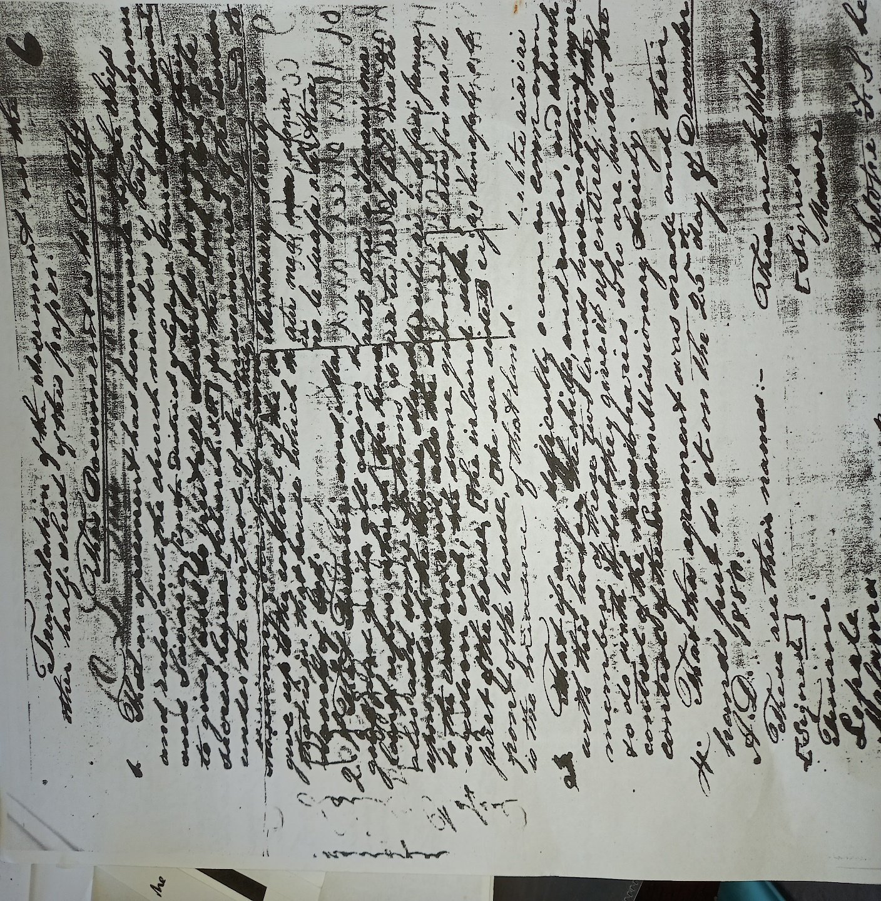
Rewriting each exact word and number written in the above copy of the original deed.

This Document is to certify:
1. That an agreement has been made by the chiefs and rulers and the church members of Tafagamanu and Savaia, (in the district of Lefaga, Aana, Upolu, Samoa) to give, and to quit all claims to forever, their sacred house (Church) for the work of God under the control of the missionaries of the London Missionary Society, so be entirely under their control and to give up to the control of the missionaries all that is in that house which they have built for the name of God.
2. That Tusani and Matualoto do now freely give and quits all claims to forever their piece of land upon which the house stands, and they also add some fathoms to the same piece of land upon which the house stands. Two fathoms to the eastern end, also the same quantity to the western end; the same quantity also to the back part of the house [the inland side]; but at the front of the house, [The sea side], eight fathoms is the measure of that land.
3. That if any difficulty occur in connection with this house, the chiefs and rulers and church members of these two lands have nothing more to do with it but they give it up entirely who are under the control of the London Missionary Society.
4. That this agreement was made and their hands put to it on the 25th day of December A.D 1880.
These are their names: These are the Witnesses:
[Signed] [Signed]
Tusani Mamoe
Lepale
Malama Setope FS: he who wrote
Taunoa and his mark this agreement
Paueli and his mark
Matualoto and his mark
Tuala
Iosefa
The above is as faithful and as nearly literal translation as I can give:
Thomas Powell
(Powell’s Signature)
(Missionary: LMS)

(b). Document 2
THE SAMOAN TRANSLATION OF THE ORIGINAL DEED
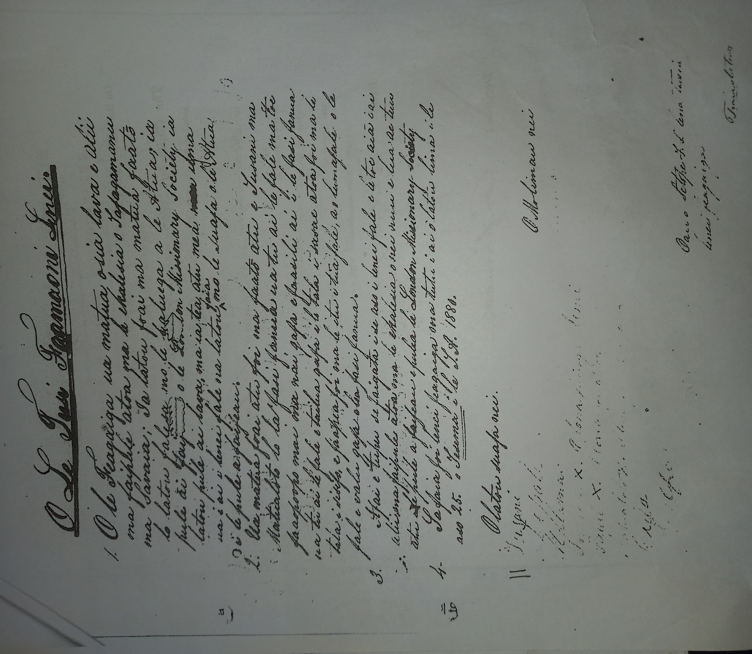
Rewriting each exact word or number written in the above copy of the original deed in the Samoan Translation.

O le Tusi Faamaonia Lenei:
1. O le Feagaiga ua matua osia lava e alii ma faipule atoa ma le Ekalesia o Tagamanu ma Savaia; Ia latou foai ma matua faatõ lo latou falesa mo le galuega a le Atua, ia pule ai faifeau o le London Missionary Society, ia latou pule ai lava, ma ia tea atu mea uma ua i ai i lenei fale na latou faia mo le Suafa o le Atua, i le pule a faifeau.
2. Ua matua foai atu foi ma faatõ atu e Tusani ma Matualoto lo la fasi fanua ua tu ai le fale ma toe faaopoopo mai ma nai gafa e faasili ai i le fasi fanua ua tu ai le fale e tailua gafa i le tala i sasae atoa foi ma le tala i sisifo, e faapea foi ma le itu i tuā fale, a o lumafale o le fale e valu gafa o lea fasi fanua.
3. Afai e tutupu se faigata i se aso i lenei fale, e le toe aiā i ai alii ma faipule atoa ma le ekalesia o nei nuu e lua ae tuu atu i le pule a faifeau e pulea e London Missionary Society.
4. Ia faia foi lenei feagaiga ma tutu i ai o latou lima i le aso 25 o Tesema I le T.A 1880.

O latou suafa nei: O Molimau nei:
Tusani Mamoe
Lepale
Malama Setope FS o le na tusia lenei
Taunoa ma lona faailoga feagaiga
Pauli ma lona faailoga
Matualoto ma lona faailogaa
Tuala
Iosefa
This is a copy of the original deed that was signed in 1880 given for the registration of the Land (Vaiola) in the 4th of January 1883 (left bottom of the deed).

(c). Document 3
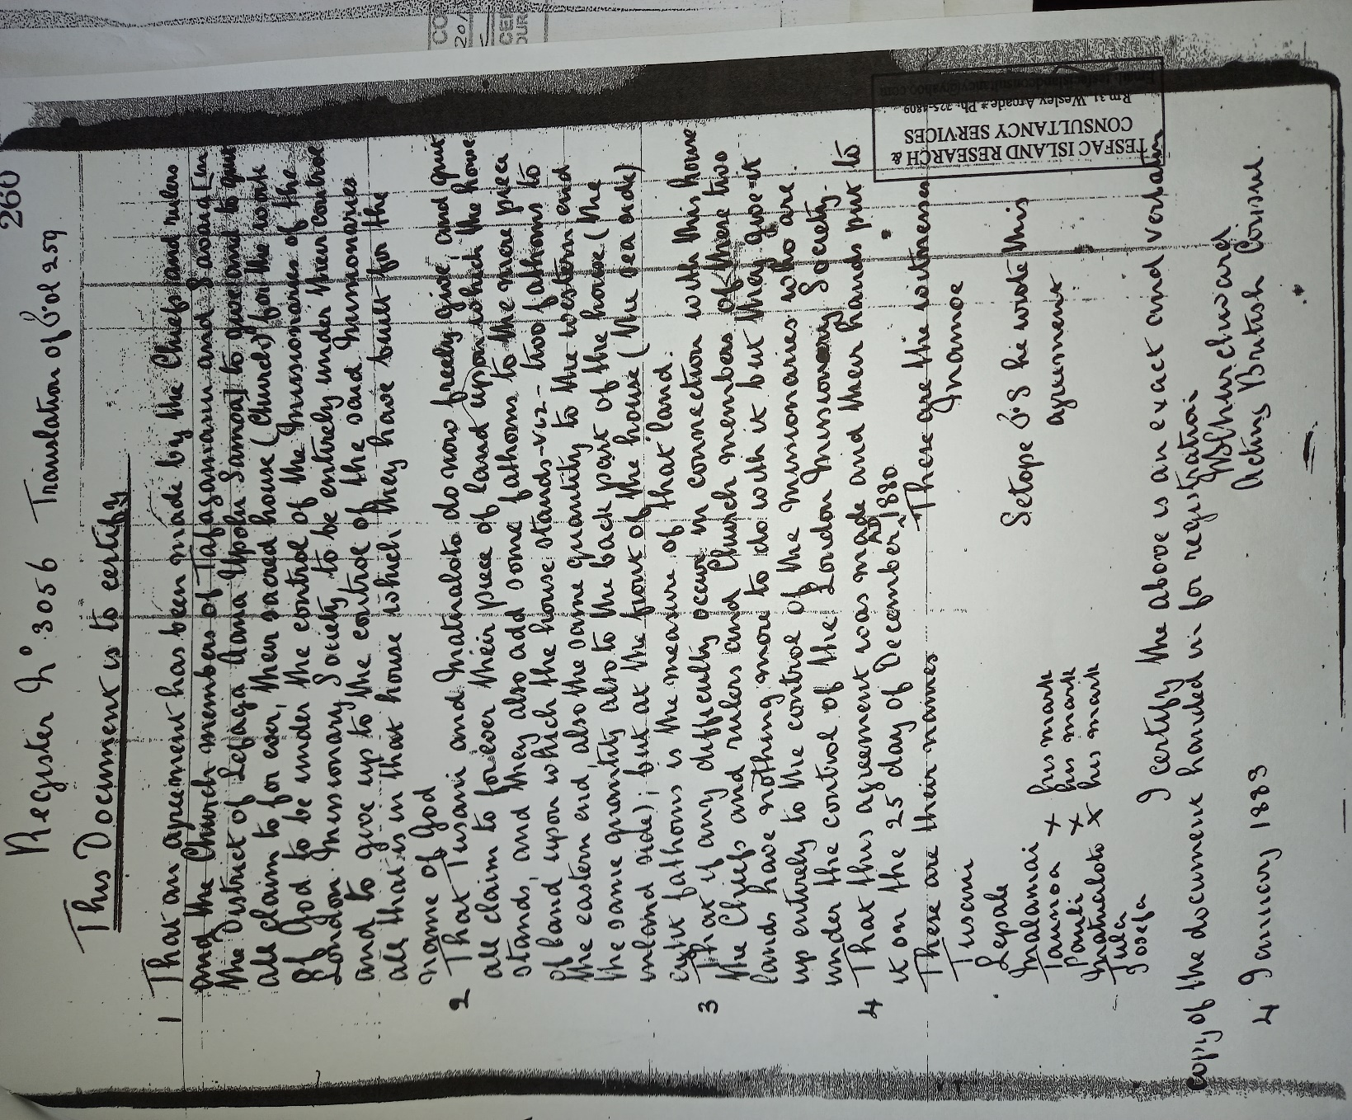

(d). Document 4
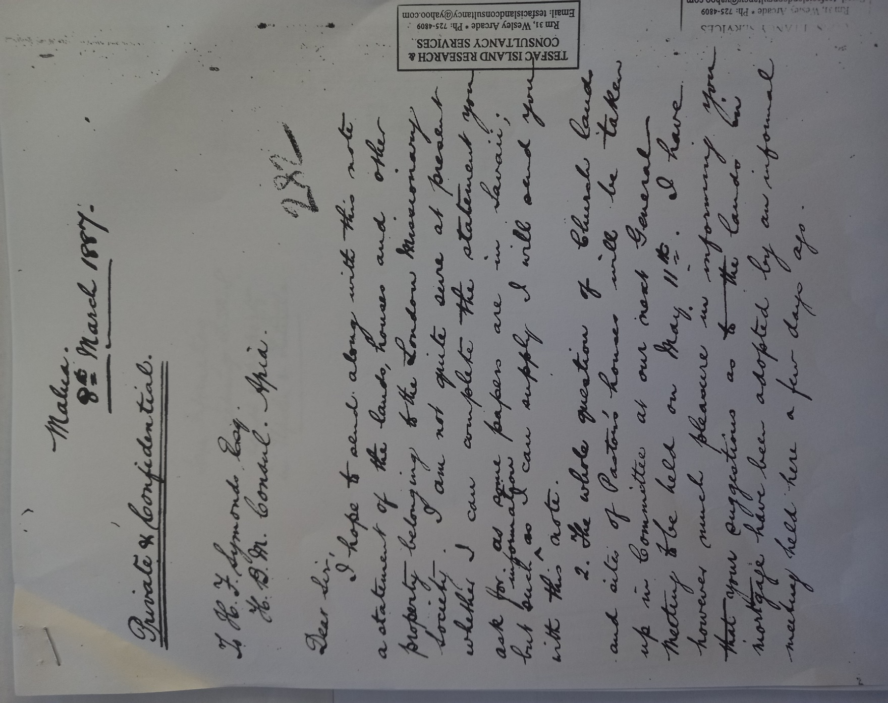

(e). Document 5
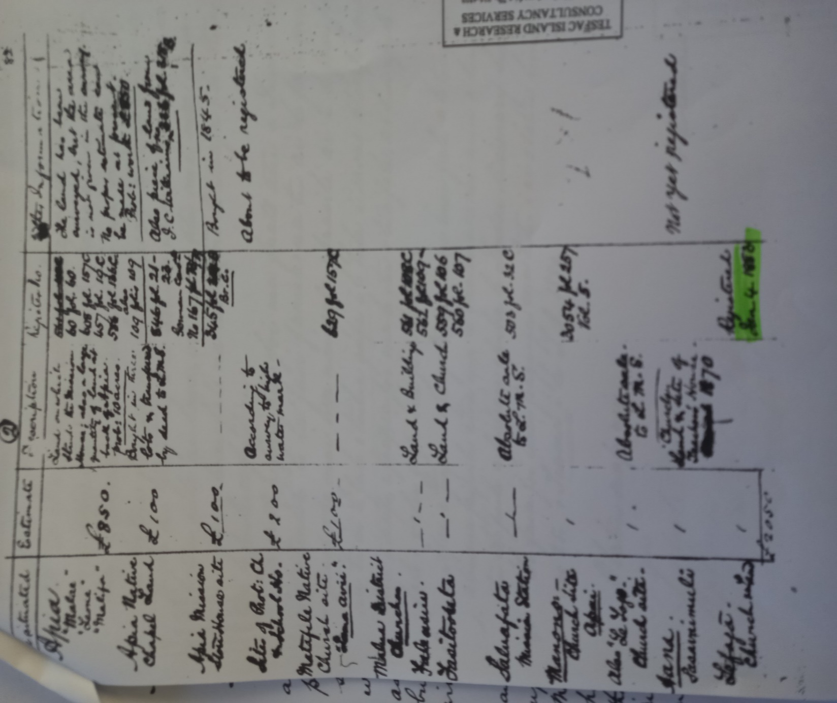
The Land of Vaiola was legally registered in 1883. The above documents are the official hand-written proof of the land freely given by the people of Tafagamanu and Savaia to the LMS Church. Within these presented documents is a list of some of the lands legally owned by the LMS Church at the time.
Comparing the original copy of the deed and the one recorded for the registration, almost everything is the same, however through comparison, both hand writings are different and of course the registration copy has a different date in which the original records indulged the 25th of December 1880, while the registration copy was rewritten in the 4th of January, 1883. This means the registered copy of the deed was rewritten by someone else in the office for the registration procedures alone. The point is, examining the 1887 list that was given, the only registered freehold land from the district of Lefaga, and was legally registered under the name Lefaga, not Tafagamanu and Savaia, in which usually causes confusions. However, the deed and its registered copy clearly stated various clauses which supports the fact that the only registered church in Lefaga at the time (in fact, there was only one church in Lefaga), was Tafagamanu and Savaia. Therefore, proving all these is to interpret the deed accordingly.

3. Clause one of the original Deed
“That an agreement has been made by the chiefs and rulers and the church members of Tafagamanu and Savaia, (in the district of Lefaga, Aana, Upolu, Samoa) to give, and to quit all claims to forever, their sacred house (Church) for the work of God under the control of the missionaries of the London Missionary Society, so be entirely under their control and to give up to the control of the missionaries all that is in that house which they have built for the name of God.”
[This clause specifically mentions the names Tafagamanu and Savaia, while Lefaga is mentioned as a district],

The list itself reveals that most lands were bought by the church, but the church of Tafagamanu and Savaia gave and offered the land of Vaiola for free to the London Missionary Society: 4th January 1883 as highlighted on the list. Secondly, the letter mentions the general meeting that was held on the 11th of May. This general meeting is now called the Fono Tele or The General Assembly. It is held each year at Malua in the second week of May (for two weeks). The purpose for this general assembly, is to give concrete solutions to all proposed subjects presented by various church districts. For instance, church assets like lands, houses and so forth. Therefore, looking at the documented letter above, this was one of the core topics of the general meeting in 1887. The presented lands reveal that the land call Vaiola in Tafagamanu was included and made official as an asset of the church since the 1887 general meeting.

3.1. The Recent Plan View of Vaiola’s Legal Map.
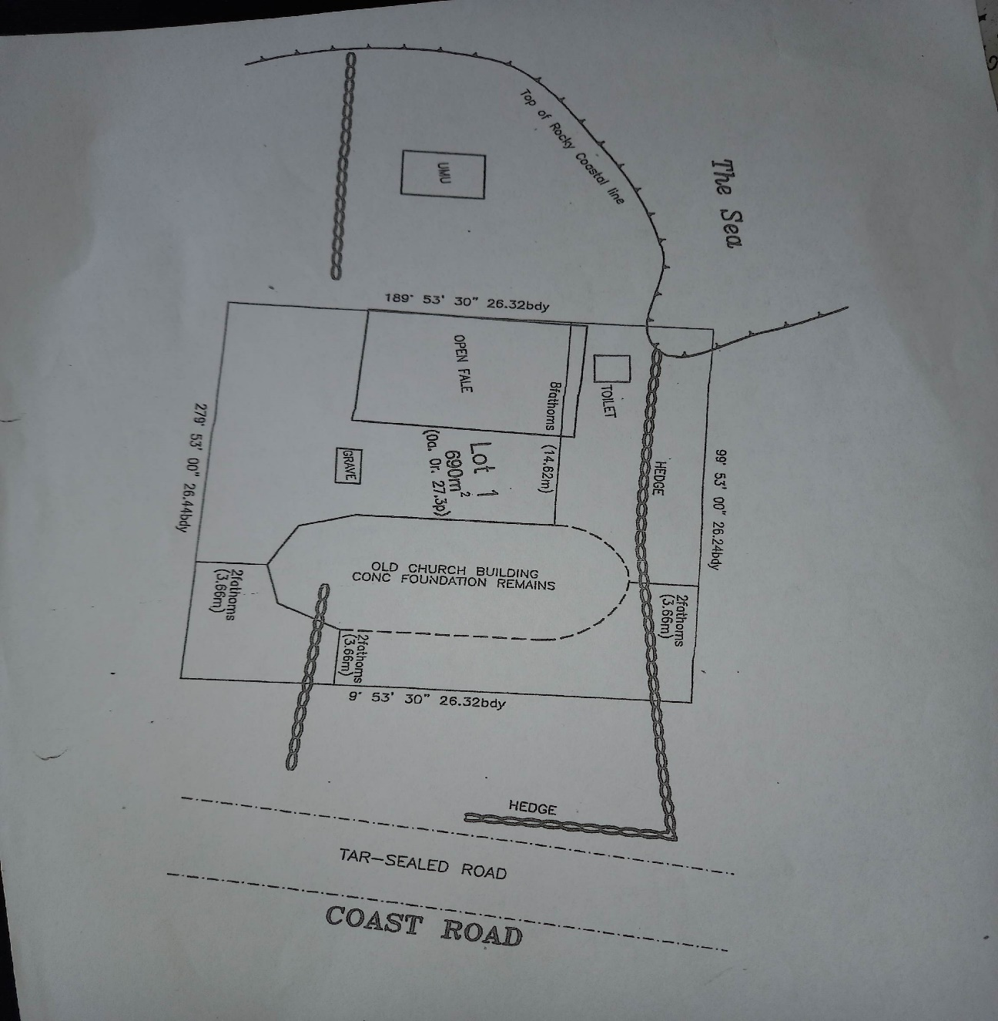

From looking at this map (plan view), the old church building remains are still intact and I took the liberty of taking some photos to prove that this landmark still explains a lot about the history of the church.
Photos of what is left of the first and old church building (I took them in the month of April, 2022).
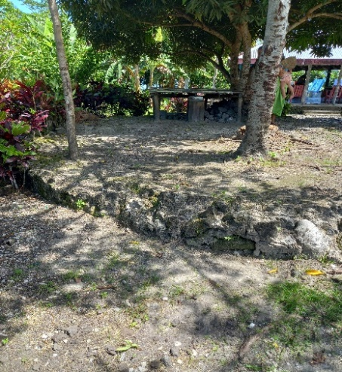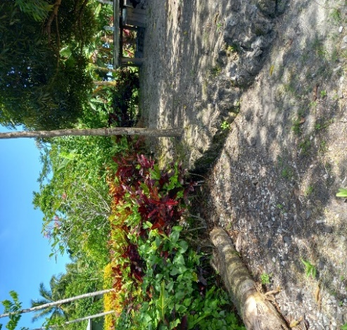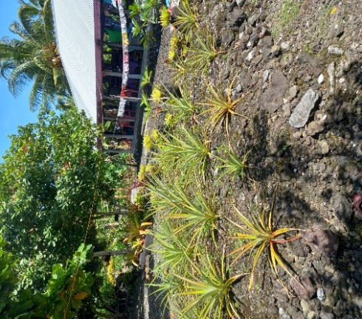

The Pool at Vaaiola:
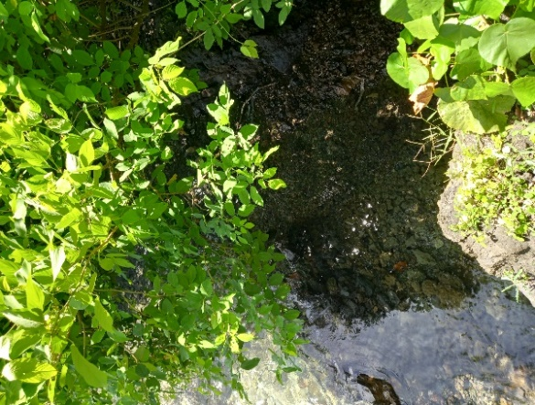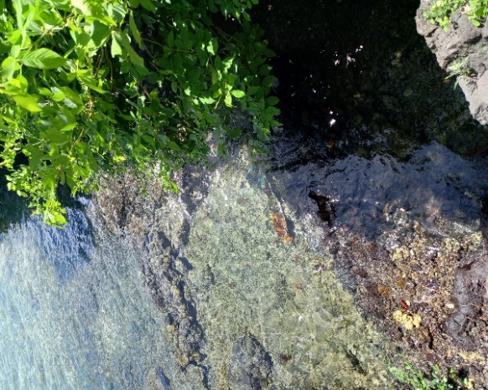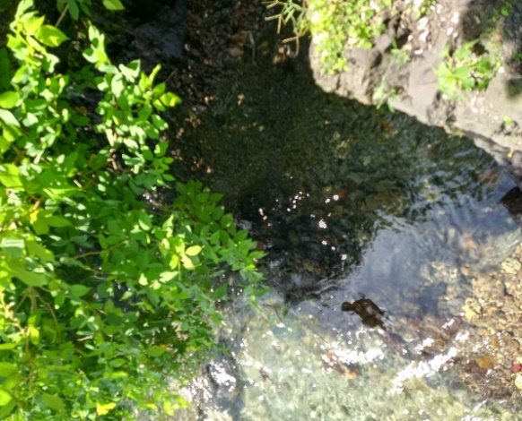

3.2. The First Church in Lefaga and Faleaseela
The list clearly mentions the name Lefaga as the registered place of the only freehold land in that area at the time. However to be exact (since Lefaga is a district) the deed was signed by the people (Chiefs) of Tafagamanu and Savaia. This means that the registered land named Vaiola is located at Tafagamanu in the district of Lefaga. Comparing the time span from 1880 when rhe deed was signed, to 1883 when the land was registered to 1887 when the Church’s general meeting was held, there was no other LMS church in Lefaga according to the presented list, only in the lands of Tafagamanu. The church is called Tafagamanu and Savaia or Savaia and Tafagamanu, but the land is registered under the village of Tafagamanu.

3.2.1. Any Other Church Denomination in Lefaga?
Based on the evidence presented, the lands of Tafagamanu is where the first church was established in the district of Lefaga. However, the date will be analyzed according to the available data. Thus, the district of Lefaga was an absolute LMS territory.
The land Vaiola was not in mortgage since it was already a freehold land, but the land of Lefaga, from Safaatoa to Matautu, with Tafagamanu and Savaia included, were all in mortgage. The reason why Vaiola was the only freehold land was because it was already a legal property of LMS and the church at the time. This proves that the first and only established church in Lefaga was in Tafagmanu. For if there were any other LMS churches or other church denominations, they might have been recorded and showed they were not in mortgage. (This will be explained in the following note below).

3.3. The Date of Arrival (Church in Tafagamanu)
These are the first two clauses of the original deed:
1. That an agreement has been made by the chiefs and rulers and the church members of Tafagamanu and Savaia, (in the district of Lefaga, Aana, Upolu, Samoa) to give, and to quit all claims to forever, their sacred house (Church) for the work of God under the control of the missionaries of the London Missionary Society, so be entirely under their control and to give up to the control of the missionaries all that is in that house which they have built for the name of God.
2. That Tusani and Matualoto do now freely give and quits all claims to forever their piece of land upon which the house stands, and they also add some fathoms to the same piece of land upon which the house stands. Two fathoms to the eastern end, also the same quantity to the western end; the same quantity also to the back part of the house [the inland side]; but at the front of the house, [The sea side], eight fathoms is the measure of that land.
These two clauses of the deed reveal a vital information about a hint on the official date on when the LMS arrived in Tafagamanu and Savaia. As we study the first clause, it declares an all agreement by church members to fully consent the ownership of the already existing Sacred House (Church House) to the missionaries of the LMS. While the second clause declares the complete transfer of ownership of the house from Tusani and Matualoto (original land owners from Tafagamanu) to the missionaries of the LMS. In addition, they added more land for the house if needed an extension. The point made here is that the church house had already been built before the deed was signed. This is significant for it reveals that the church was not established in 1880 (year the Deed was officially signed), but before. With the above interpretation, another mission is to discover the date the church arrived and established in Tafagamanu. Some traditions may help this research provide relevancy to the dating.

4. Tradition 1.
White people who settled and resided in Tafagamanu.
The Story of ELIJAH HUTCHINSON JENNINGS in Samoa

Mr. Jennings was a rich white businessman (whaler) from (USA). He was born in New York in the year1814. It was believed that he travelled to Samoa in 1842 and by the year 1848, he was mentioned on gifting guns to Tuala and Tusani of Tafagamanu to protect the village from an upcoming war that was almost on the verge of commencing at the time (Taua ole Faitasiga/The war of Faitasiga). This war happened in 1849.
He married a young Samoan lady named Malia (Maria) in the Swains Island later on. Malia was the daughter of Faumuinā Tupusē (high Chief from the district of Faleata) and To’ivao of Tafagamanu. To’ivao on the other hand, was the daughter of Tuala Su’a Aliitavini of Tafagamanu who was a decendent of Tuala Tamalelagi Maluolelagi (high chief in Tafagamanu and one of the paramounts in Samoa as well).
There was a very common tradition that where ever white people travel to and reside in, they brought the gospel with them and establish a church. As for that reason, an establishment of a church was always in high expectations when Eli Jennings resided in Tafagamanu in 1848. Therefore, this motive supports a relevant reason for the church to be established at the time when they arrived in Tafagamanu and Savaia.
In 1852, Jennings legally bought a seven acre land in Tafagamanu and registered under his name. He settled there for a few years before he bought an island named Olohega or Olosega in 1856. This island was later called Swains Island. Jennings and Malia later moved to Olosega or Swains Island. There is a story by Daniel Jennings which described the island as sandy and unproductive where Eli Jennings and wife Malia with the natives of Tafagamanu (Malia’s people) carried soil from Samoa (probably from Jennings property in Tafagamanu) to start his garden on the island.

4.1. The Significant Contribution of the name Malia
As elaborated above, Mr. Jennings married Malia, a young woman from Tafagamanu. The name Malia is the Samoan translation of the name Mary (a biblical name). Therefore, Malia or Mary was named by her parents since birth. This information shows that Faumuina and To’ivao (Malia’s parents) must have had this biblical knowledge way before the Jennings arrived with the church, in their lives through his marriage to Malia. Therefore, the year 1848 may be well questioned as the founding year the church arrived and established in Tafagamanu and Savaia. The question is, where and how did Malia’s parents gained this knowledge? Was it from somewhere else? Or maybe someone with a biblical knowledge was there at Tafagamanu and Savaia before the legal settlement of the Jennings? Or perhaps their biblical knowledge was gained from a random oral gospel tradition spread in Samoa at the time (since the gospel arrived in 1830). All these questions gave an opportunity to a productive conclusion with the blood line of Faumuina Tupuse (Malias’ Father) and the Tuala and Tusani dual.

4.2. Faumuina Tupuse
Faumuina Tupuse was the paramount chief holding all the power in the district of Faleata. Faleata is located near Apia. With his connections with his Lefaga village named Gagaifolevao was the reason why he had access to an open relationship with the Tuala Family in Tafagamanu and had the chance to meet the lovely To’ivao the daughter of Tuala Maluolelagi.
In the district of Faleata, the holders of the title Faumuina are the villages of Lepea and Vailoa. Faleata is still one of the largest districts in Samoa and the title Faumuina is the paramount chief with its kingliness that is widely admired and respected in the whole of Samoa. It was also believed that the gospel reached its lands before the district of Lefaga. Therefore, Faumuina’s upbringing within the scale of the gospel was a gain to the LMS’s early missions, especially in one of the most crowded areas in Samoa. However, bringing that biblical knowledge in his marriage to To’ivao may have been the key introduction of the church’s work in Tafaagamanu and Savaia.
Comparing the time the gospel reached Faleata, to the time Faumuina Tupuse married To’ivao of Tafagamanu Lefaga, then the nearest solution would be between 1838 and 1840.

4.3. Reason why Eli Jennings moved to Tafagamanu.
Was it out of love for the young Samoan girl, or was it another white man’s political strategy? According to the Samoan descendants of Eli and Maria Jennings, Mr. Jennings moved to Tafagamanu to marry Maria the daughter of Faumuina Tupuse (from Gagaifolevao) and To’ivao of Tafagamanu (daughter of Tualatamalelagi Malueolelagi). Tualatamalelagi and Faumuina are some of the royal family names in Samoa (paramount chief of Samoa). Secondly, having a blood relation to the Tuala’s and the Faumuina’s would probably made it easier for him to spread his prestige amongst his fellow white colleagues including the LMS missionaries. His marriage to Maria gave him the opportunity to expand his riches through all the lands he bought in Tafagamanu. Therefore, Jennings’ involvement with the people of Tafagamanu and Savaia at the time was a family oriented relationship (since he was married to Maria).
From the looks of things, this was the greatest opportunity for the LMS, not in the sense of taking advantage as many did, but to cement the church within this area through the help of the Jennings Family (white man to another). For the Jennings’ were then became a part and residents of Tafagamanu and Savaia.
Again, was it love or a political strategy? From the given evaluation above, Eli Jennings came out of love for the Tafagamanu and Gagaifo young woman. This act of love was put into good use for the benefits of all (the people of Tafagamanu and Savaia, the LMS and the Jennings family as well).

4.3.1 White Man’s Influence
There was that common tradition on how the white man worked in order to be successful in all missions in which they were assigned to fulfill. Some may say it was a blessing, some was bribe, however, some believe it was all politics and its benefits.
Whatever the strategy was, it surely worked for both sides (the white man and the natives of Tafagamanu and Savaia). The fact is that before the missionaries came to Samoa, Samoans had already familiarized themselves to white men and what they could do for them (Samoans). Samoans had already learned about the white man’s life style. Therefore, thinking that the whites took advantage, but it was not the case to the people of Samoa in the 1800s. It was more like a two way tradition, where the Samoans took advantage as well according to Rev. Dr. Featuani Ben Liuaana. It is believed that the arrival of the church in Tafagamanu may trace way back to the arrival of explorers, traders and even convicts on the shores of Samoa. The London Missionary Society arrived in Samoa in the year 1830. However, Samoa was not new on seeing the white man.

5. Lefaga including Savaia and Tafagamanu lands in Mortgage
Document 4 paragraph 2 reveals a subject about the lands that were in mortgage.
“2. The whole question of the church lands and sites of Pastors houses will be taken up in the committee as our General Meeting to be held on May 11th. I have however take much pleasure in informing you that your suggestions as to the lands in mortgage have been adopted by an informal meeting held here a few days ago.”
This statement “lands in mortgage” says everything about the situation at the time. It proves the point of having agricultural developments in Lefaga including Tafagamanu and Savaia.
There was no way the people of Tafagamanu and Savaia would have been able to build a church house (with bricks) without any financial assistance; not without the influence of foreigners. The idea of mortgaging the lands to earn financial aid was clearly a white man’s, (for Samoans only have their knowledge and skills on building traditional Samoan houses). Therefore, in order to achieve the building of a new church house, they were advised to mortgage their land. The development of the land was focused basically on agriculture. Harvesting coconut farms and cocoa plantations, was the main source of income. In doing this, they were able to rebuild a new church house.

5.1. Mortgage and the Church
It was believed that more workers from around the country were brought in by foreigners in Savaia and Tafagamanu. These workers were not all Samoans, as for the British government in Samoa, brought more foreign workers and introduced various ethnic groups like the Chinese, the Solomons and so forth. There was a misunderstanding over the Samoans laziness to work, however Samoans were a proud people. Looking at the conditions of the Samoan lands being mortgaged, the people of Tafagamanu and Savaia (not being the lazy people as they were labelled but as owners of the mortgaged land), ceased the opportunity to be benefitted from. As the white man’s mentality always reflected a mindset of taking advantage on the natives, the chiefs of the land were instead very cautious about what they were doing. Meanwhile, the church in Tafagamanu and Savaia gained more church goers (workers) and their financial contributions were increased rapidly, and helped the development of the church.
Becoming the only church and only area of governmental agricultural developments in Lefaga, was a clear and true declaration that Tafagamanu and Savaia was not only the center of the church in the district, but the political arena where all were based upon. However, this mortgage did not last since the traditional government of Samoa led by Tamasese declared a halt to it. His intension for all Samoans was not to mortgage off their lands to the white man.
Other sources suggested that the land was given the name Vaiola by Rev. Alama Moreli (Savaia and Tafagamanu’s Pastor from 1932 to 1970), as a reminder of the original land that served God from the beginning. The land catered the Gospel and provided the water of life for not only Savaia and Tafagamanu but the whole district of Lefaga and Faleaseela. However the land was originally called and named Gaoā. The family of Tusani and Matualoto who offered the land to the LMS, revealed this information and the original name of the land since the place was never up to the standard in which an official public offering is acceptable accordingly, for the Samoan word gaoā is of course the name given to a very rough, rugged and rocky place. Not just any kind of rock but the kind with very sharp edges that always cause permanent injury, or perhaps instant death.
Metaphorically speaking, this rough and rocky piece of land may reflect the spiritual conditions that the people of Tafagamanu and Savaia may have encountered at the time in a manner of speaking, or may indeed reflect on what the future the gospel may or will endure. For spreading the gospel and its nature always face hardships. However, whatever the presented hypothesis was according to the context of the word, the feeling that gaoā conveys was communal, which may have caused and led to the renewal of the land’s official name which was and still is vaiola or the water of life. Therefore, the comparison of the two Samoan words, gaoā and vaiola shows the fruits of faith from the people through the spiritual works of the church. In addition, Vaiola has a pool and it still exists today. The word pool is simply translated in Samoan as vai as well.

6. Tradition 2
The Ship Wreck in 1865 (Mulitapuili)
(Prepared and presented by Rev. Elder Misipalauni Faatau)

This oral traditions suggests that the missionaries were travelling at sea on their way to Vaie’e in the district of Safata (neighboring district), since Vaie’e was another center of the LMS missionary work in Upolu (main island of Samoa). They travelled across the sea opposite the lands of Tafagamanu. This part of the sea is called by the Tafagamanu people “Mulitapuili” and that’s where the ship wreck occurred.
It was at late afternoon and the weather was rough for the crew ship to handle, and the accident happened. The people of Savaia and Tafagamanu out of love, lend a helping hand and managed to pierce through the strong winds and rough seas and reached Mulitapuili where the ship wrecked. The natives of Tafagamanu and Savaia came to the rescue and brought them to the shores, at the place they now called Vaiola.
Therefore, since it was the safe arrival of the missionaries while still sustain life, they named the land Vaiola, this piece of land has a pure water pool that quench the thirst of the villages, and the crew members comforted themselves by having a dip in the pool. Naming this piece of land Vaiola is more like a tribute, offered to God for saving the lives of the people that were on board. Therefore the name Vaiola would always remain as a reminder of what God the Almighty had done not only to the ship crew but the people of Savaia and Tafagamanu in terms of the arrival of the gospel on their lands. This tradition is still very sacred to the people of Tafagamanu and Savaia, for the precious thought that Vaiola was the gateway of salvation through the Gospel of Jesus Christ not just to our people, but the district of Lefaga and Faleaseela as well.
From then on, Vaiola became the center of the LMS missions in Lefaga and Faleaseela. This information is indeed being confirmed and better more, the land of Vaiola in Tafagamanu was the birth place of the church in the whole district of Lefaga and Faleaseela. The first church in the district to be precise.

6.1. Reflection on what happened at Mulitapuili in 1865
The word mulitapuili means boundry of the deep and the shallow. It is of course one of God’s wonders at the seas of Tafagamanu. An unusual connection of the deep and the shallow in this part of the Tafagamanu seas. It is a beautiful place when the weather is fine, but it is one of the most dangerous places when it becomes rough. Since there is no reef to render as a warning mark for fishermen and travelers as well. Only those who are familiar to the sight and the area would have the experience to control the speed of travel when it enters Mulitapuili. Probably the reason why the mission ship was destroyed, with the great contribution of the stormy and rough wheater, the ship crew definitely could not see the connection of the deep and shallow area.
The literal translation of the Samoan word reflects the excrutiating nature of what had happened and took place. According to I’a Solomoa, there is no reef at mulitapuili. It is said that mulitapuili is the end of the shallow area of the sea when tarvelling from land, but the end of the deep when travelling from the ocean side. As mentioned above, it is the boundry of the deep and the shallow.
A biblical and theological evaluation of the place and the scene that took place caters God’s plan for the already established church in the lands of Tafagamanu. From Tafagamanu to the boundry of Mulitapuili is all but shallow. It was a very significant characteristic of the young church in terms of deeper understanding of the kingdom of God. The church in Tafagamanu and Savaia may have needed more understanding of the Gospel or perhaps the Almighty was working and planning to use more people on His own accord for the benefit of the His holy work. For this, the ship wreck was an essential occurance for the presence and help of more missionaries were so much in need and a necessity to refresh and ignite the hungry souls who were keener to promote the work of God.

6.2. Judges 14: 14
Then he said to them, “Out of the eater?? came something to eat. Out of the strong came something sweet”.

Whatever caused the separation of the church or village??, one thing for sure, nothing happens without a reason, and this reason portrays God’s plans to reverse what seems to be originated from pain and agony to something more valuable and better. Out of something bad comes goodness. Out of all the adversaries, two new churches were established.
Despite the fiercesome nature of the lion, its’ deteriorated dead body becomes a permanent place for a bee hive from within, which produces one of the sweetest honey. It is an allegory corresponding to what had happened in the church which caused the separation between the two villages. Therefore, despite various hurtful interpretations on the matter, God always turns things around for the betterment of his church and his faithfuls.

7. Progress of the Church in Lefaga and Faleaseela
As interpreting the evidences presented, Tafagamanu and Savaia had contributed massively in building the district of Lefaga and Faleaseela not just the church with the spiritual approach but with the political influence of the church as well. All six villages in Lefaga and Faleaseela, were believed to be attending the church in Tafagamanu and Savaia in the beginning, since it was the only church in Lefaga. Not until the LMS missionaries and Le Mamea, one of the paramount chiefs of Matautu signed a deed for their church to be legally established on the 3rd of July 1889.

7.1. CCCS Matautu’s Official Deed: signed on the 3rd of July, 1889.
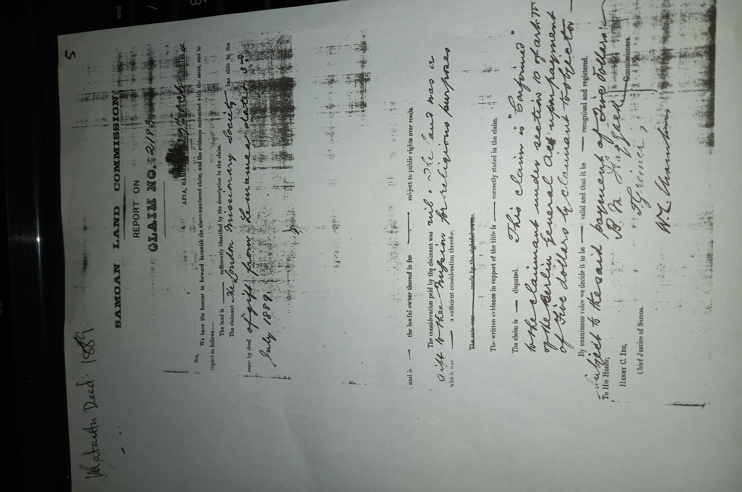

Rewriting each word and number within the Matautu Church Deed
SAMOAN LAND COMMISSION
REPORT ON
CLAIM NO. 2183
APIA SAMOA 29TH OCT 1894
SIR,
We have the honour to forward herewith the above numbered claim, and the evidence connected with the same, and to report as follows:-
The land is sufficiently identified by the description of the claim.
The claimant The London Missionary Society has title to the same by deed of gift from Lemamea dated 3rd July 1889.
and is the lawful owner thereof in fee subject to public rights over roads.

The consideration paid by the claimant nil. The land was a gift to the mission for religious purposes
Which was a sufficient consideration thereof.

The written evidence in support of the title is correctly stated in the claim.
The claim is disputed. This claim is ‘confirmed’ to the claimant under section 10 of act TC of the Berlin General Act upon payment of five dollors by claimant to objector ________
By unanimous voice we decide it to be ______ valid and that it be _________ recognised and registered.
Subject to the said payment of five dollars

To His Honour, Commissioners
HENRY C, IDE, [signitures]
Chief Justice of Samoa.

The above deed proves that the church of Matautu was established later as a result of the growth and progress of the church’s development from Tafagamanu. To further this statement, Matautu’s pastor in 1885 before the deed was legally signed, was Iolamo and wife Aupiu from Tagamanu and Savaia. This deed was signed on the 3rd of July 1889 but was officially registered on the 29th of October in 1894 as shown on the top right of the deed.

8. SUMMARY: Evaluation on the presented Traditions

8.1. Church’s Arrival Date (Officially was 1838)
There is an interesting point in clarifying the deed (Tafagamanu and Savaia). The first clause of the deed was about giving authority to the missionaries of the London Missionary Society over the house (church) that was already built and used. Marking that the deed was signed in 1880 and was registered in 1883, this had really opened the door to a much farther date before the actual deed was signed. This depicts a vital point that the church had been established before the deed was signed. However, the question is, when was the church established? Various accounts were presented and were strongly focused on some of the most relevant dates or the nearest dates on when the church was established in Tafagamanu and Savaia.
Therefore, attempts to trace a relevant period for the dating of the arrival is of course as explained in the given data presented before, it came to the conclusion that the church in Tafagamanu and Savaia was established between the years 1838 to 1840. Before the Jennings’ family resided in Tafagamanu, the influence of the church was basically from a wider scale corresponding with the rapid spread of the gospel or the new religion in Samoa. For that reason, traders and merchants as Rev. Elder Misipalauni Faatau had mentioned, were included and the firm contribution of Faumuina Tupuse and his family from the district of Faleata where the gospel reached earlier. Therefore, the date of the establishment of the church in Tafagamanu and Savaia was from 1838 to 1840. (From 1838 to 2022, it has been 184 years since the gospel had officially reached the shores of Tafagamanu and Savaia).

8.2 Missionaries Involved
- Rev. Wright Archibald Murray (Misi Mare - worked in the A’ana district including Malua)
- Thomas Powell (Misi Pa’ueli)
- Rev. J. M Mills (Misi Milo - worked in the District of A’ana 1864)
- Dennis (Misi Tenise)
- Barff (Misi Pati)
- Rev. Thomas Heath (Misi Ite - worked in the A’ana district)
- Rev. S. J. Whitmee F. R. G. S (Misi Uitime – worked in the district of A’ana from 1864 to 1875)
- Rev. A. E Ciaxton (Misi Talatonu – worked in the district of A’ana from 1885 to 1888)
- Rev. J W Hills (Misi Elise – worked in the district of A’ana from 1890 to 1915)
- Rev. J W Sibree (Misi Saipere - worked in the district of A’ana from 1914 to 1918)
- Rev. Goward

8.3. Natives involved in the beginning
1. Tuala Maluolelagi (To’ivao’s great grand father)
2. Faumuina Tupuse (To’ivao’s Husband)
3. Tuala Su’a Aliitavini (Tuala Maluolelagi’s grandson & To’ivao’s father)
4. Malia (Eli Jennings’ wife)

8.3.1. Those who signed and witnessed the 1880 deed.
1. Tusani (from Tafagamanu)
2. Lepale (from Savaia)
3. Malama (from Savaia)
4. Taunoa (from Savaia)
5. Paueli (from Tafagamanu)
6. Matualoto (from Tafagamanu)
7. Tuala (from Tafagamanu)
8. Iosefa (another Samoan pastor)

9. London Missionary Society Program:
How the LMS was operated on distributing its missionaries and Samoan pastors at time.

Unless a church’s legal deed was officially registered and labelled, the LMS would never considerappointing a resident pastor to reside in the village as their parish pastor. Thus, since the Vaiola land deed was only officiated in 1880, there were no resident pastors (Samoans and LMS missionaries) in Tafagamanu and Savaia, only those who took turns with specific periods of time. So, from 1838 to 1879, only a few names were recovered, while from 1880 to present, a list will be presented as well.

10. List of LMS Missionaries and Samoan Pastors from 1838 to 1879
- Missionary J W Hills
- Missionary A. W. Murray
- Missionary T. Powell
- Vavega FS (Samoan Pastor)
- Setope FS (Native Preacher)
- Iosefa FS (Samoan Pastor)

11. Pastors from 1880 to 2022
- Missionary Goward – between 1885 and 1900 (Misi Kovati)
- Fia (FS) (1901 to 1911)
- Asotasi (FS) (1912 to 1920)
- Tufue and wife Gia (FS) (1920 to 1924)
- Apela and wife Tai (FS) (1926 to 1931)
- Alama Moreli and wife Litara (FS) (1932 to 1970)
- Urika Saifoloi and wife Oomi (FS) (1971 to 1981)
- Roseti and wife Arasi (FS) (1982 to 1986)
- Poka Maua and wife Malo (FS) (1988 to 2008)
(This List is based on the Tala o le Lotu a Tama Fanau a Savaia ma Tafagamanu: provided by Rev. Elder Poka Maua, Rev. Keneti Le’aupepe and Rev. Clay Tofilau)

In 2009 the church of Savaia and Tafagamanu split. It will be explained in chapter four. However, the churches still progressed after the split. For this, the original church called Savaia and Tafagamanu does not exist anymore. However, it was the birth of two new churches called Congregational Christian Church of Tafagamanu and the Congregational Christian Church of Savaia. For now, here is how the two churches stand in the two villages:
CCCS Tafagamanu (Independent) CCCS Savaia (Independent)
1. Toosavili Atimalala Tu’a and wife Epenesa (FS) 1. Poka Maua and wife Malo (FT)
(2011 to present) (2009 to 2019)
2. Clay Tofilau and wife Eseta (FS)
(2020 to present)

Within these 184 years, more than twenty pastors (including missionaries) served and are serving in the church of Tafagamanu and Savaia. Though, there is still a chance that there might be others who are not yet to be recovered. Tafagamanu and her people, Savaia and her people had been sacrificing their lives for the work of God for 184 years now.

12. Summary
In this conclusion, it is an honor and privilege for me as the resident church minister in Tafagamanu to claim that the church in Lefaga and Faleaseela was initiated in Tafagamanu. Being the original land (Tafagamanu) to establish the church of Jesus Christ upon is the greatest honor that any village could have ever asked for due to matters of the being faithful to God.
In addition, as far as the coalition of Tafagamanu and Savaia is concerned, the evidence and facts are presented that the original church and the original church house (building) was situated and located in Tafagamanu (Vaiola) and the land of Vaiola was clearly offered by Tusani (high chief) and Matualoto (Tusani’s Orator/talking chief) of Tafagamanu (as their own).
The sacrifices made by the people of Tafagamanu at the time conveyed a higher spectrum of faith in God. Noting the efforts they offered to sustain the progress of the church at the time was immeasurable.
The LMS was very obvious on how to operate their work in Samoa. Using the help of their fellow foreigners like Mr. Jennings family who had a Samoan connection through marriage to Malia of Tafagamanu, contributed so much to the spreading of the gospel. For they had blood connections to the natives. Whatever good ideas that were literally available, were utilized and put into practiced for the sake of the church. For instance, Mr. Jennings was a wealthy young whaler from New York and his wealth and ideas on how to be wealthy was given mostly to the people of Tafagamanu (his Samoan family). Like giving cultural lands into mortgages in order to receive money for the church and the families. The sincerity of the hearts towards the Gospel of Jesus Christ was overwhelmed and aspired with the full commitment of people, where Tafagamanu on the other hand, gifted most of their lands to the church and the work of Jesus Christ.
This reminds us of how the Holy Spirit works in mysterious ways as the Book of Acts bears witness.

12.1. The Official Claim
  - The church arrived in 1838.
  - The church was brought to Tafagamanu by To’ivao and her husband Faumuina Tupuse.
    - To’ivao – Daughter of Tuala Su’a Aliitavini.
    - Faumuina Tupuse – From the district of Faleata who was related to the Tusani Family. With the title Faumuina, he is related to the Tuala Family in the bigger scale of the Samoan Family - Tree.
  - Tafagamanu is the Official Arrival Place

CHAPTER 3

THE SHIFT OF THE CHURCH

1. INTRODUCTION
In the previous chapter, an abundance of historical recoveries were presented. This chapter will look at the shift of the church from Vaiola to Niue. An attempt will be made to identify some of the motives behind the shift using the uncovered root of the church presented in chapter two. This is one of the biggest event in the history of the church in Tafagamanu and Savaia that needs to be unveiled. Some of the influences that contributed to the success of the church’s development during this period will be discussed as well. Just to note, there is also a lack of written or documented material about this period. However, using the evidence elaborated in chapter two might be a good start for this chapter, with the lending hand of some historical landmarks.

1.1. Reasons for the Shift of the Church from Vaiola to Niue

1.1.1. Population Growth
When Eli Jennings bought his land at Tafagamanu in 1852, there were only six chiefs in both villages who signed the deed. It was recorded that only forty six (46) people of Savaia and Tafagamanu combined. This population grew over the years and their church building or falesa became too small, which contributed to the reason why the decision was made to shift the church. The building of the new church house at the boundry of Savaia and Tafagamanu happened before the 1880 deed was signed.

1.1.2. The Church was too close to the sea
Looking at the plan view of the presented map of the land Vaiola, shows that the land is too close to the sea. It was then the awareness of the people who knew this area well saw that their might be endangerment to the people through natural disasters like stormy seas and tidal waves. Though it did not happen, but this reveal how sensitive the people were towards the protection of their church and the gospel of Jesus Christ. It must have been very hard for the people and the missionaries to move the church since Vaiola was the original landmark of the work of God.

2. 1875 to 1879:
The Falesa that marked the boundry of the two villages
(This information was drawn from an Interview with Fonoti Samagape’a Tivasa Namulauulu and the TESFAC ISLAND RESEARCH & CONSULTANCY SERVICES. Their sources about this matter is confidential due to Fretton’s family reasons. However, the location of this church house was confirmed by Rev. Elder Poka Maua during one of our interviews)
One of the main reason for the shift of the church was that the number of people increased and could not fit in the church house in Vaiola. The missionaries and the people of the village decided to build a new temple of God for worship. They were scanning the area for a perfect site for the falesa. However, Anne Elizabeth Jennings and husband Fretton stressed that, since the church is formed up of two villages, it was better to build the church right on the spot where the boundry of the villages was. The suggestion was to make the falesa the mark of the boundary. It was then accepted by the missionaries and the people of Tafagamanu and Savaia. Therefore, they started to build on the designated spot. The building was a stone-walled house for worship. This is the third falesa.

2.1. These are some of the remains of the church building that was built between 1875 and 1879 (THE THIRD CHURCH BUILDING)

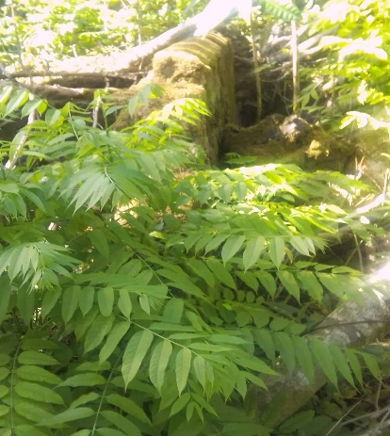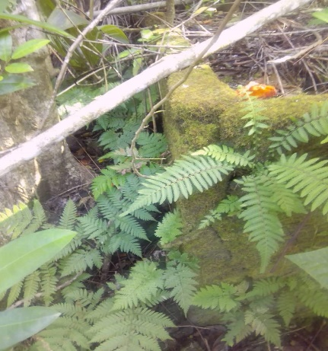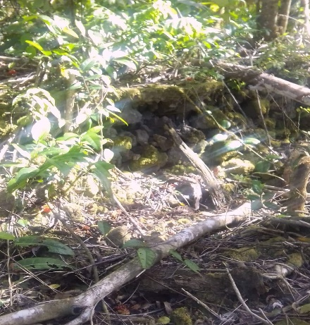
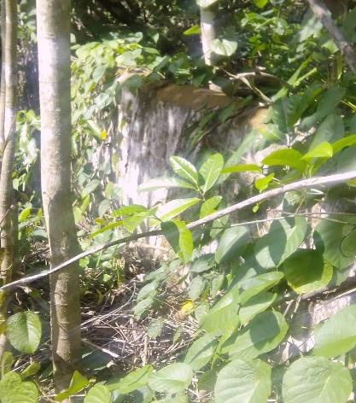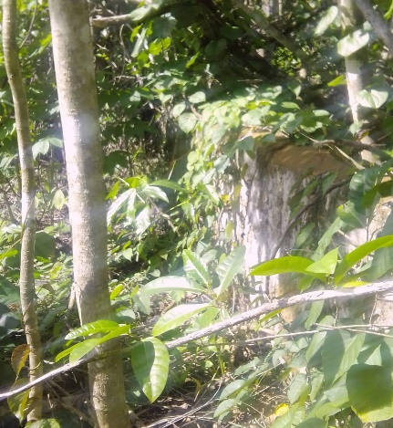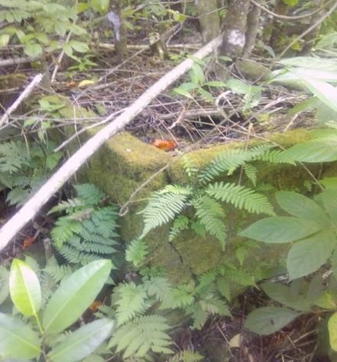

3. The Second Shift of the church in 1915
The church house at the boundry of Savaia and Tafagamanu existed for 25 before it shifted back to Tafagamanu on the land of Niue. After twenty five years, the village’s population grew more and their church house was again in need of an extention. Therefore, in 1915, the villages decided to build a new church house. During the demolishing of the old church house, an accident happened and changed the cause of history. This was the only reason behind the second shift of the church from the boundry to its new location in Niue alone (for Niue and Tililagi shared the boundry which the church house was used as a mark).

3.1. The Death of James Charles Curry
In 1915, the rebuilding of the old church house was underway. Mr. Curry was one of the carpenters who were present in the demolishing of the old church building. The below piece of document provides evidence that describes the last work done by James Curry (J.C). It reveals that Mr. Curry died when a stoned wall collapsed and fell on him. It was said that his last job was the demolishing of the old church building.
The abnormality of this accident may have caused panic and devastation to the people. Watching one of their warriors died in the church house must have been a very terrifying seen. Envisioning what was going through Ellen and their children’s minds as this sad news came reached their ears.
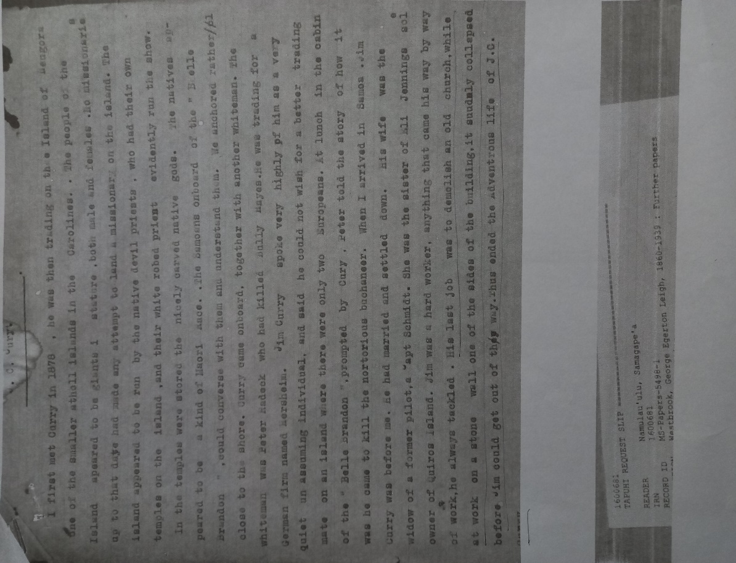
The document above I quote, “His last job was to demolish an old church, while at work on a stone wall one of the sides of the building, it suddenly collapsed before Jim could get out of the way. Thus ended the adventurous life of J.C.”
The resident pastor at the time was Asotasi (1912 to 1920) as presented, he fought to change the location to build the new church since the whole land was of course being stained by the blood of Mr. Curry in a manner of speaking. There would always be that ungodliness and uncleanliness within the land because a person died there.
Furthermore, it was a contextual Christian superstition where everything must be clean and pure for the work of God. For Samoans as very religious and superstitious people reacted accordingly and effectively. For this reason, the people of Savaia and Tafagamanu with the help of Ellen Jennings Curry (James Curry’s wife, and her Tuala-Tusani family), decided to move the church to another location. Therefore, the Tuala family and the people of Tafagamanu accepted to build the forth church on the land of Niue.

4. Falesa/ Church Houses and Buildings that were built and where they were built
      - Tusani and Matualoto’s (Fale Afo Lau) Samoan House (Vaiola: from 1838 to 1865)
- Stoned-wall House built by missionaries in 1865 to 187 9 (Vaiola)
- Stoned-wall House built between the lands of Niue and Tililagi
(Marked the Boundry between Savaia and Tafagamanu). This was believed to be built between 1875 to 1879 before the church building in Vaiolola was offered to the pastor as their home and the center of the LMS work, as mentioned in the 1880 Deed.
  - Stoned-Wall Building built by the people of Savaia and Tafagamanu on the land of
Niue from 1915 to 1922 but was renovated in 1937 and opened in 1938. It was rebuilt in 1983 to 1988 (This was a massive project). In 2019 before Rev. Elder Poka Maua was retired, they once again renovated the church building.

Here are some photos of the church building as it stands today in NIUE, where CCCS Savaia are using. (But it used to be the church building for both Savaia and Tafagamanu)
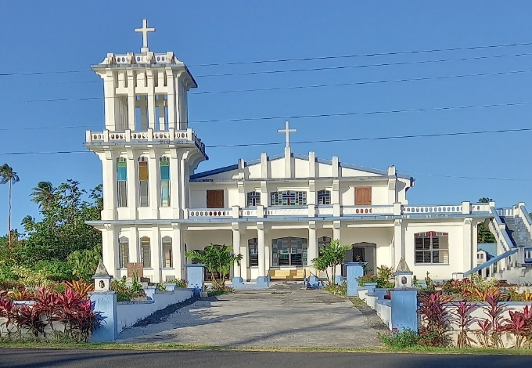
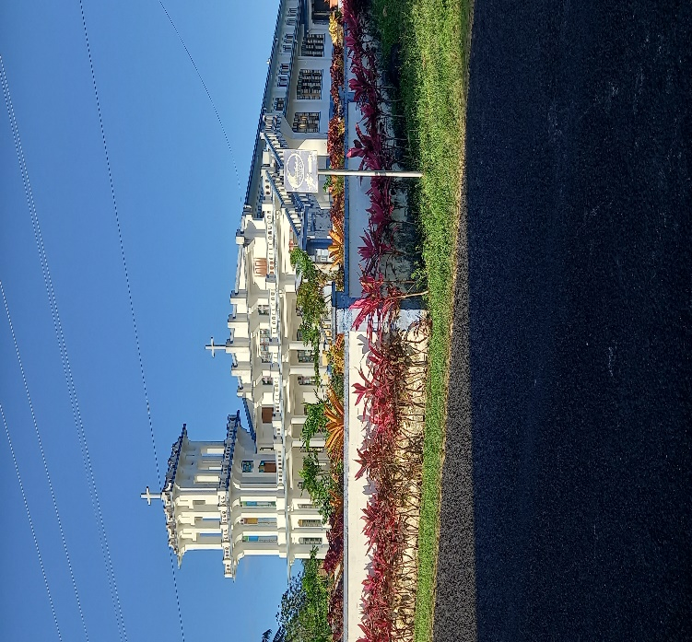

This church building was built on the 18th of July in 1985 but was opened on the 14th of July 1988 as shown on the markings carved in the building’s front wall. It took three years for the people of Savaia and Tafagamanu to complete this massive project.
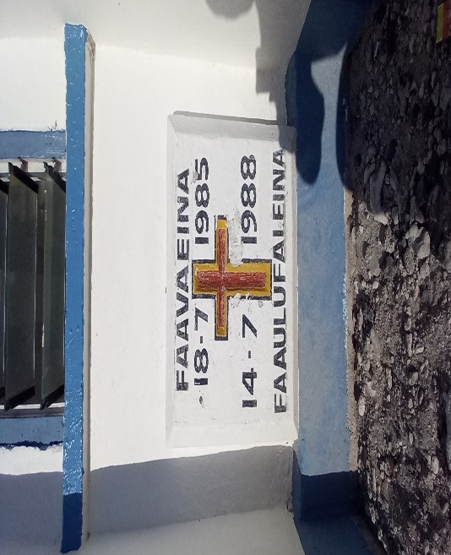
Thankfully, God’s love was abundantly fulfilling. The sacrifice through sweat and blood was immeasurable. The three year period of building and structuring the new falesa seized most opportune prospect of stabilizing each family’s mutual life style. However, this unconditional heresy through this new nature had no effect to the hearts of the faithful. Considering the biblical and theological significant of number three (3), as in three years of building, it reveals a powerful resemblance to the holy Completeness of God himself through his triune nature, the Father, the Son, and the Holy Spirit. As for the Bible itsef, the usage of number three is a common tradition.

5. Biblical Reflections

5.1. 1 Corinthians 13: 14.
“May the grace of the Lord Jesus Christ, and the Love os God, and the fellowship of the Holy Spirit be with you all.”

As mentioned above, the Trinity is the holy completeness of God’s three persons. The Father, the Son and the Holy Spirit.

5.2. Exodus 3: 6.
Then he said, “I am the God of your Father, the God of Abraham, the God of Isaac and the God of Jacob.” At this, Moses hid his face, because he was afraid to look at God.
This is commonly known as the geneology of the Israeli’s Patriarchs (forefathers). As we can see here, the sequence was well planned by God through choosing three different individuals within three different time spans before it was amplified in the fourth generation with Jacob’s family. Apparently, we can say that God’s perfect plan was in full completion as for the first phase (of the plan) was concerned. The other important aspect here which is worth considering is not just only the three individuals but the three different time spans. This time-aspect seals the preciousness of its existance in which any individual shares once in this life. For time does not wait for anyone. As for our almighty God, time is in his control. Like the time of Abraham and all its undertakings, the time of Isaac and all its happenings, and the time of Jacob and its endeavors, then a different time and its occurances was born.
Therefore, the generations who built the falesa from 1985 to 1988, were the chosen for that time. It was then completed and they became the blessings of their time which challenges the generations of today.
According to the 1880 Vaiola deed , the first church building was built before the deed was signed. This interpretation is supported by the story about the ship wreck in 1865, where the missionaries involved surely attested the idea of building the first modern house (for church services), because the only house that had been used by the villages for church services before, was Tusani and Matualoto’s Samoan House (fale afo lau: maota faasau).
That same year (1865) a modern style house was built on the land of Vaiola (Gaoā) by the missionaries with the assistance of the people of Savaia and Tafagamanu, where Tusani and Matualoto’s house was.
This means there was a Samoan Fale (Samoan house) for their church services before the modern cemented and stoned walled house was built.
It is believed that the third falesa was built right on top of the boundry of Savaia and Tafagamanu before the 1880 deed was signed. For this deed reveals that the people of Tafagamanu and Savaia offered their church house for the pastors. It was not mentioned in the deed but the house became the mission center, and secondly for the pastors to stay. However, the church house can not be offered for different uses unless there was another house for church services. That is why the relevant explaination on when the third falesa or church house that marked the boundry of Savaia and Tafagamanu was built at about 1875 to 1879 before the deed was signed and the old church was offered to the pastors for other church plans.
The new church building was then built and located according to this boundary. In accordance with the 1880 deed (Vaiola), the first church building was built way before the 1880 deed was signed in the year 1865 as mentioned in chapter two, then the new church building that marked the boundary of Savaia and Tafagamanu must be the third one.
The Church was once again moved to the other side of Niue where it stands today. As mentioned above, Asotasi (FS) was the resident pastor at the time. Tufue (FS) came in 1920 to 1924, while the next faifeau came on the year 1932. Therefore the church was left without a resident pastor. This gap is believed to be filled by Setope (FS & Native preacher. Not a resident pastor). In 1925, Setope resumed the unfinished work (the new church), and finished it before Alama arrived in 1932. In 1937, Alama and the church of Tafagamanu and Savaia renovated the church building since its conditions were not up to the standard and for safety precautions. In 1938 the new improved church was reopened.

6. Pastors from 1880 to 2008 before the Separation
- Missionary Rev. Willam E. Goward (Misi Kovati)
An oral tradition suggest that the reason why there is no information about missionary Goward in Savaia and Tafagamanu was because he was stripped of of his titles due to various reasons. Similarly to what Rev. Dr. Featunai mentioned in his book Samoa Tula’i, Goward was known as a very ruthless man. He was very discriminative towards the Samoan pastors during their mission in other countries. Even when he was stationed at the Falealili District, he was reported over beating Samoan people and the pastors.

- Fia (FS)
- Asotasi (FS) (1912 to 1920)
- Tufue and wife Gia (FS) (1920 to 1924)
- Apela and wife Tai (FS) (1926 to 1931)
- Alama and wife Litara (FS) (1932 to 1970)
- Urika and wife Oomi (FS) (1971 to 1981)
- Roseti and wife Arasi (FS) (1982 to 1986)
- Poka Maua and wife Malo (FS) (1988 to 2008 with Savaia and Tafagamanu: 2009 to 2019 with Savaia [Independent])

7. LAND OFFERING NIUE
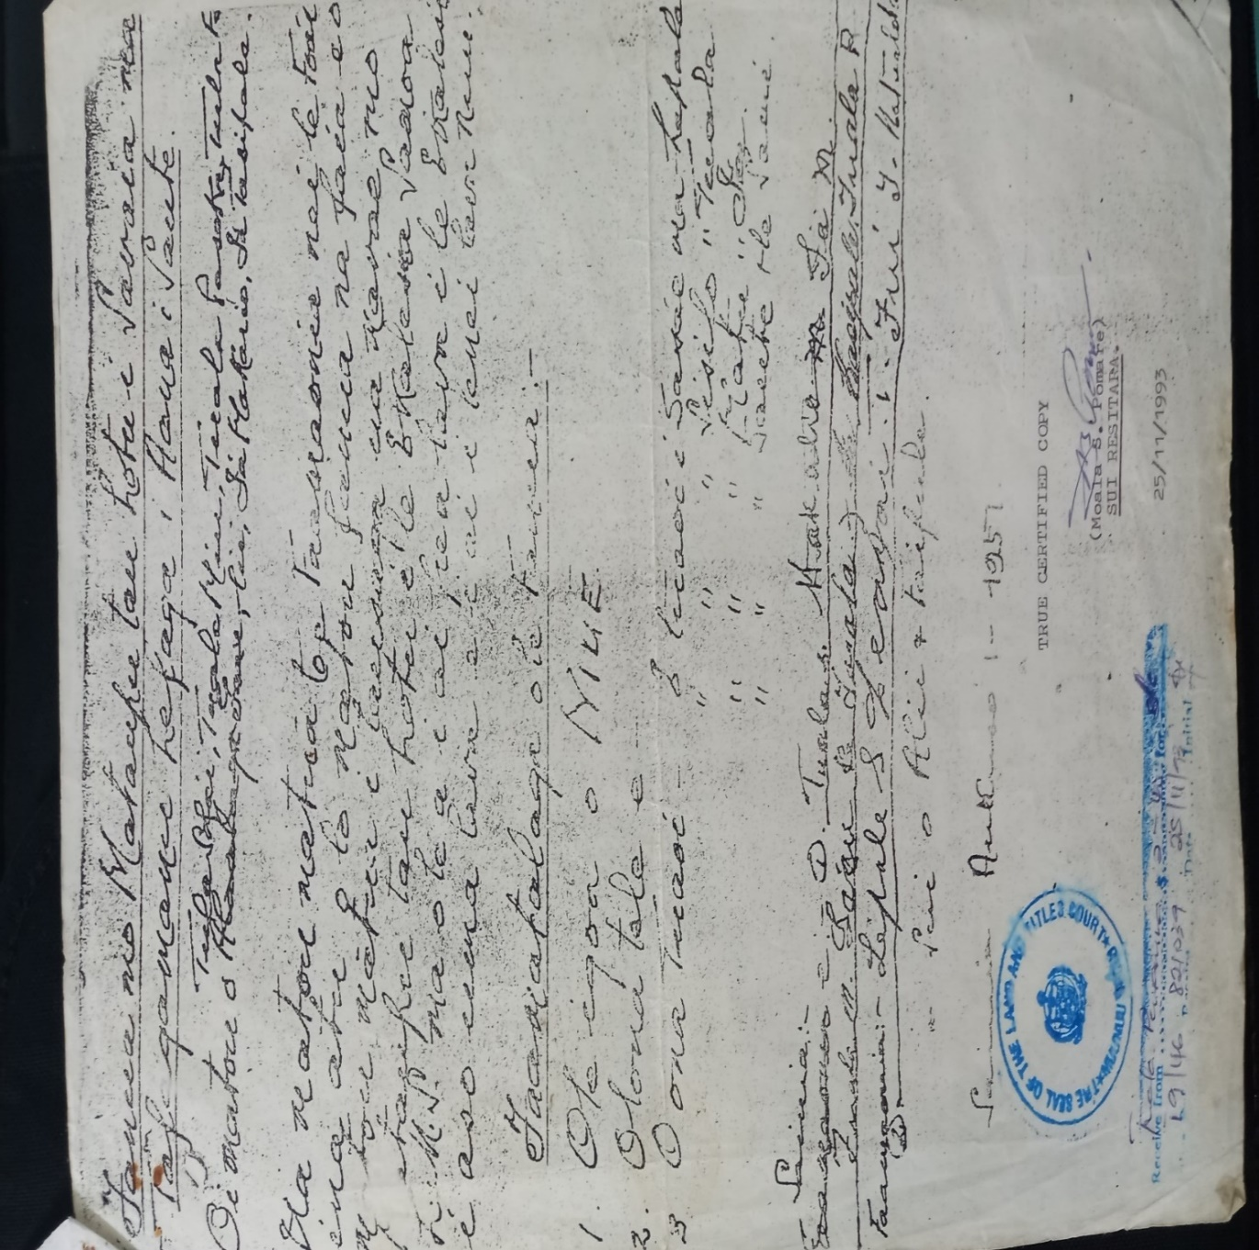
The above document is the Samoan Version of the available information of the land of Niue. This land belongs to the Tuala family of Tafagamanu. Gifted to LMS/CCCS.
Note: I will rewrite it again in Samoan for Samoan readers and in the English translation.
Fanua mo Mataupu tau le Lotu i Savaia ma Tafagamanu Lefaga i Aana i Saute. O i matou o Tuala Sofa’i, Tuala Miu, Tuala Paseka, Tuala Fiaalii, I’a Makaio, I’a Tasipale. Ua matuā matou toe faamaonia nei le foaiina o lo matou fanua na faia e o matou mātua i tausaga ua mavae mo mataupu tau lotu o le Ekalesia Samoa LMS ma o le a i ai pea lava i le Ekalesia i aso uma lava e i ai i lenei nuu.
Faamatalaga o lenei Fanua:
1. O le igoa o NIUE
2. O lona tele e –
3. O ona Tuaoi – E tuaoi i sasae ma Lepale
E tuaoi i Sisifo ma Tuala
E tuaoi i matu ma I’a
E tuaoi i Saute ma le Sami
Sainia: Tuala S, Tuala Fiaalii, I’a M, Tuala M, Laau Tuala, I’a Kasipale, Tuala P
Faamaonia: Lepale S, Leapai T, Fui T, Matualoto S. o sui o Alii ma Faipule.
Sainia: Aokuso 5 1957

7.1. The English Translation of the deed
Land for Church purposes in Savaia and Tafagamanu, Lefaga in the South of Aana

We, Tuala Sofa’i. Tuala Miu, Tuala Paseka, Tuala Fiaalii, I’a Makalio, I’a Tasipale.
We solely bear witness to the gifting of the land that was made by our fore-parents years ago for church purposes of the Samoan Church L.M.S and will remain to the church every day in this village.

7.2. Land Description:
1. Land’s Name is NIUE
2. Measurements of the Land -
3. Land Boundries:
East- Lepale (Savaia)
West- Tuala
North- I’a
South- the Sea

Signed: Tuala S, Tuala Fiaalii, I’a M, Tuala M, Laau Tuala, I’a Kasipale, Tuala P
Witness: Lepale S, Leapai T, Fui T, Matualoto S. (representatives of the chiefs and rulers from both villages.

Signed in August 5th 1957

The Niue Land Deed. A claim by the Tuala Family of Tafagamanu to reinforce the gift (land of Niue) made by their fore-fathers to the LMS. Therefore, this document cannot be treated as a reliable source since a claim’s nature may reveal more than one. However, as we came through in studying this history, the name NIUE as that specific land is called, belongs to the Tuala Family in Tafagamanu. The land was freely given to the church (LMS). This land is still a customary not a freehold land.
Every paramount chiefly title is assigned and designated a given cultural name, and this name Niue belongs to the Tuala Family, not any other family in Savaia and Tafagamanu. There were no other family claims about the land Niue, just the Tafagamanu and Savaia Church against the Tuala Peniamina Tuala claim.
A different matter up rose the subject about the land Niue which ended up in court between the church and Tuala Peniamina with his nuclear family. The matter took place which resulted with the church winning the court battle. As the land was offered by the Tuala Family for the church. Ironically, it was the same notion presented by Tuala Peniamina. In the Samoan translation of the story, E tumau pea le foai a le matou aiga e ala i le fanua o Niue mo le Lotu EFKS a Tafagamanu ma Savaia. It translates, Our Tuala family’s gift of the land Niue for the church of Tafagamanu and Savaia still remains and there is no intention for me and my family to take it back. This statement was presented to the court by Tuala Peniamina and their family.
Under the Samoan court System through the national laws in 2008 concerning cultural lands (not freehold), the government of the independent state of Samoa, evoke the return of cultural lands to their original owners if the intended and supposed party seize the usage of the land.
For now, the Tuala family as the original owner of the land of Niue together with the village of Tafagamanu left the combined church to independently start their own, while their land Niue is still being used by the village and the CCCS of Savaia as their own (for church purposes). Considering the legality of this usage through the Lands and Titles Act of 2008, it may end up in court once again between the Tuala Family of Tafagamanu and the CCCS Savaia.
Tuala Peniamina Tuala was only fighting to maintain what his father Tuala Sofa’i and the aiga Sa Tuala’s claimed in 1957. It was clear that he did not want to return their family land that was gifted by his ancestors (the Tuala Family in Tafagamanu), but wanting the church of Savaia and Tafagamanu just to realize what his family had done for God and his work, not for pride but God alone. However, Savaia’s intense and aggressive influence on the people of Tafagamanu was well mandatorily enforced throughout the years,that most people from Tafagamanu preferred to follow Savaia out of being oppressed in every way, or whatever caused it, presumably than being objective. Thus, the problem was a mutual issue, Tafagamanu is lower than Savaia like the bible says about Nazareth, ole a se mea lelei e tupu mai i Nasareta? (“Can anything good come out of Nazareth?) John 1:46.
Note: Every Samoan land has a given name according to family traditions, or many family members are named according to their lands. This is one of the most common practice in Samoa and it is an idea practiced of maintaining security of Lands within one’s land.
This Land is known by the name “NIUE” as shown in the deed. It is not a freehold but still a cultural land, which means leagally the land still belongs to the family of Tafagamanu. The two villages and the church went through a lot of court cases later on due to inner political interests, especially the issue of ownership. These cases brought up evidences that the ‘Foa’i’ or Offering of Land is believed to be made by the ‘TUALA FAMILY’ from Tafagamanu under the leadership of Tuala Sofa’i (Lay Preacher and Paramount Chief) to the LMS during the shift of the church from Vaiola (original land). The prime switch was due to known reasons and evaluated reasons as mentioned above.
However being a Savaia or being a Tafagamanu at the time was all about pride and ego, and it took advantage on their journey throughout history. It was just a matter of execution, on who was going to initiate a glory taking process. As for the execution itself, there are a number of capabilities in human nature that are required in order to pull a succession. Therefore, Savaia became the dominant of the two which caused Tafagamanu to leave.

8. Summary
The first church was in Vaiola as mentioned in chapter two. The church’s population was increased and the church could not fit in their old church house in Vaiola. Therefore the second church house or stone walled house was built upon the boundry of Savaia and Tafagamanu on the lands called Niue and Tililagi. However, when Mr. Curry died during the destruction of that church building in 1915, the people decided to build new church house somewhere else because the old place was stained with human blood. Therefore, they moved the church back to Niue. The overall analysis, is that the land of Vaiola belongs to the people of Tafagamanu. Secondly, the land of Niue belongs to the people of Tafagamanu as well.
Tafagamanu’s service to God does not seek fame and popularity, but must never go unnoticed for the sake of the future. Today’s generation in Savaia and even Tafagamanu do not know that.
God has shown and conveyed his love to/for both villages in the past. We are fully convinced that without God, the people’s spiritual journey would have been gone forever considering what happened between the two villages in the past. For me as a resident pastor, everything was well planned by the Almighty. He knew exactly what was needed at his own time.

CHAPTER 4

THE SPLIT OF THE CHURCH IN 2009

1. INTRODUCTION
It had always been unknown from the beginning where the relationship between the two villages would end up. However, it happened and ended up in separation.
The separation was of course due to many reasons. This includes being a Savaia or being a Tafagamanu which means the name Tafagamanu and Savaia as one village and one church, was in danger of being broken and dismantled. Savaia was fighting for herself and Tafagamanau doing the same.
It was due to the contribution of many aspects where pride and ego solely took advantage of a flourished journey throughout history. It was just a matter of execution, on who was going to initiate a glory-taking process and what time it would happen. As for the execution itself, there are a number of capabilities in human nature that are required in order to pull it successfully.
When the separation actually happened, the mutual feeling which this separation brought to both Savaia and Tafagamanu was hatred, which resulted in the rise of pain, heart ache with more agony and distress between the two families (Savaia and Tafagamanu). Using the word family brings more pain because it is the truth, Tafagamanu and Savaia is simply one family. especially when recapping on what had happened. The past still haunts the villages.
Many suggest that this separation should not have happened due to family-oriented reasons and looking from a wider scope with one village and one church. However, viewing the separation from a biblical perspective may give reasons to forget the misdeeds of the past while embracing the present on their way to the future. There are always benefits from this separation that will be elaborated upon throughout this chapter.

2. Reasons that contributed to the Split of the two Villages
There were a lot of reasons (good or bad) that contributed to the separation of these villages. These reasons that caused the rise of a burning feeling for being neglected and isolated where the ignition of hatred between a few of the most powerful chiefs within both villages had contributed the most. According to various interviews and personal written confessions, it was simply human nature of trying to be dominant above others was the cause of the separation. However, this research will never accuse anyone because our own failures in which had made their own mark.

2.1. 1980: The two villages separated not the church
Tafagamanu and Savaia are a family that worked together since the existence of the church. Their blood relations are so close that no one in a million years could have ever believed this could have happened to them. Considering what they have accomplished as a village and especially as the original church in the district of Lefaga and Faleaseela.
However, there is a common saying that nothing happens without a reason. There is always a reason (or an excuse) on everything that happens. For this, both villages have their own reasons that caused the separation according to interviews and other given sources. Therefore, investigating these given sources, what had been found was the blame on development and pointing fingers was commonly portrayed, with Savaia blaming Tafagamanu and Tafagamanu blaming Savaia.

3. Tafagamanu and Savaia o Nu’u Mavae or traditional villages
There are two kinds of village in Samoa. First, the kind of village that calls Nu’u Mavae (traditional founding village) and Nu’u Fou (new village)
Nu’u Mavae are the oldest villages in the country which consist of formal and nationally accepted salutation. These salutations connect the bloodlines of Samoa. Therefore, every village with salutations is an original or founding village. While nuu fou or new village does not have any salutations. In order for a village to be recognized and accepted in Samoa, one has to have salutations. It is one reason why Tafagamanu and Savaia became separated. For Savaia and Tafagamanu are both nuu mavae.

3.1. The Salutations (Faalupega) of Tafagamanu and Savaia
1. Tafagamanu
Afio mai lau afioga Tuala Tamalelagi (high chief)
Afio mai Tusani (high chiuef)
Afio mai Leaupepe (high chief)
Susu mai le Matua ia Pale (high chief)
Susu mai Afumatino (high Chief)
Susu mai Laititimalu (high chief)
Alala ta’i Sa Iãuta (talking chiefs)
2. Savaia
Afio mai Fui (High Chief)
Afio mai Malama (High Chief)
Afio mai Tusanilefai’a’ao (High Chief)
Fetalaiga Leatialiifaiga (talking chiefs)

As we can see here, the two villages have two separate and very different salutations. They both have separate dignities. Therefore, the two villages have to be separated in order for their salutations to be stood out and recognized in the eyes of Samoa as a whole. Secondly, if they stay together as one village, problems will always engulf them. There will always be the comparison of the two salutations and their dignities on which is better and may lead to the weakness of being the dominant above the other. But note that Savaia and Tafagamanu are all blood related from the beginning. It is such a disgrace when families are constantly at war with each other on a subject that will defeat the sacrifices they had made to the work of God in the village of Tafagamanu and Savaia. Therefore, in order to save God’s work and their ancestor’s dedications from embarrassment, they must go their separate ways. They needed to be free from each other to avoid confrontations that will not reflect any Jesus-like lives in Savaia and Tafagamau.
Though it was painful, but the two villages were separated anyway. To put in note, from 1980, the two villages were separated but the church was still one, not until the year 2009 when Tafagamanu officially established their church, The Congregational Christian Church Samoa in Tafagamanu. By doing this, Savaia was officially an independent church as well, The Congregational Christian Church Samoa in Savaia.

4. 2008 to 2009: The Separation and the birth of two New Churches

4.1. The Tuala Peniamina Tuala Dairy
(Written by Tuala Peniamina Tuala from his point of view)
Tuala Peniamina Tauala is the son of Tuala Sofa’i Ioramo and Meavalē from Tafagamanu. He became a lay preacher of the CCCS in the year 1980. He is the paramount chief of Tafagamanu. Mr. Tuala was the person who led Tafagamanu during the time of the separation from 2008 to August in 2011 when we came as resident pastor of the Congregational Christian Church in Tafagamanu, he led as a Lay Preacher and as the paramount chief.
This is a summary of Tuala’s written confession on what happened.It was a subject about someone from one of the villages stealing money from the pastor’s house. There was a cultural tradition that had been practiced by the two villages for years when it came to matters of the church. Whenever a person from one village does wrong to the church, the other village is responsible on endorsing the punishment. However, in this case, that did not happen. The village where the person that stole the money made the call to endorse the punishment without letting the other village know. As a result, tension began which resulted in the split

5. The Cause of Separation
Here is the actual diary written by Tuala Peniamina Tuala,Money was stolen from the Pastor’s house. I (Tuala Peni) only heard about what happened while the Alii Matua of Savaia had already travelled to New Zealand with his wife. Therefore, I went and met Alii Matua’s sister Malia and asked her if there was any information on when the Alii Matua would be back from New Zealand; not just he was the Alii Matua of the village, but the chairman of the CCCS Savaia and Tafagamanu as well. I asked her if whenever she could or would come in contact with her brother, could she pass him a message about the current matter concerning the pastor’s money that had been stolen so that Tafagamanu could preparing the normal protocols between the two villages.
Without any knowledge, Savaia had already held a meeting on the 18th of October 2008, and punished the family of the young woman involved (Samoan common Traditions). In my opinion, due to the founding conditions upon the two villages were sealed to obey and walked by, Savaia with no hesitation intentionally broke it. Not rushing to conclusions, I therefore summoned some of the chiefs of Tafagamanu, (Pale Ilo, Laititimalu Lui, I’a Ioramo, I’a Tanielu and Matualoto Faitala, Matualoto A’a), to fix what the problem for the village’s sake. We met and came up with a solution to go back to Savaia and discuss why they had violated the founding protocols on protecting the church. I’a Ioramo and Matualoto A’a were Tafagamanu’s representatives.

5.1. Beginning of the Separation
They came back with an unacceptable response from Savaia. Very harsh and disrespectful words were said to I’a Ioramo and Matualoto A’a. (Tuala did not write the exact words that were said). This ignited pure hatred like a flaming fire burning our hearts to ashes, and it began. It seemed like Savaia was proposing its authority over us like they own us. Like they could do whatever they wanted because Tafagamanu is below them, and we must only listen and do nothing.
We then put a stop to all Tafagamanu people from attending the church on the following Sunday until this matter is settled.

5.1.1. Sunday 19th October 2008
On the first Sunday no person from Tafagamanu attended the church service conducted by Onosai Leapai Soo (Savaian and Malua Theological Student). On Saturaday 25th October 2008, the whole village of Tafagamanu held a meeting in which we came up with the solution of the matter:
i. We have to wait for another couple of Sundays. Let us wait for our pastor to come as our shepherd to gather his flock. However, if our pastor does not come within these two weeks, then we will start our own church. (since the matter was a church related subject)
ii. The following two Sundays, we will ring the bell at 9am and 4pm, then each family conduct
is required to conduct their own service
iii. No one is allowed to attend any other church. (sa le liu lotu) (This is the Golden Rule)
A chance was given to others that were not members of the Tafagamanu and Savaia CCCS Church. They can attend their old churches.
Weeks passed and still our pastor did not come for us. We wished we were treated the same as he was treating Savaia. It’s more like he’s holding and caring Savaia on his chest but pushing Tafagamanu away to the side. Maybe because we are poor. Maybe because we are sinners in accordance to every wrong deed that we had done in the church while Savaia witnessed. This was a full heart breaking scenario, for he was only taking Savaia’a side but neglected Tafagamanu.

5.1.2. The Plan for a New Church in Tafagamanu
Despite the hurtful and broken hearts (lototiga) on what had happened between Savaia and Tafagamanu, the chiefs of the CCCS Tafagamanu and others, were very eager to form up the new church. But I adviced them to go through the process in the constitution of the mother church. Therefore, we approached Rev. Elder Situfu Tanielu, the Faatonu of the Matagaluega of Aana. The matter of establishing a new independent church of Tafagamanu was the core subject of the meeting. However, when we got to Nofoalii where the Faatonu was the resident pastor at the time, he was not there since he was attending and opening ceremony of a new church building in Australia (one of the many CCCS churches) since he was the vice chairman of the CCCS General Assembly (Fonotele) at the time. He was representing the church as a whole. We came back to Tafagamanu. We then decided to commence the establishment of the new church the following Sunday, but an inconvenient occasion caused us to postpone. I was appointed by the Government of Samoa (through the Fisheries Division Program) to participate in one of the London based Commonwealth’s environmental program in the Pacific held in Papua Niu Kini and Vanuatu (Study Tour Visit).
When I returned, on Monday the 1st of December 2008, I met Pale Ilo and asked him if it was time to pay another visit to Rev. Elder Sitifu Tanielu concerning the commencement of the new Church. Pale Ilo replied to leave it as it was and wait until the following village meeting (last of the year).

5.1.3. Some wanted to return to Savaia
On Tuesday 9th December 2008, the village chiefs gathered and held the last meeting for that year. After several subjects, the issue about the establishment of the church was therefore was brought up. As our meeting proceeds, I realized that some chiefs changed their minds of wanting to return to Savaia, but most still stood firm on their first decisions, not to go back.
This division caused panic to the meeting, I (Tuala Peniamina Tuala) as a Lay Preacher of the church, took the opportunity to give an encouraging speech.
I am a Lay Preacher (Aoao Fesoasoani) of the church, and this is taking so long for our people and they are tired of waiting. Since the time we separated ourselves from Savaia, we made the rule that no one goes to any other church until our church is established. Our people are dying to go to church, therefore we must make a decision. Of course I understood very well how hard to establish a new church would be. However, nothing is impossible to God. We can do this if we stand and work together. I (Tuala) and my family can go back, but I know exactly how our people feel which made them never wanting to go back of being shamed by others, being picked upon and being pointed at. Even our bloodlines had been shamed and belittled. After so many years of being looked down at, we can never go back. Therefore, today Tuesday 9th of December 2008, we will visit the Faatonu Rev. Elder Situfu Tanielu. We will reveal him the subject concerning the establishment of our own CCCS Church in Tafagamanu.
I (Tuala Peniamina), with Ia Ioramo, Pale Ilo, and Laititimalu (Lui) went to Nofoalii and met Rev. Elder Situfu Tanielu. We told him why we came, with no hesitation, Tanielu approved our proposal with one condition, was to wait a little longer in order for the four Elders of Aana to meet and discuss the subject, then the establishment of the new church may commence.

6. Saturday 20th December 2008

6.1. Meeting with the CCCS Board
This meeting was held at the John Williams Building, Tamaligi, in Apia. Those who were present from Tafagamanu were I (Tuala), Pale Ilo, Ia Ioramo, and Matualoto Petivia. Together with Rev Elder Situfu Tanielu (Vice Chairman of the CCCS General Assembly), Rev. Elder Mose Mauinatu (Secretary of the Elders Committee), with all the Elders from the A’ana District where we are from.
We explained everything to all the elders that were present, especially the reason why we were separated from Savaia and wanting to establish our own church without them. They then gave us their advice to converse with our Elder in Lefaga and Faleaseela. We accepted their advice and took action accordingly.

7. The Unofficial Opening of the Church
On Sunday, 21st December 2008, we met our Rev. Elder and decided that the Tafagamanu church will be established and opened on the 28th December 2008. However, later that week, were advised that the Elder and the Pulega (religious sub district) were not coming. It seemed like the elder agreed for the sake of our conversation but did not want to. Whatever the reason was, I did it myself and we did not postponed the opening ceremony of the church. I called the resident Methodist Pastor in Tafagamanu to join me on conducting the service. I will lead the service while he prepares the sermon.

7.1. People who attended the ceremony based on Family Names (Matafale).
1. Tuala Peniamina and wife Sofa’i.
2. Pale Ilo and wife Salome
3. Ia Tavita and wife Taalo
4. Ia Ioramo and wife Leiloa
5. Ia Tanielu and wife Siū
6. Laititimalu Lui (wife: deceased)
7. To’alepai Fetui (wife: deceased)
8. Matualoto Faitala Tuala and wife Gali Mareta
9. Matualoto Petivia and wife Faalagilagi
10. Maligi Pale Hofeni (husband Pale Hofeni: Deceased)
11. Suifu’a Ia Simaika (Assisting Family)
12. Tino Tusani (L. Risati)
13. Time Siaosi
14. Tioleaoauli Tauasosi

7.2. Villagers and Chiefs who participated (Non CCCS members)
1. Etevise L. Dick Stowers
2. Afumatino Nofogata Tuala and wife Va
3. Pale Asa
4. Leaupepe Latu and wife Fiasili (from New Zealand visiting families)
5. Tuala Tausaga and wife Evo (from Matautu, Lefaga)
6. Maleoalii Tala and wife Aupiu (from New Zealand visiting their mother Maligi and families)
7. Matualoto A’a

The Tafagamanu Methodist Church participated as well, and sang some church hymns. There were a lot of people from overseas and Samoa who attended our opening ceremony.
Other families of the church did not attend due to slight differences not to be mentioned but they came back when the church was official opened.
Note: To officially open a church according to the CCCS Constitution, the Elder and the Pulega must be present and conduct the ceremony.

8. The Official Opening
The official opening of the CCCS Tafagamanu was held on the 25th of January 2009. The Rev. Elder Poka Maua and the Pulega came and officially opened the church and they officially appointed me to lead the church until Tafagamanu selected a resident pastor for themselves. During this official opening, families who did not turn up in the beginning showed up. Tuala Ta’i and Laititimalu Valovalo were present as well.

8.1. Pastors from the Pulega who were present
1. Rev. Elder Poka Maua (from Savaia)
2. Rev. Nomeneta Simanu (from Safa’ato’a-Uta)
3. Rev. Esaroma Fatilua (from Matautu and Gagaifo-Tai)
4. Rev. Lauama Fonotaga (from Matautu-Uta)
5. Rev. Tavita Lefale (from Gagaifo-Uta/ Gagaifolevao)
6. Rev. Keneti Leaupepe (from Savaia and Tafagamanu-Uta)
7. Rev. Motuga Matagi (from Tanumalala)
8. Rev. I’aeva Amitai (from Safa’ato’a-Tai)
9. Rev. Tuitoga Leota from Faleaseela was taking a three-month break at the time.
Rev. Kaisara Asiasiga was here as well, with some people of the district of Lefaga and Faleaseela.

8.2. People from the district who participated
1. Le Mamea Ropati Maulia (Member of Parliament from Lefaga and Faleaseela District; he was
a lay preacher of the CCCS Church in Matautu and Gagaifo-Tai)

2. Lalaga Faamelea (from Faleaseela)
3. Masina Tusipa and wife Apaula (Safa’ato’a)
4. Lemalu Iese (Safa’ato’a)
Some people of Tafagamanu who helped out (Non CCCS Members)
1. Ata Tauasosi
2. Etevise Titi
3. Faalogoifo M. Sio
4. Loseni To’alepai
5. Laititimalu Valovalo Tusani
(There were a lot of people that I could not recall)

9. Founding Families of the Church
1. Tuala Peniamina and wife Sofa’i.
2. Pale Ilo and wife Salome
3. Ia Tavita and wife Taalo
4. Ia Ioramo and wife Leiloa
5. Ia Tanielu and wife Siū
6. Laititimalu Lui (wife: deceased)
7. To’alepai Fetui (wife: deceased)
8. Matualoto Faitala Tuala and wife Gali Mareta
9. Matualoto Petivia and wife Faalagilagi
10. Maligi Pale Hofeni (husband Pale Hofeni: Deceased)
11. Suifu’a Ia Simaika (Assisting Family)
12. Tino Tusani (L. Risati)
13. Time Siaosi
14. Tioleaoauli Tauasosi
The Tuala Peniamina Tuala Diary ends here.

10. Summary of Tuala’s Diary
This Tuala Diary speaks for the Tafagamanu village as a whole. It speaks out a belittled voice that had been in severe enslavement for so many years (as history is concerned), from within a sphere that is supposed to provide and give freedom, warmth, and love. A sphere that is naturally designed to propose equality and fairness but not dominion through aggressiveness. A place we called family because Savaia and Tafagamanu are fairly blood-related and this makes them family. Therefore, this looks like a family feud in the bigger scale. For this analysis, there is a Samoan saying, E misa lava tama a o le uso, it means that, though they fight, but in the end they are still brothers.
Thus, the feeling of being neglected and belittled still echoes within this diary and the society as well. As a proof of this, we resided in 2011 in Tafagamanu as their resident pastor, the people’s frustrations took the best of them without any control, while trying to adapt to their new environment of being independent. This made our work very hard. Pointing fingers and blaming others was the central nature that was portrayed without hesitations. The saddest part was, me and my wife (the new pastor) always took the blame from this frustrating lot. I do not blame anyone for our cruel and rude treatment in the beginning since their wound has not been healed from being dominated for so long. This healing process is still in progress.
However, no wonder why God decided to separate the two villages. A lot has been drowned and lost within this relationship throughout their history together, which indeed needed to be unveiled so that the healing process may commence. The ministry can not continue this blind journey.
The point here is that, there will always be feuds and conflicts between the two villages if they had not been separated, but the most important thing is, now there is a chance to reveal and revive their history especially what their forefathers did for God and the gospel of Jesus Christ, for it can not be done if they were together.

11. Savaia’s Side of the Story
I have interviewed most people in Savaia about what happened that caused the separation of the church. Their responses were similar to what Tuala’s diary had explained. However, one chief from Savaia mentioned something about waiting a long time for Tafagamanu to initiate the process. However, Tafagamanu took forever to proceed while the pastor at the time might thought the village had under minded him and his family over the incident. Therefore Savaia performed what needed to be done. They gave the official apology (using Samoan traditions) to the pastor and his family on behalf of the two villages, and this caused the conflict which led to the separation.

12. Evaluation of the two Stories (Faifeau’s perspective)
It does not matter who’s right or wrong because it’s not going to change what had happened between them. There will always be that blaming nature like when God asked Adam, if he had eaten the forbidden fruit but he blamed his wife Eve and Eve blamed the serpent. That nature is in all of us and it’s not easy to remove. This looks like it is the only nature encircling their environments and their everyday contexts. This signifies an embryonic lifestyle and mind set that became the normality of many people in the two villages, where the big men play the maneuvering ideas while others just blindly followed without any voice due to cultural barriers.

13. The Land called OLI
After the church was officially established on the 5th of January 2009, the feeling of being free from their adversities lingered like the wind on where it would blow and lead the new church to in a manner of speaking.
However, being steadfast on their strong will with that spiritual focus revealed their belief in God on what He had planned for them. This was the main motivation for the people of Tafagamanu. Therefore, the first step was to find a piece of land to establish the chuch upon. The Tuala family under Tuala Peniamina’s leadership, offered their piece of land called Oli.
Oli is now the center and base of the CCCS Tafagamanu and it is where we are residing now.

13.1. The Official Map OLI
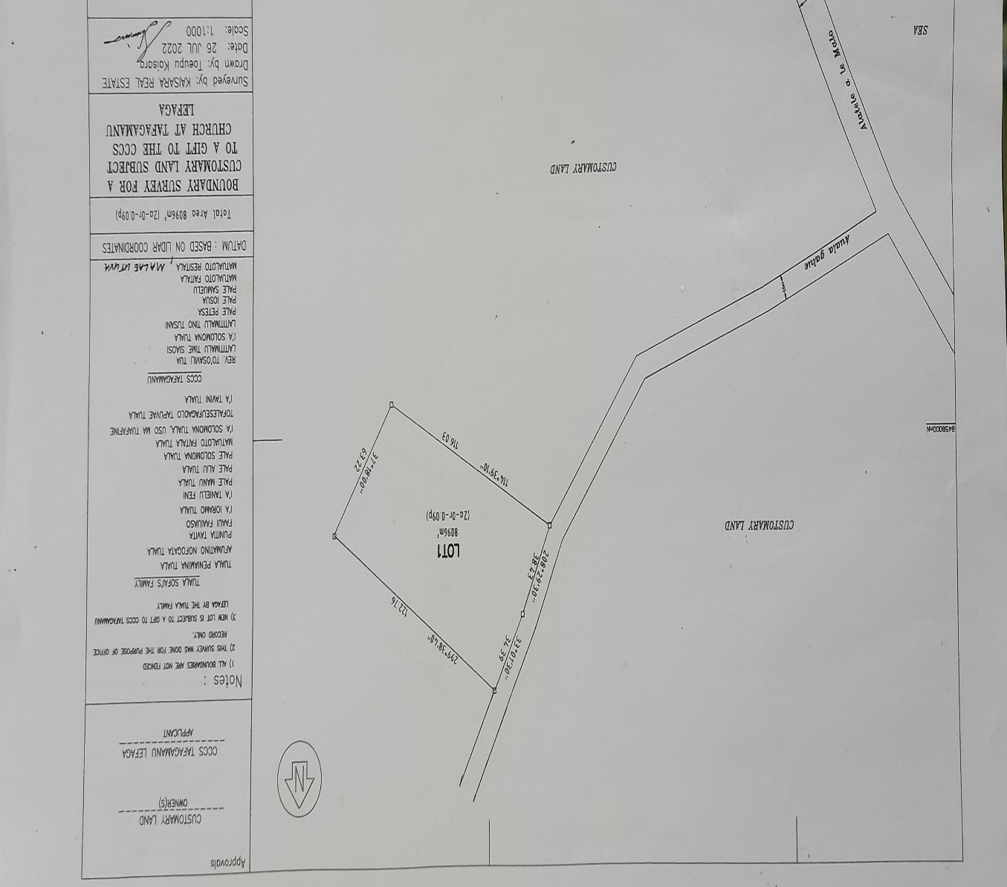

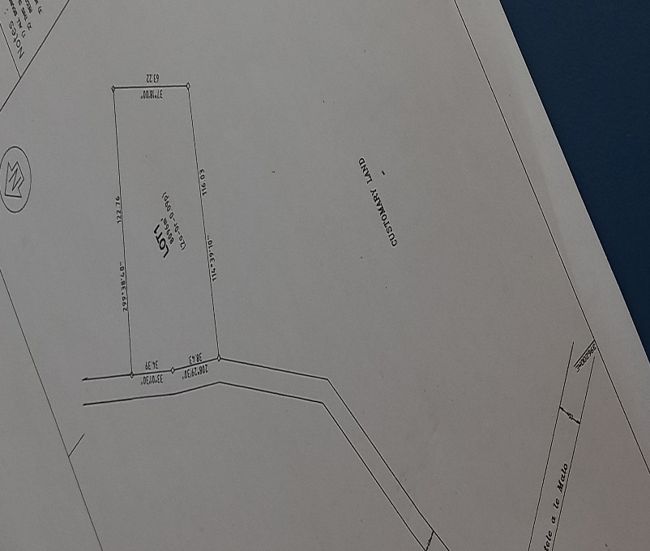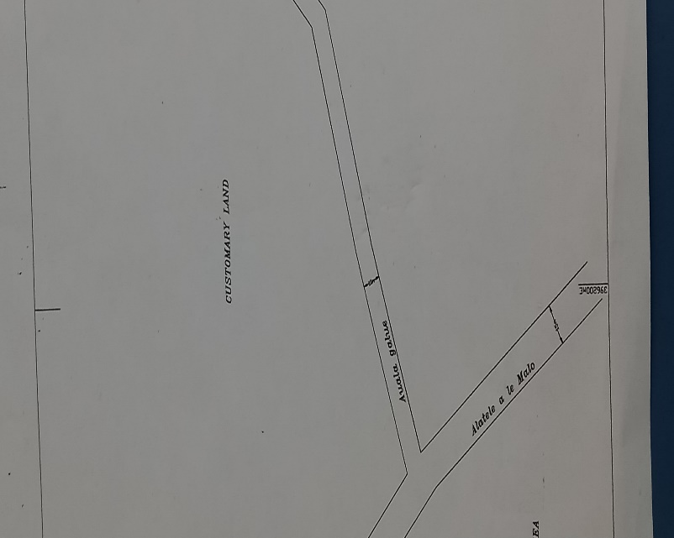
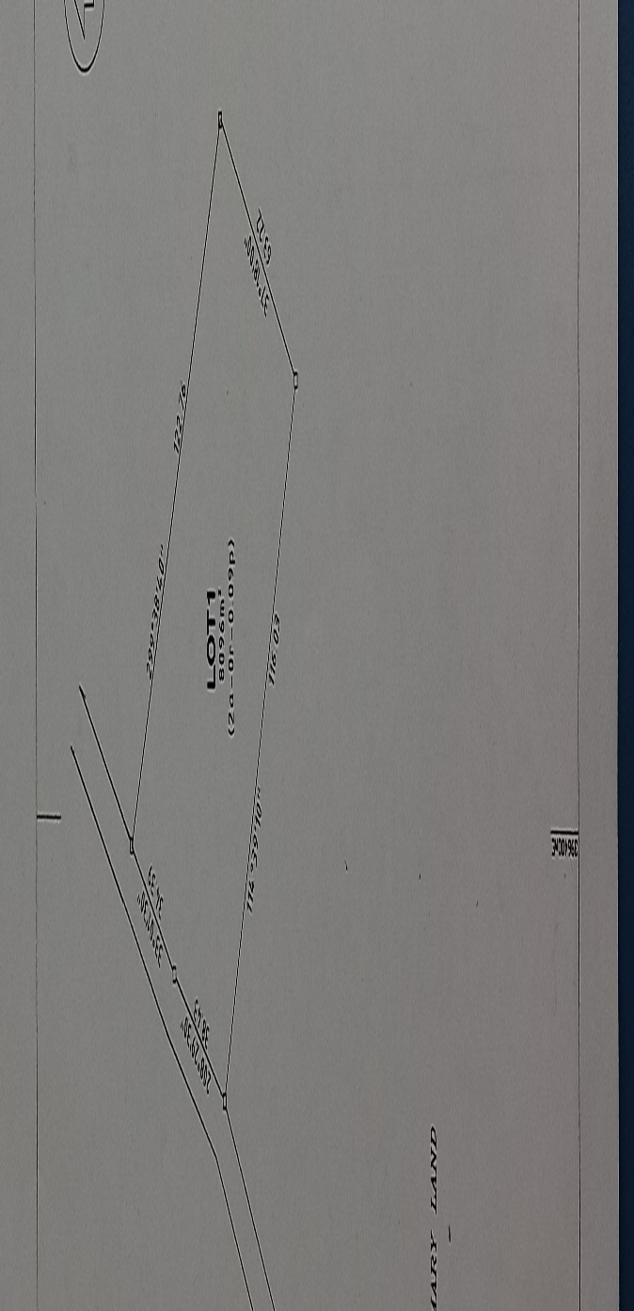

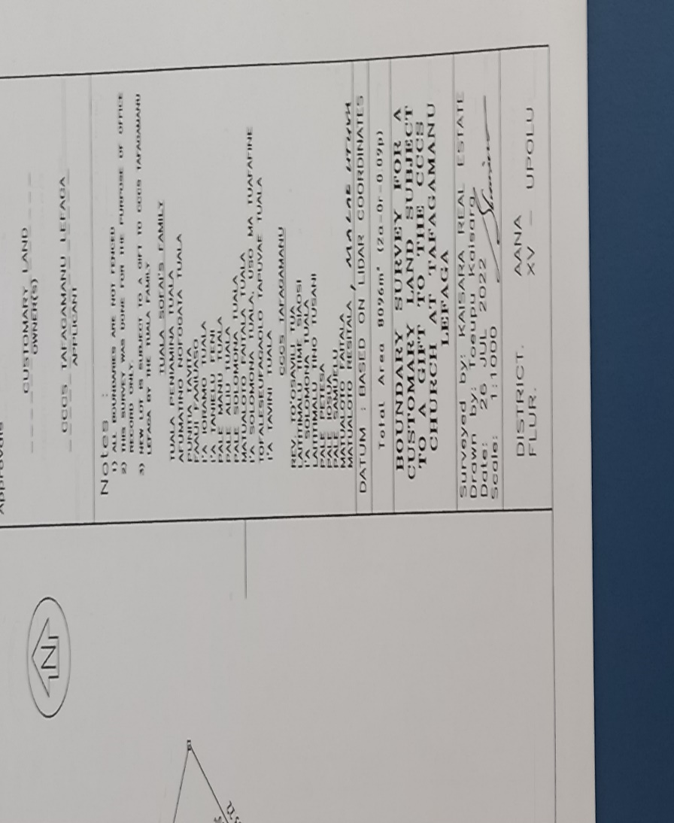

13.2. Rewriting what is written on the Map
Approvals
Owner(s) - Customanry Lands
Applicant – CCCS Tafagamanu Lefaga
Notes:
1. All boundries are not fenced
2. This Survey was done for the Purpose of Office Only
3. New lot is Subject to a gift to CCCS Tafagamanu Lefaga by the Tuala Family.

TUALA SOFA’I’S FAMILY
Tuala Peniamina Tuala
Afumatino Nofogata Tuala
Punitia Tavita Faaiuaso
Faaui Faaiuaso
I’a Ioramo
I’a Tanielu
Pale Manu Tuala Faaiuaso
Pale Aliu Tuala
Pale Solomona Tauala
Matualoto Faitala Tuala
I’a Solomona Tuala, uso ma tuafafine
Tofaleseuifogaolo Tapuvae Tuala
I’a Tavini Tuala

CCCS TAFAGAMANU
Rev. Toosavili Tua
Laititimalu Time Siaosi
I’a Solomona Tuala
Laititimalu Tino Tusani
Pale Petesa
Pale Samuelu
Matualoto Faitala Tuala
Matualoto Resitala
Malae Utuva

14. Meaning of the name OLI
(Explained by Tuala Peniamina Tuala)

The land where our church is located is named after a Tree called Oli. Oli produces green colored flowers which is very rare in Samoa. Its green flowers release one of the sweetest fragrant that almost every bird in the area is fully attracted to. It is a garden tree with strong branches and firm roots that can withstand any natural disaster.
This is theologically significant for the green color is universally accepted as the color of life. This I may say that the CCCS Tafagamanu provides a sporadically sweetness of Godly life to whoever seeks it. It is of similar attributes to God’s paradise on earth. This is a long term plan for God’s work in our village.

15. Our Testimony
(Rev. Toosavili Atimalala & wife Epenesa Tangatauli Tua)

15.1. 08th February 2011
When I came home after CCCS Faatoia’s youth program on that Sunday night, my wife Epenesa told me that Tafagamanu, a village from Lefaga had finalized their decision on who their resident pastor was going to be, in which, me (To’o) and my wife Epenesa Tangatauli, were selected through the CCCS voting process.
She was informed by one of the CCCS Faatoia deacon named Pale Salima Manu Faaiuaso and wife ‘Atatai came to our family at Ma’agao (part of Faatoia) that night and updated our family about Tafagamanu’s final vote and decision.
I did not accept it for a number of personal reasons especially because Tafagamanu was separated from the Faifeau Toeaina (Rev. Elder and their former resident pastor at the time), with an elaboration which showed the fear in me since I was a very young faifeau (pastor) considering all the cultural barriers between the young and the old in Samoa contextually. There were sorts of questions that came storming to mind, What would a young pastor like me could do to and for this village and church, while instead, they rebelled and moved away from the leadership of the Reverend Elder Poka Maua despite their own reasons?
All these thoughts forced me to say no to my wife. I was hundred percent sure in my heart. Things heated up between me and my wife since her positive reactions were due to what every Samoan family always wished for; to have a son or daughter in the ministry and to spread the gospel of Jesus Christ. It is one of the highest honors received by any Samoan family is when one of their people is offered to/for the work of God.
We argued that night until we decided to visit our resident pastor at Faato’ia Rev. Dr. Paulo Koria and late wife Mafutaga, for an advice on what to do, since the Tafagamanu church would meet with us the next morning. We discussed the matter and ended up with another split decision. Rev. Dr. Koria agreed with my decision due to personal reasons while his late wife Mafutaga and my wife Epenesa agreed to take the opportunity. Therefore we went to seek my mother’s advice and that was when some sense and heart came to me. Considering the nature of being a faifeau tausi nu’u or resident pastor is not easy, for all the wrong is the faifeau’s fault or his wife despite the goodness offered. Secondly, being a stranger in a different village, all the pastor and his wife’s salutations are cancelled for they do not count in this different village. As a Samoan is all about cultural pride for family glory in terms of traditional rankings. This cultural practice portrays much barriers between families and even villages. Everyone is a king or queen in their own house as that common saying is concerned.
However, when CCCS Tafagamanu arrived at our place in Faatoialemanū in Apia, a sudden change of heart sooths and calms my troubled and uncertain mind. Our meeting came in an agreement when we accepted the Churches request. CCCS Tafagamanu retuned with the good news that we have agreed to their request, but to return in the future to inform us of when was the date the covenant will be held. After three months, the date and time was set and we proceeded with the settled program. Finally, on the 6th of August 2011, our journey with the CCCS Tafagamanu commenced.
It was like every other work. We slowly tried to get to know each other. However, our first three months in Tafagamanu was unforgettable. I could not belive what I had realized that there was a great lapse in the spiritual lives of the people. It felt like there was an evil force residing within the hearts of most of the people. The sad part was the effects upon the people and including their lands. No one wants to read about such things concerning families and villages, but my analytical approach as an alien to this place, made me wonder on the existence of the church in the village for more than hundred years. I am not questioning and judging the work that had been done by many pastors that came before but I was reflecting on this evilness.
Looking at it from a faifeau tausinuu’s perspective, the split was a holy lan of God for Tafagamanu. The people of Tafagamanu can be called The Chosen People and were seriously in need of help in ever aspect of their spiritual reign. Their spiritual lives needed to be instantly revived because most (not all) lack the knowledge of knowing God, and living according to God’s principles and holy standards. No wonder why the almighty stood firm on the split to be commenced.
Looking back after eleven years of service in the CCCS Tafagamanu, I may humbly say that God knew what needed to be done and the people for his mission while His timing was His alone. When God’s plan is in progress, no man, family or village can stop it. Remembering a part of Jesus’ prayer in Gethsemane, “Let your will be done”
Our Church in Tafagamanu, is a true reflection of the sensation and prodigy of God. We solely needed spiritual guidance to sort out God’s plan for us all, and God provided unconditionally for us. It’s now twelve years of our relationship, our church is growing and keeps on growing in God’s favour. Of course there are problems but these problems are taken as lessons and learning processes for us. The ultimate goal is to praise the almighty God for using all of us to serve Him.

15.2. Saturday 6th of August, 2011
Day of Covenant
I had never felt deeply humbled before when the ceremony started. Rev. Elder Poka Maua led the service with all the CCCS pastors in Lefaga and Faleaseela taking part. The ceremony was full of pastors and their wives but one in particular was the resident pastor of the Methodist Church Samoa in Tafagamanu Rev. Livigisitone Peseta and wife Luana. Rev. Peseta and wife Luana helped us unconditionally, and they guided us through the first six years of our new ministry in the village.
There was no falesa/church building for worship, therefore the ceremony was held in the church hall. We used that multipurpose hall to conduct our services for four years before we opened our new church building in 2014.
In 2012, our church articulated a notion to build a falesa/temple for worship. I was in so much doubt considering the content of our everyday lives financially speaking, and thinking that the church had just been officially established in 2009, the land Oli had just been offered and given to the church which they spent a lot of time and money for land scaping. In addition, in 2010 after landscaping the land, they built two new houses at the same time. They opened the new house for their proposed pastor and family, and the new multipurpose hall for worship and this may have costed them a fortune. Not mentioning, they had just finished with the covenant cerermony which was not a cheap occasion. At the time, we were still advancing with our loans repayments.
However they were willing to pursue the idea they had conveyed; to build a church building. This gave me an idea on their level of faith that needed to be unbridled. With a theological understanding that, the time of God is the best and the right time.

16. The Trip to Sydney Australia in 2013
A major fundraising trip to Australia was planned and took place in 2013. We prepared more than two hundred ie toga or fine mats. We went to Australia in October 2013.
Church Members on the Trip:
1. Rev. Toosavili A Tua
2. Tuala Peniamina Tuala
3. I’a Maka Ioramo Tuala
4. Matualoto Faitala Tuala
Only four of us travelled to Sydney Australia for the tusigaigoa. Before the trip, we met Rev. Elder Peleti Toese To’ailoa to seek assistance since he was the leader of the church in Sydney. He organized a group of people from Tafagamanu residing in Sydney Australia to help prepare the tusigaigoa for the trip from Samoa. This group is commonly known as Alo ma Tama-fanau o Tafagamanu (Sons of Tafagamanu).

16.1. Alo ma Tamafanau o Tafagamau i Sini
(People of Tafagamanu from Sydney who were involved in this group)
1. Laititimalu Fuimaona Robert & wife Eti with Family (Chairman)
2. Tupuola Viliamu & wife with Family (Secretary)
3. Galumalemana & wife Faafiti with Family (Tresurer)
4. Tuala Meafou & Family
5. Afumatino Simativa Tuala & Family
6. Rev. Farani Tofilau & wife Paono with Family
7. Su’a & Liuina with Family
8. Leatigaga & wife Viola with Family
9. Pale Tuifaasisina Penani Tuala & wife Elisapeta and Family
These people sacrificed a lot for the tusigaigoa. Before we arrived, they held mutiple fundraising in Australia for financial assistance; to help them cater the occasion. They were responsible for the food during the day of the tusigaigoa, promoting the occasion on radio stations, transportation for us, venue where the occasion was held (fee) and so much more.
Pale Tuifaasisina Penani and wife Elisapeta brought us in their lovely home and that’s where we stayed for three weeks before I returned to Samoa. The group also catered us with food and lots of gifts during our stay.
The tusigaigoa was held at the CCCS Fairfield multipupose hall. It took one whole day, and I did not attend since I was not allowed. At the end of the day, we made more than sixty thousand Australian dollars . We sent the money to our CCCS Tafagamanu bank account in Samoa the following week and the exchange rate for one Australian dollar was similar to $SAT2. 91 (Samoan Talā), which gave us $SAT131, 000.00 . Our Tusigaigoa was an overall success.
I would like to take this opportunity to thank our people in Australia once again. Not just the group in Sydney who organized the whole occasion but the people of Tafagamanu, our friends and families from all over Australia who travelled to Sydney to support the tusigaigoa. To all the CCCS and Methodist Samoan churches in Sydney who lend a helping hand and donated thousands of dollars for our project, thank you so much and God bless.
We had no connection to most of those who donated, but through the Spirit of God and the secret holy work of the Spirit was shown through their generosity. I witnessed the unconditional love of God through the love shown by many strangers who came together with our people and lifted this immense load off of our shoulders. Amazing is our Lord who will never abandon His people.
We returned in November 2013 and started the plan for 2014. The month of March 2014 was the ground breaking of the project for a new falesa. Rev. Livigisitone Peseta, Tuala Peniamina Tuala (representing the Tuala Family), Laititimalu Lui Mafua (representing the Tusani Family), and Rev. Clarke Stowers Tusani (Student at Malua Theological College at the time) did the honor of breaking the soil.

17. Let the Construction Begin: March in 2014
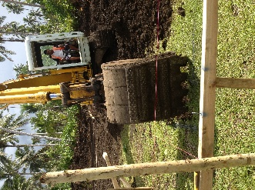 | 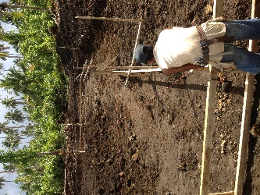 |  | 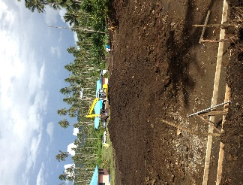 |  | 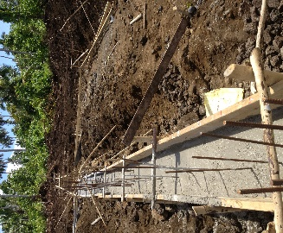
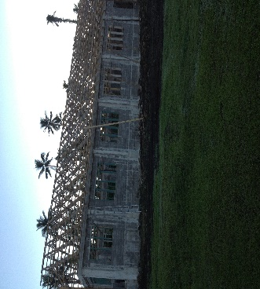 | 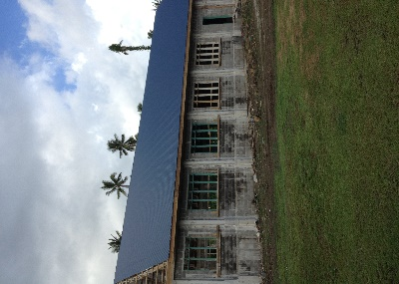 |  | 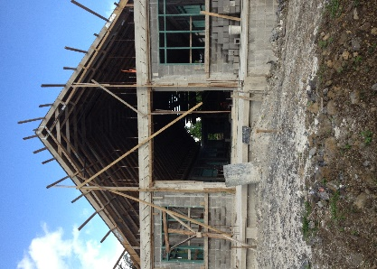 |  | 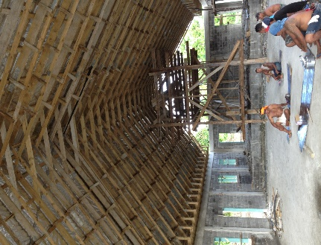
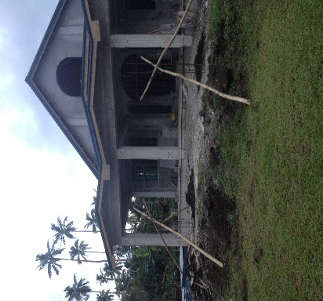 |  | 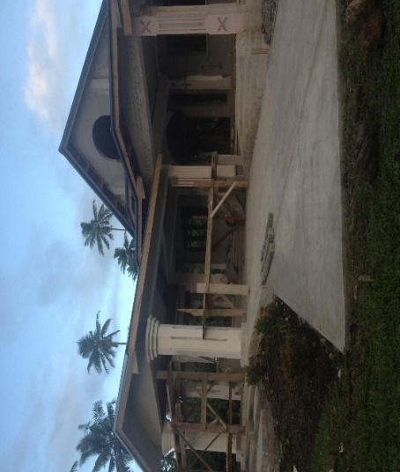 |  | 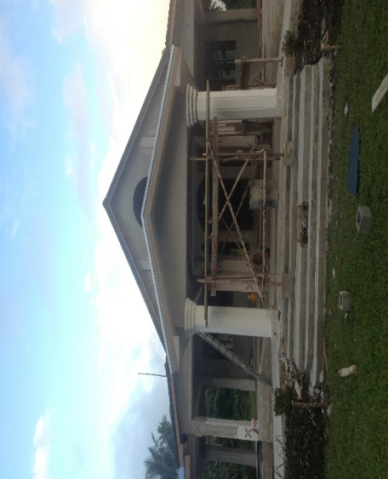

18. MALUMALU O MATAGOFIE
THE TEMPLE OF
“BEAUTIFUL”

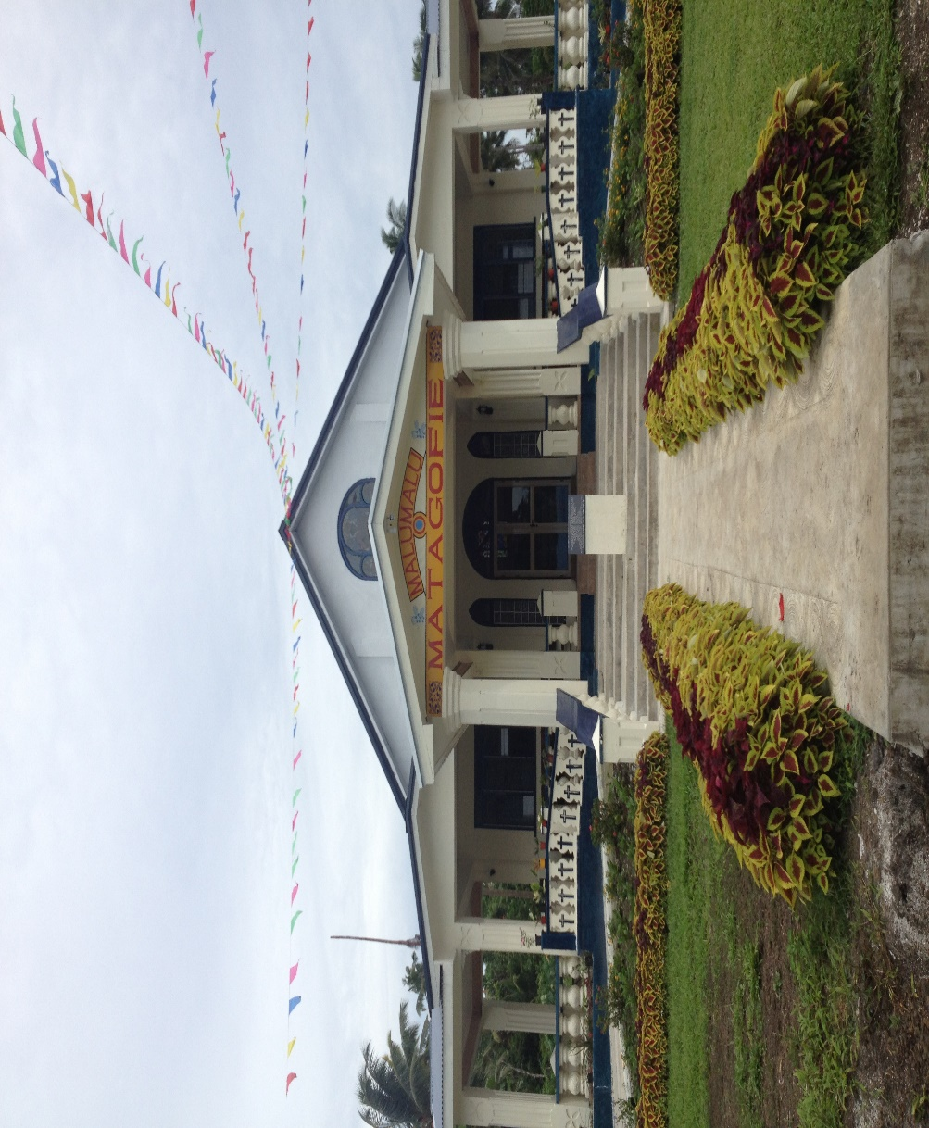

18.1. The Openning Ceremony:

19th December 2014

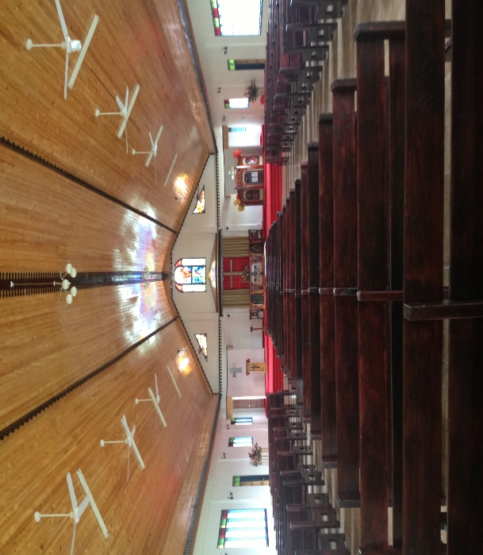

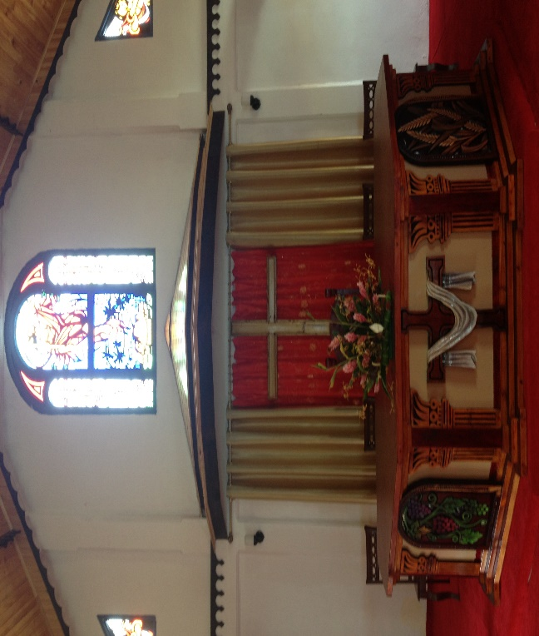

19. Summary
Despite the failed relationship nevertheless, as a faifeau, everthing happens for a reason. No matter how it started but using a positive approach to reverse all the negativity of any incident, for sure benefits and positive outcomes will be born and emerge to overtake any affiliated consequences that may follow. There is always an opposite to everything. Therefore, instead of pointing fingers and blaming each other, God has called the two villages to continue building his Kingdom from their repective designated areas. We can never and must not relive the hurts of the past. We can only learn from our mistakes and build a new and flourishing platform for the future generations of God’s people.

CHAPTER FIVE
(Progress of the Church in the District of Lefaga and Faleaseela after 184 years of its arrival in Tafagamanu)

1. Summary

1.1 Progress of the Church in Tafagamanu and Savaia.
There are five churches that are officially established in Tafagamanu and Savaia. Two in Tafagamanu and Three in Savaia.

1.1.1 Tafagamanu
- Congregational Christian Church of Samoa in Tafagamanu / Ekalesia Faapotopotoga Kerisiano Samoa i Tafagamanu. (CCCS/EFKS)

- Methodist Church Samoa Tafagamanu

1.1.2 Savaia
- Congregational Christian Church of Samoa in Savaia / Ekalesia Faapotopotoga Kerisiano
- Samoa Savaia. (CCCS/EFKS) Congregational Christian Church of Samoa Savaia and Tafagamanu Uta / Ekalesia Faapotopotoga Kerisiano Samoa i Savaia ma Tafagamanu Uta. (CCCS/EFKS)
- Pentecostal Church of Savaia / Ulua’i Ekalesia Penetekoso Samoa Atoatoa o le Talalelei

2. Churches that were derived from the original church in Tafagamanu and Savaia

2.1. CCCS/EFKS Savaia and Tafagamanu Uta. (Located in Savaia)

2.1.1. Interview with Professor Fui Asofou So’o
Before Rev. Keneti Leaupepe’s report on their history, an interview with Professor Fui Asofou So’o was held at his place at Moamoa (Faleata, Samoa). He humbly stressed out the point that his grandfather Le’apai Seleni offered their land to Rev. Alama and the people of Savaia and Tafagamanu Uta to establish the new church. Le’apai Seleni had eight siblings but only two remained in Savaia by the time this new church was established; his younger brother Le’ai Pua’iaunofo and himself. Le’apai Seleni had two sons (not mentioning his daughters), Maioa (Le’apai Vaeloto’s Father) and Le’apai So’o (my father). Maioa continued the work to sustain the new church while my father (Maioa’s brother) still serves the original church.
As for now, my cousins Le’apai Vaeloto and Family, Le’apai Ta’a and family and family members are still members of the church of Savaia and Tafagamanu Uta, while us, the other side of the Family are still serving God through the original church of Savaia.
It is a sacrifice made by the Le’apai family to God and his extended mission in Savaia and Tafagamanu. As Jesus said to his disciples, “Go and make disciples of all nations, babtizing them in the name of the Father and of the Son and of the Holy Spirit....”
It has become easier and easier for the people of Savaia and Tafagamanu to offer their most valued possessions (like lands) for the church. This conveys a highly shifted sign of the ethics and morals that were circulated within their midst, especially when it comes to their unrendered faith to God. Everything is out of their unlimited fondness in their service to God Almighty.

2.1.2. A history of CCCS Savaia and Tafagamanu Uta
(Prepared and presented by Rev. Keneti Leaupepetele)

It was believed that Rev. Alama Moreli (resident pastor in Savaia and Tafagamanu) established this church in the year 1963. It was believed that the decision was made by Rev. Alama due to various difficulties. The villages grew more in number and most people move to inhabit other family lands (Samoan people used to live in coastal areas since the beginning), since the coastal plains were all populated. Therefore, considering other options since there were lots of uninhabited lands, and this made the people move further and farther away from the church. It was then the plan to establish another CCCS church in Savaia for the people of both villages. Rev. Alama then commenced the plan with great hope that it will grow and flourished in the future, and it did.
From the year 1963, Rev. Alama took the new church under his supervision until his death in 1970. The original CCCS church of Tafagamanu and Savaia and the new one had lost their resident pastor. Therefore, they selected Rev. Urika Saifoloi and wife Oomi to take over in 1971. The new church (Savaia and Tafagamanu Uta) was under their supervision as well, until 1980 in which the new church of Savaia and Tafagamanu Uta finally decided to select a resident pastor of their own. Therefore, Rev. Lomiga Matafeo and wife Malama was selected to be their first resident pastor. Sadly, they only worked together for not more than one year. Rev. Lomiga and family left due to personal problems between them (pastor and church) in 1981.
The church then rested for one whole year before they selected another resident pastor. At the time, the original church had just witness the parting of their resident pastor Rev. Urika Saifoloi, wife Oomi and family due to heath complications to one of their sons in the same year. It was a very difficult time for the whole village since their churches had been left without any ordained minister to lead the work.
The following year (1982), the original CCCS in Tafagamanu and Savaia had selected Rev. Roseti Faamausili and wife Arasi to lead their church. While CCCS Savaia and Tafagamanu Uta had their next resident parish minister in the year 1983. This means Rev. Roseti Faamausili must have helped the CCCS Savaia and Tafagamanu Uta on ministerial matters until they had selected another parish minister in 1983; in which they did and selected Rev. Taulia Si’a and wife Lepeti.
The church and Rev. Si’a spent a period of not more than six years before leaving in 1989, and the church was left without an ordained resident pastor once. This became more like a habit not just for the people of Savaia and Tafagamanu Uta but to resident pastors as well. Whenever problems took the best of them, the only solution was to break their relationship (their vows and testimonies before God). This is not a one sided evaluation but both parties were not innocent before God considering the nature of the work. Whatever caused those short-termed relationships, it surely portrayed an instability within the beginning of the new church. The church needed more time to adapt to their new environment and normality as a new independent church. This instability may have caused various crucial turn-arounds in their history, in which considered beneficial in terms of clearing the pathway for me and my wife (Rev. Keneti Leaupepetele and wife Faaleleiga) through learning from mistakes.

2.1.3. Rev. Keneti Leaupepetele and wife Faaleleiga
(Current Resident Church Minister)
The year 1991, Rev. Keneti Leaupepetele, wife Faaleleiga and the church of Savaia and Tafagamanu Uta made their covenant. They are still their resident parish church minister. They have been working in this village for thirty one years (31 years). To every faifeau or resident pastor, it is the greatest honor and everlasting blessing to serve God for so many years and still counting. It seemed like Rev. Leaupepetele and wife knew what was in the list of options for the work of God. For far too long since the church had not been able to maintain its stability in so many ways.
“I was twenty seven years old (27) and Leiga was twenty five (25) when we came to Savaia and Tafagamanu Uta. We were in our youth when the church approached us to be their resident church minister. It was an unimaginable set of mixed feelings, but the tranquility and peace bestowed upon us by the power of the Holy Ghost was overwhelming and prodigious at the same time. However, we knew the work we were about to enter was not going to be any easier, considering the fact that no pastor who came before to this new church surpassed a ten year mark of service”.

For now, the church of Savaia and Tafagamanu Uta had flourished throughout the past thirty years.
God works his wonders for and through his people. Savaia and Tafagamanu Uta came across so much struggles throughout their history. However, the ever presence of God the Almighty through his fighting Spirit engaged the church through perseverance. The church is now in a peaceful state and everything is intact according to the word of God.

2.1.4. List of Church Ministers in Savaia and Tafagamanu Uta
Temporary:
1. Rev. Alama Moreli: 1963 to 1970
2. Rev. Urika Saifoloi: 1971 to 1980
3. Rev. Roseti Faamausili: 1982 to 1983
4. Rev. Elder Poka Maua: 1989 to 1991

Permanent
1. Rev. Lomiga Matafeo: 1980 to 1981
2. Rev. Taulia Si’a: 1983 to 1989
3. Rev. Keneti Leaupepetele: 1991 to Present

2.2 Methodist Church in Tafagamanu
(Prepared and presented by Rev. Mareko Posi)

The Methodist Church Samoa still continues their practice on distributing their resident pastors to all their parishes in Samoa and abroad using a rotating system. This system declares a seven (7) year period for every Methodist pastor before rotating or moving to another parish. Where ever to move next depends on what they call the Tusi Tofiga or the official list prepared for the rotation of pastors in Samoa and abroad.
However, Rev. Mareko Posi and wife Siulepa and family arrived in August 2017. Their seven year period will be over in 2024. Therefore, he presented a comprehensive history of the Tafagamanu Methodist church.

2.2.1. A History of the Methodist Church Samoa in Tafagamanu
This is a story about a history of the Methodist Church Samoa in Tafagamanu, on how it came to being. It was a definite complicated history but thankfully, the best of all is God is with us.
It was not easy to collect the appropriate and relevant data and information on concerning the establishment of the church, for the original generation who stood out for the Church and its development are gone through death and most of their descendants have moved to other church denominations. There is only one young lady with her husband and their children, who are the descendants of Leaupepe Kovati and wife Upu, are still in our Methodist church.
The people who are within our church today are not descendants of the originals who founded and established the church. They are all new people who converted to the Methodist from other churches.
The year 1962, Avea’u Lepale Niko Palamo’s parents (from Savaia) brought the Methodist church in Savaia. This year was the beginning of the Methodist church in Savaia and Tafagamanu. However, there were lots of difficulties faced by the church because the village of Savaia disapproved of this new church and they did not accept it. It was presumably the LMS or the CCCS/EFKS had been in the village for more than a century and wanted to maintain it that way. Rev. Alama Moreli, the current resident pastor for the CCCS advised the the village council to remove the Methodist church freom Savaia. Nevertheless, the chuch continued despite the ban that had been endorsed by the village. The same year, Rev. Faleiva F and wife were appointed by the mother church to become the first resident pastor for the Methodist Church in Savaia and Tafagamanu. As Leaupepe Latu pointed out, there were many people of Savaia and Tafagamanu who attended the church that year (1962).

2.2.2. Nature of the Work in Savaia
The village of Savaia never accepted the Methodist Church. This created a lot of difficulties and personal attacks on our pastor. Rev. Faleiva’s son who is named after his father and a Reverend as well, Rev. Faleiva Faleiva, mentioned a glimpse of what his parents and their family went through while residing in Savaia as resident pastor.
“It was very hard for my parents when they became the resident church minister of the Methodist Church Samoa in Savaia. My father had no support from the village. Rev. Alama through the village council officially disallowed my father to visit any family of the village (a part of the pastoral work). Even during funerals or any other special occasion in the village, my father was prohibited from attending. The saddest part was the authority bestowed upon the Methodist church by the council, in which whether an occasion is Methodist bound, my father was not allowed to conduct a church service or even to participate.
Out of pity for this cruel and ill treatment, the people of the church were so in to loving us unconditionally, and it was the prime reason why members of the church from Savaia (like Palamo’s parents) fondly asked and sought refuge from their brothers and sisters in Tafagamanu for a land to establish the Methodist Church.
Therefore, in 1963, one of Tafagamanu’s paramount chiefs, Tuala Tamalelagi Iosefa who was a member of the CCCS church, approached Rev. Alama in notification of the Methodist Church to be moved to his land in Tafagamanu. Tuala and his family cater the church since it the CCCS was a bit far from where they were residing. Rev. Alama accepted the notion and advised Tuala, “If you can do it, then do it, but do it good”.
May be this was Alama’s true and real intention after all. To retain the CCCS in Savaia while the Methodist in Tafagamanu, and it was the reason why the Methodist church came first in Tafagamanu.
The mistreatment of the Methodist Church by Savaia and Rev. Alama triggered an uprising of anger which almost led to mutiny within the new church’s members towards the village and the CCCS pastor. They hated Rev. Alama, for disowning their right to be free in worship, however, this view did not amend the image of this great leader from the two villages’ point of view. This man changed the lives of the people of Savaia and Tafagamanu in every possible way available. He led the people of Savaia and Tafagamanu to God.

2.2.3. The Establishment of the Church
(1963)
In the year 1963, the church was then moved to the lands of Tafagamanu. There was no agitation within the church members on how Tafagamanu village was going to respond. They were in peace during the establishment of the new church in the village.
There were two Samoan traditional houses that were built for the church. One for Rev. Faleiva and his family, and one for worshipping (church). The church was established in the land of Tuala Tamalelagi Iosefa in Tafagamanu.
All of the founding members are no longer with us. They have moved on to the after-life as we, Christians all believe in. But the problem is, when the first generation is gone, their children turned their backs to the church and left. For instance, when Tuala Iosefo and his wife died, their children turned away from the church and tried to bring the Baha’i Faith in the village. From that time on they are still members of the Bahaula congregation in Samoa, while at the same time, one of their daughters is currently in the Methodist Ministry. On the other hand, Mase and wife Fuarosa died as Methodists. After them, none of their descendants returned to the church. When Leaupepe Kovati and wife Upu died, most of their descendants moved abroad. Only one of their descendants are still in our church.
The Methodist church in Tafagamanu does not have many members as the CCCS. It is the reason why the development of the church from the beginning was not that easy. Even in today’s period, the church is still in great burden considering the economic crisis the world is facing comparing to the number of people attending the church. However, all these stumbling blocks do not stop these warriors from building the new temple of God for worship which costs almost half a million dollars in the Samoan currency. These barriers do not stop the church members from contributing tens of thousands of dollars to the mother church’s annual taulaga (for the development of the church). It seems like within this process of struggle, the church is still resolute in its stance for Christ and the Gospel and no doubt it is the reason why we always prevail and for assurance to the amazing unconditional love of God for His people. Therefore, the church is now in stable condition. Though it is still a small and trivial compilation of souls, but what we have achieved and offered for the work of God is more than what we expected.

2.2.4. List of Resident Church Ministers
(Through the Methodist seven year scheme)
1. Rev. Faleiva F & wife Sara and Family
2. Rev. Sakaria Leilua & wife Vi and Family
3. Rev. Ualesi L & wife Mataniu and Family
4. Rev. Apelu L & wife Palesoo and Family
5. Rev. Rev. Elia Taulia & wife Faalogoifo and Family
6. Rev. Ioelu Seualuga & wife and Family
7. Rev. Fomai S & wife Meleane and Family
8. Rev. Sakila S & wife Tafaoga and Family
9. Rev. Fagaesea M & wife Falele and Family
10. Rev. Apineru & wife Tiute and Family
11. Rev. Aoina Tupu & wife Telesia and Family
12. Rev. Taiulu & wife Vao and Family
13. Rev. Viliamu S & wife Fouvale and Family
14. Rev. Pili S & wife Manuia and Family
15. Rev. Vaipapa Asiata & wife Leonia and Family
16. Rev. Livigisitone Peseta & wife Luana and Family
17. Rev. Mareko Posi & wife Siulepa and Family (Current Resident Church Minister)
Note: Some of these pastors did not finish their seven years in Tafagamanu due to unknown and confidential reasons.

2.2.5. The Founding Families of the Church
1. Tafeamaalii Faitala Palamo with wife Lote and Family
2. Tuala Tamalelagi with wife Tavaū and Family
3. Leaupepe Kovati with wife Upu and Family
4. Mase Pe’a and wife Fuarosa and Family

2.2.6. Families of the Church in 2022
1. Rev. Mareko Posi Leota with wife Siulepa and Family
2. Afumatino Nofogatā Tuala with wife Va and Family
3. Leaupepe Filifilia with wife Fale and Family
4. Tioleaoauli Tauasosi
5. I’a Leaiā Fetu with wife Toetu and Family
6. Lusila & Talosaga and family
7. I’a Aliitavini with wife Pativaine and Family
8. Karene Ah Soon with wife Betty and Family

2.3. Pentecostal Church of Samoa in Savaia.
(Prepared and presented by Pastor Faamaile Christian Faoa)

This church was founded in the year 1970 but officially established in 1971.
In 1970, only the implementations of Bible Studies were allowed, since at the time, Savaia village had a law of having only one church denomination in the village, which is the Congregational Christian Church of Samoa (previously called the LMS). These bible studies were officially conducted by Pastor Joseph Sinclair (the parish/resident pastor of the Assembly of God Church in Vaivase, Apia).
Encountering the village Law was not easy with a village council which was made up of titled men or matai (chiefs) of the village, almost all of them were CCCS members. But the people, however, after long consultations with the high chief of the family at the time, Afioga Fui Tauaivale, the church was finally established. With this, the church was given specific guidelines and conditions by the village to follow upon and abide by.

2.3.1. List of resident pastors of the Church.
NAMES YEAR
1. Pastor Pulaa Siliato Laulu and wife Faaeteete 1971-1982
2. Pastor Luatua Toatasi and wife Malaetea Vesi 1982-1987
3. Pastor Fuimaono Matemate and wife Sugalu 1987-1999
4. Pastor Faafetai Tilo and wife Fiaapia 1999-2008
5. Pastor Faauuga Tili and wife Kirisimasi 2009-2012
6. Pastor Faamaile Christian and wife Orepa Faoa 2013- PRESENT

A new church building was built and opened on the year 2021 under the leadership of Pastor Faoa and wife Orepa.

3. CHURCHES LEFAGA AND FALEASEELA

3.1. TANUMALALA
  - One Congregational Christian Church of Samoa

3.2. FALEASEELA
- One Congregational Christian Church of Samoa
- Two Catholic Churches
- One Methodist Church
- One Samaritan Church

3.3. SAFA’ATO’A
- Two Congregational Christian Churches of Samoa
- One Assembly of God Church

3.4. TAFAGAMANU
- One Congregational Christian Church of Samoa
- One Methodist Church

3.5. SAVAIA
- Two Congregational Christian Church of Samoa
- One Pentecostal Church

3.6. GAGAIFOLEVAO
- One Congregational Christian Church of Samoa
- One Assembly of God Church
- One Catholic Church
- One Church of Latter Day Saints

3.7. MATAUTU
  - Two Congregational Christian Churches of Samoa
  - One Catholic Church
  - One Church of the Nazarene
Note: There is a combined church located at Matautu. The CCCS Matautu and Gagaifo Tai.
This parish is labelled under Matautu.

4. There are twenty two (22) established churches in Lefaga and Faleaseela
1. Ten (10) Congregational Christian Church
2. Four (4) Catholic Churches
3. Two (2) Assembly of God Churches
4. Two (2) Church of Latter Day Sain
4. One (1) Pentecostal Church
5. One (1) Church of the Nazarene
6. Two (2) Methodist Churches

The church grew and is still growing. As we can see, Lefaga and Faleasee is an LMS or CCCS district. Thanks to the work of ancestors of Tafagamanu and Savaia who established the first church and helped spread the gospel with the assistance of the LMS and other foreigners in the past, and her contribution to all the villages of Lefaga and Faleaseela. Other church denominations were added to the count of churches in the district of Lefaga and Faleaseela due to the influences and impacts through the humble efforts of the CCCS Tafagamanu and Savaia (The Original) had contributed for almost two centuries.

5. Summary

5.1. Tautua Eleele (Service through Land)
Eleele is another Samoan word for palapala which means soil. These terms palaplala and eleele are Samoan terms for toto as well. The word toto in English simply translates blood.
The significance within these three words’ interaction is massive in terms of their nature and deeper meaning to the Samoan context. The inter connection of these terms is elaborated by Rev. Dr. Samasoni Alama Moleli in one of his written articles called OBSA:
The Samoan faasinomaga (identity) is wrapped up in three inter-related forms : matai title, customary land under the matai title, and the Samoan language.12 The words eleele and palapala both mean soil or blood; the word fanua is translated ‘land’, and is also Samoan for ‘placenta’, where one’s life begins. The burying of the placenta in the land after childbirth signifies the return to the soil of the very blood that formed life. Thus with the parallel in meanings of the words, we find a close relationship between land and one’s life from the Samoan perspective. Eleele/palapala (soil) forms fanua (land) and fanua (placenta) forms life. Just as soil forms land, so does blood forms life. One needs his/her attachment to customary land to be a complete Samoan; for without that connection to their land, one is missing an important piece that completes one’s Samoan identity. Customary land is an inheritance from the aiga (family) ancestors 13and such land is placed under the pule (authority) of the matai appointed by the extended family, where the matai has authority over who tanoa for ava ceremony (taulaga). As they were clapping (tapati) and droplet of ava, all were asking and begging god to restore life on Pava’s son. As a result, Le Tagaloa answered by saying ‘Ola’! ‘Soifua’! and the son alive (see Aiono Fanaafi Le Tagaloa, O le Faasinomaga, Alafua: Lamepa Press, 1997), p.15-16. 7 By Tuiletufuga Henry Enele. 8 Prov. 22:28: ‘Do not remove the ancient landmark that your ancestors set up.’ 9 Deut. 19:14: ‘You must not move your neighbor’s boundary marker, set up by former generations, on the property that will be allotted to you in the land that the Lord your God is giving you to possess.’ 10 Brett, Decolonizing God, p. 52-53. 11 Deut. 6:10- ‘When the Lord your God has brought you into the land that he swore to your ancestors, to Abraham, to Isaac, and to Jacob, to give you- a line with fine, large cities that you did not buid..’ 12 Aiono Fanaafi Le Tagaloa, O le Faasinomaga, (Alafua: Lamepa Press, 1997), p. 4. 13 Fanaafi, O le Faamasinomaga, p. 266. 3 OBSA: 1-3 August, 2013 (PTC: Suva Fiji) Samasoni Moleli lives on it and use it. 14 With the interpretation that a matai is a ‘atua o lalo nei’, (earthly god) we may then refer to Samoan customary lands as ancestral inheritance under the authority of ancestral gods via the matai. The matai title carries the ancestors’ name throughout generations, and the authority that comes with that name represents the authority from the ancestral gods. 15 Here, we see the two go hand in hand – the name of ancestors and the authority of the gods. But over time, things have changed. There is a popular song today that goes: ‘Ua tofia e le Atua Samoa ina ia pulea e matai, aua o lona suafa ua vaelua iai’ translated as ‘Samoa has been sanctioned by God, to be ruled by matai, as it was the matai with whom God’s name has been shared.’ Here in this song, we see the earthly gods in the matai definition being replaced by the Christian God. Just as Deuteronomy implies Israel’s land being owned by Yhwh rather than an ancestral inheritance, in a similar manner Samoa is also referring to the Christian God as one that gave the matai the authority over their land. And somehow Samoa has learnt to accept such an interpretation today, in support of our national motto of ‘Faavae i le Atua Samoa’ or ‘Samoa is founded on God.’

Rev. Dr. Samasoni Alama clearly states the deeper significance of the inter connection between these three Samoan words, as his elaboration expresses that soil is palapala or eleele and can be referred to as blood.
When Tafagamanu offered their lands (Vaiola, Niue and Oli) for the church, they were offering their blood as well considering the deeper Samoan meanings of the word land as expressed by Rev. Dr. Samasoni Alama Moleli. These valuable contributions for the church are immeasurable in terms of giving up everything for God. To live for God and his holy purpose in this world was everything to the people of Savaia and Tafagamanu. These sorts of sacrifices are very rare nowadays, for most things is about money or what to gain or always expect a reward.
A life for God is an honor for our people in the past. That teaching is still been carried out by most people of the two villages. Believing that God will bless the lands and the sea, especially their children in the future. Even I, do believe that what we do for God today will open the door of blessings for tomorrow’s generation.
Tafagamanu had offered and sacrificed their lands Vaiola, Niue and Oli to servw God and His will for the past 184 years.

5.2. Tautua Tagata (Service as Human Sacrifices)
It sounds a bit odd considering the nature of the term human sacrifice as learnt from other cult practices. However the terms are contextually referred to those who sacrificed their lives for the work of God. Those people who give up their normal lives to join the ministry. For instance, becoming a pastor in Samoa is every Samoan family’s dream, for it is considered as the highest honor from God. This indulges a firm and mutual belief of the faithfuls that God notices them and their services. Thus, selecting one of the family members (male or female) to enter ministry is also considered as the highest calling from our Lord. Therefore, comparing oneself (humble servant) to the sovereignty of the Almighty causes this common belief.
The people take this matter very seriously, not because of ones ability to be qualified but in order to be qualified, one must have the ability, in which it is of Gods’. For one’s strength and ability is limited and only Jehovah gives and provides more so that his loyals and chosen are able.
Therefore, this is a list of some who were parted for the ministry of God in Samoa and abroad as Sacrifices from Tafagamanu and Savaia.

5.2.1. CCCS Pastors from Tafagamanu and Savaia offered as sacrifices since the beginning of the Church in the village
  - Rev. Iolamo Tuala and wife Aupiu (FS) (was an LMS pastor for Afega & Matautu Lefaga)
  - Rev. Setope (was an LMS pastor who became the main coordinator of the LMS and the Samoans in matters of the church)
  - Rev. Mamoe (FS)
  - Late Rev. Elder Tavita Faaiuaso and wife Punitia (was a CCCS resident pastor at Patamea and Avao)
  - Late Rev. Elder Faafili Tusani and wife Nafanua (was a CCCS resident pastor at Saaga,
Siumu).

4. Rev. Elder Ionatana Faaiuaso and wife Alapeta

A brief Profile
i. Name- Ionatana Faaiuaso
ii. Villages – Tafagamanu, Avao, Falealupo and Sapapalii
iii. Date of Birth – 08th August 1958
iv. Date of Marriage - 21st February 1980
v. Entered Malua Theological College - 1991
vi. Graduated from Malua Theological College – 1994
vii. Currently the Resident Church Minister - Church: Logan City, Logan, South Queensland,
Australia.
viii. Date of Covenant with the Church in Logan City – 23rd December 1995
ix. Date of Ordination to be Pastors – 17th May 1998
x. Annointed as the Rev. Elder for the Pulega (Sub-Church District) - 2015
xi. Secretary for the Matagaluega (Church District) – 2006 – 2008
xii. Member of the CCCS Finance Committee – 2001 – 2004
xiii. CCCS Vice Tresurer from Queensland Australia – 2009 -2011

Wife/Faletua
i. Name - Alapeta Faaiuaso
ii. Date of Birth - 08th December 1956
iii. Villages - Sa’asa’ai, Vaitoomuli Palauli
iv. Profession before became the pastor’s wife – Certified Nurse

5. Rev. Elder Misipalauni Faatau and wife Tafao
A Brief Profile

i. Name - Misipalauni Faatau
ii. Villages – Tafagamanu, Savaia
iii. Date of Birth –
iv. Date of Marriage –
v. Entered Malua Theological College -
vi. Graduated from Malua Theological College –
vii. Currently the Resident Church Minister – CCCS Fugalei, Faleata, Samoa
viii. Date of Covenant with the church in Fugalei –
ix. Date of Ordination to be a Pastor –
x. Annoited as Rev. Elder for the Pulega (Sub-Church District) –

Wife/Faletua

i. Name – Tafao
ii. Date of Birth –
iii. Villages –
iv. Profession before became pastors wife –

6. Rev. Dr. Vaitusi Nofoaiga and wife Mile (CurrentMalua Theological College Principal)

A brief Profile

i. Name – Vaitusi Lealaiauloto Nofoaiga
ii. Villages – Tafagamanu,
iii. Date of Birth –
iv. Entered Malua Theological College – 2001
v. Graduated from Malua Theological College – 2004
vi. Graduated from (Master’s Degree) –
vii. Graduated from (Phd ) –
viii. Currently the Principal of Malua Theological College –
ix. Date of Ordination as a Pastor –

Wife/ Faletua

i. Name – Mile
ii. Date of Birth –
iii. Villages –
iv. Profession before becoming the Pastor’s wife –

7. Rev. Faatamalii Tanielu and wife Tagiilima

A Brief Profile

i. Name – Faatamalii Tanielu
ii. Villages – Tafagamanu, Sa’anapu
iii. Date of Birth –
iv. Date of Marriage –
v. Entered Malua Theological College - 2001
vi. Graduated from Malua Theological College – 2004
vii. Currently the Resident Church Minister – Liverpool, Sydney, Australia
viii. Date of Covenant with the church in Liverpool, Sydney –
ix. Date of Ordination to be a Pastor –

Wife/Faletua

i. Name – Tagiilima Tanielu
ii. Date of Birth –
ii. Villages –
iv. Profession before becoming the Pastors Wife –

8. Rev. Aukuso Taumate and wife Tofaifaalua

A Brief Profile

i. Name – Aukuso Taumate
ii. Villages –Savaia, Tafagamanu, Sa’anapu
iii. Date of Birth –
iv. Date of Marriage –
v. Entered Malua Theological College - 2002
vi. Graduated from Malua Theological College – 2005
vii. Currently the Resident Church Minister – Samata i Tai
viii. Date of Covenant with the church in Samata –
ix. Date of Ordination to be a Pastor –

Wife/Faletua

i. Name – Tofaifaalua Taumate
ii. Date of Birth –
ii. Villages –
iv. Profession before becoming the Pastors Wife –

9. Rev. Clarke Tusani Stowers and wife Fofoga (current Lecturer at Malua Theological
College)

A Brief Profile

i. Name – Clarke Tusani Stowers
ii. Villages – Tafagamanu, Saleaumua, Leauvaa
iii. Date of Birth – 17th January 1984
iv. Date of Marriage – 20th March 2010
v. Entered Malua Theological College - 2014
vi. Graduated from Malua Theological College – 2017
vii. Graduated From the Pacific Theological College in Fiji (Master’s Degree) –
vii. Date of Ordination to be a Pastor – 24th September 2022

Wife/Faletua

i. Name – Fofogalevai Tusani Stowers
ii. Date of Birth – 8th May 1985
ii. Villages – Falelatai, Sasina, Sataoa, Tafitoala
iv. Profession before becoming the Pastors Wife – Teacher

10. Rev. Onosai Soo and wife Toafa
(Current Teacher at Leulumoega Fou College: CCCS school. They were recently selected to be the recident pastor at Saoluafata and willcommence on their new calling on the 4th of November 2022)

A Brief Profile
i. Name – Onosai So’o
ii. Villages –Savaia
iii. Date of Birth –
iv. Date of Marriage –
v. Entered Malua Theological College -
vi. Graduated from Malua Theological College –
ix. Date of Ordination to be a Pastor –

Wife/Faletua

i. Name – Toafa So’o
ii. Date of Birth –
ii. Villages – Sa’asa’ai
iv. Profession before becoming the Pastors Wife – Teacher

11. Rev. Onosai Nofoaiga and wife Aloese (currently working at the CCCS Main Office)

A Brief Profile

i. Name – Onosa’i Nofoaiga
ii. Villages – Faleaseela, Savaia, Tafagamanu
iii. Date of Birth –
iv. Date of Marriage –
v. Entered Malua Theological College -
vi. Graduated from Malua Theological College –
vii. Date of Ordination to be a Pastor –

Wife/Faletua

i. Name – Aloese Nofoaiga
ii. Date of Birth –
ii. Villages – Savaia, Tafagamanu
iv. Profession before becoming the Pastors Wife – Teacher

12. Rev. Ariota Tiatia and wife Upulasi
(former CCCS resident pastor in Brisbane, Australia)

A Brief Profile

i. Name – Ariota Tiatia
ii. Villages –Leauvaa
iii. Date of Birth –
iv. Date of Marriage –
v. Entered Malua Theological College - 2001
vi. Graduated from Malua Theological College – 2004
ix. Date of Ordination to be a Pastor –

Wife/Faletua

i. Name – Upulasi Tiatia
ii. Date of Birth –
ii. Villages –
iv. Profession before becoming the Pastors Wife –
13. Rev. Farani Tofilau and wife Paono

A Brief Profile

i. Name – Farani Tofilau
ii. Villages –Iva, Vaitele
iii. Date of Birth –
iv. Date of Marriage –
v. Entered Malua Theological College -
vi. Graduated from Malua Theological College –
vii. Currently the Resident Church Minister –
viii. Date of Covenant with the church in Melbourne–
ix. Date of Ordination to be a Pastor –

Wife/Faletua

i. Name – Paono Tofilau
ii. Date of Birth –
ii. Villages –
iv. Profession before becoming the Pastors Wife –

14. Rev. Rev. Faraimo Tiitii and wife Sarona

A Brief Profile
i. Name – Faraimo Tiitii
ii. Villages –Savaia, Tafagamanu, Sataoa
iii. Date of Birth – 07th April 1967
iv. Date of Marriage – 20th January 1996
v. Entered Malua Theological College - 2005
vi. Graduated from Malua Theological College – 2008
vii. Currently the Resident Church Minister – Utualii
viii. Date of Covenant with the church in Utualii – 29th January 2011
ix. Date of Ordination to be a Pastor – May in 2011

Wife/Faletua

i. Name – Sarona Tiitii
ii. Date of Birth – 26th August 1968
ii. Villages – Apia, Vaivase, Lalomalava, Saluafata
iv. Profession before becoming the Pastors Wife – Television News Announcer

15. Rev. Martin Taumate and wife Rosalote
(currently working at the CCCS Television Station)

A Brief Profile
i. Name – Martin Taumate
ii. Villages –Savaia, Tafagamanu, Sa’anapu
iii. Date of Birth –
iv. Date of Marriage –
v. Entered Malua Theological College -
vi. Graduated from Malua Theological College –
vii. Date of Ordination to be a Pastor –

Wife/Faletua

i. Name – Rosalote Taumate
ii. Date of Birth –
ii. Villages –
iv. Profession before becoming the Pastors Wife –

5.2.1.1. Six Malua Theological Students
      - Taualeoo Tusani (first year) from Tafagamanu and Savaia
      - Frank Faatau and wife (second year) from Tafagamanu and Savaia
      - Andrew Solomona and wife (first year) from Tafagamanu and Savaia
      - Eucharist Faafoi Faatau (third year) from Tafagamanu and Savaia
      - Sapati Sapati and wife (first year) from Savaia and Tafagamanu
    - Filipi Leapai and wife (third year) from Savaia and Tafagamanu

6. God’s Kingdom: Hope, Peace and Properity
For the loyal and faithful servants from Tafagamanu and Savaia, establishing the church in their lands is the building of the Kingdom of God not just for them but the district as well. It is the development of hope, peace and prosreity. The prolonged service offered by the people had great effects over changes to the betterment of their social, political, cultural and religious ways of life throughout history. From being servants to being leaders, from being infants of the word of God to becoming matured and well versed and nourished. No one is perfect but being unwholly as servants is perfect to the Holy Face of God.
This makes Tafagamanu and Savaia the Holy heirs of the Holy Kingdom of God in this world, for they underwent this transformation with great focus and greater determination for the Kingdom to be firm and steady for the past 184 years.

7. Concluding Remarks
This thesis is not just a normal historical recording. It is the unveiling of some of the lost, the forgotten and the unknown work of God through the people of Tafagamanu and Savaia in the past. The past will always teach today through genuine interpretations and understanding on what had been offered as the ultimate platform for the future of God’s work. Sacrifices were made to God by fore fathers and fore parents as their prime signature in life, with their greater hope that today’s generations will benefit from and moreover, to continue without failing for the sake of the future.
Jesus Christ with an enthralled turns of events, changed the cause of history when the Son of God became the servant to the people. His toto/eleele/palapala (blood) served us in the most brutal way imagined. All he asked for, was his father to forgive persecutors and accusers for they did not what they had done.
“Tafagamanu and Savaia, your fore fathers never persecuted Jesus in the past. They never accused Jesus of anything or put Jesus on trial. They served as Jesus did. They had sacrificed as Jesus did. They were persecuted as Jesus was, and carried the cross throughout history so that you shall be blessed. Never forget what your families did for God and his Kingdom. Become servants not persecutors. Become sacrifices for Jesus Christ not accusers.”
Rembering the biblical phrase, “Can anything good come out of Nazareth?” Can anything good come out of Tafagamanu?

APPENDIX ONE
1. afio mai lau afioga Tuala Tamalelagi - welcome your excellency Tuala
Tamalelagi
2. afio mai Tusani - welcome your excellency Tusani
3. afio mai Leaupepe - welcome your excellency Leaupepe
4 susu mai le matua Pale - welcome Elder Pale
5. susu mai Afumatino - welcome Afumatino
6. susu mai Laititimalu - welcome Laititimalu
7. alalata’i Sa Iauta - assemble Sa Iauta
8. afio mai Fui - welcome your excellency Fui
9. afio mai Malama - welcome your excellency Malama
10. afio mai Tusanilefai’a’ao - welcome your excellency
Tusanilefai’a’ao
11. alalata’i Leatialiifaiga - assemble Leatialiifaiga

APPENDIX TWO
1. alii matua
2. a’oa’o fesoasoani - lay preacher
3. tusigaigoa - registration
4. alo ma tama fanau - sons and daughters
5. tusi tofiga - ?
6. o le ala i le pule ole tautua - pathway of gaining authority is to
Serve or through service.

7. malosi o le nu’u - strength of the village
8. alu i le fale o matai e poto ai - participating in serving the chief’s
house will make you culturally
intelligent

9. o se tui ogaoga le lē amana’ia - not being recognized is a piercing to
the heart.

10. api o le galuega - book that records major happenings in
the church.

11. O le a se mea lelei e tupu mai i Nasareta? Can anything good come out of
Nazareth?

12. nu’u mavae - founding village (has cultural
salutations)

13. nu’u fou - new village (no cultural salutations)

GLOSSARY
tautua - service or servant
faifeau - pastor
matai - chief
taule’ale’a - untitled young man
aiga - family
fale - house
Atua - God
matavela - mata (eye) vela (cooked)
toto - blood
tuāvae - tuā (having enough) vae (leg)
upu - word
gafa - bloodline
diakonos - deacon
doulos - slave
auauna - servant
faalupega - salutations
vaiola - water of life
gaoā - rocky and rough
faatonu - command
fonotele - general assembly
eleele - soil
tagata - people

BIBLIOGRAPHY
Rev. Dr. Vaitusi Lealaiauloto Nofoaiga,
Rev. Clark Tusani Stowers, Mamanu: Exploring Samoan Indeginous Patterns in the Pre-Missionary Era, Samoa Journal of Theology, Vol 1. No. 12022, (Malua Theological College, Samoa), 151.
Malama Meleiseā, Change and Adaptation in Western Samoa (Cantebury: University Press, 1992); Malama Meleiseā, Lagaga: Short History of Samoa (Suva: University of the South Pacific, 1987).
J. W. Davidson, Samoa mo Samoa: The Emergence of the Independent State of Samoa (Oxford: Universty Press, 1967).
Rev. Elder Oka Fau’olo, O Vavega o le Alofa Lavea’i: O le Talafaasolopito o le Ekalesia Faapotopotoga Kerisiano Samoa (Apia: Congregationa Christian Church Samoa, 2005).
Bebbington David, Patterns in History: A Christian Perspective on Historical Thoght (England: Inter-Varsity Press, 1990) 48.
Braeuer Daniel, Theory and Practice of Historical Writing in Times of Globalization, in Philosophy of Globalization (Berlin: De Gruyter, 2018) 397 – 408.
Kittle and Friedrich, eds., Theological Dictionary of the New Testament (Grand Rapids: Eerdmans) 152 – 154.
The Holy Bible, New International Version: The Quest Study Bible Fully Revised, 1421.
The Catholic Biblical Association, A Commentary of the New Testament, 285.
Jamieson Fausset and Brown, A Commentary on the whole Bible (Zondervan 1870) 80.
Internet: Samoa Bureau of Satatistics, Government Building, Eleele Fou, Apia Samoa, 2022.
Congregatonal Christian Church Samoa, Archive: Main Office, John Williams Building, Tamaligi, Apia, Samoa, 2022.
Ministry Of Natural Resources and Environment (MNRE), TATTE Building, Savalalo, Apia Samoa, 2022.
TESFAC ISLAND RESEARCH & CONSULTANCY SERVICES, Rm 31, Wesley Arcade, Matafele, Apia Samoa, 2022.
Rev. Dr. Liuaana Featunai Ben, Samoa Tula’i: Ecclesiastical and Political Face of Samoa 1900 – 1962, Malua Printing Press, 2004. 215.
Holy Bible: New Revised Standard Version (The National Council of Churches of Christ in USA), 475 Riverside Drive, New York. New York 10115 – 0050: Printed in China, Twelth Printing Hendrickson Publishers Edition – January 2019.

INTERVIEWS
Rev. Elder Maua Poka, Interview with Author, 23rd May, 2022. Vaivase, Vaimauga, Apia Samoa.
Rev. Dr. Nofoaiga, Vaitusi Lealaiauloto, Interview with Author, 13th April, 2022. Malua Theological College, Samoa.
Matualoto Faitala Tuala, Interview with Author, 19th April, 2022. Tafagamanu, Lefaga & Faleaseela, Aana, Samoa.
Pale Petesa Faavae, Interview with Author, 8th March, 2022. Tafagamanu, Lefaga & Faleaseela, Aana, Samoa.
Laititimalu Time Siaosi, Interview with Author, 30th March, 2022. Tafagamanu, Lefaga and Faleaseela, Aana, Samoa.
Mama Tofilau Aliimuamua Anisi Tu’a, Interview with Author, 21st February, 2022. Magiagi, Vaimauga, Apia, Samoa.
Tōfaleseu’ifōI’gāolo Ⅰ Tapuvae Ioramo Tuala, Interview with Author, 24th April, 2022. Tafagamanu, Lefaga & Faleaseela, Aana, Samoa.
I’a Solomona Tuala, Interview with Author, 25th April, 2022. Tafagamanu, Lefaga and Faleaseela, Aana, Samoa.
To’alepai Fetui To’alepai, Interview with Author, 2nd May, 2022. Tafagamanu, Lefaga and Faleaseela, Aana, Samoa.
Le’aupepe Malama Tiitii, Interview with Author, 16th April, 2022. Savaia, Lefaga and Faleaseela, Aana, Samoa.
Talalelei Tiitii, Interview with Author, 16th April, 2022. Savaia, Lefaga and Faleaseela, Aana, Samoa.
Professor. Fui Asofou So’o, Interview with Author, 5th September, 2022. Savaia, Lefaga and Faleaseela, Aana, Samoa.
Rev. Kaisara
Pale Lova. Interview with Author, 26th March, 2022. Tafagamanu, Lefaga and Faleaseela, Aana. Samoa.
Le’apai Vaeloto Maioa, Interview with Author, 2nd July, 2022. Savaia, Lefaga and Faleaseela, A’ana, Samoa.

Rev. Elder Poka Maua, (Parish/Resident Church Minister in Savaia and Tafagamanu from 1988 to 2019), Interview with Author, 23rd May, 2022. Vaivase, Vaimauga, Apia, Samoa.
Rev. Dr. Vaitusi Lealaiauloto Nofoaiga, (Principal of Malua Theological College), Interview with Author, 13th April, 2022. Malua Theological College, Samoa.
Rev. Clark Tusani Stowers, “Mamanu: Exploring Samoan Indigenous Patterns of Knowledge in the Pre-missionary Era,” Samoa Journal of Theology, Volume 1. No. 1 2022, (Malua Theological College Samoa), 151.
Malama Meleisea, Change and Adaptations in Western Samoa (Canterbury: University Press, 1992); Malama Meleisea, Lagaga: Short History of Western Samoa (Suva: University of the South Pacific, 1987).
J. W. Davidson, Samoa mo Samoa: The Emergence of the Independent State of Western Samoa (Oxford: University Press, 1967).
Rev. Elder Oka Fauolo, O Vavega o le Alofa Lavea’i: O le Tala Faasolopito o le Ekalesia Faapotopotoga Kerisiano I Samoa (Apia: Congregational Christian Church Samoa, 2005).
David Bebbington, Patterns in History: A Christian Perspective on Historical Thought (England: Inter-Varsity Press, 1990), 48.
Daniel Brauer, “Theory and Practice of Historical Writing in Times of Globalization,” in Philosophy of Globalization (Berlin: De Gruyter, 2018), 397 – 408.
Vaitusi Lealaiauloto Nofoaiga, "Towards a Samoan Postcolonial Reading of Discipleship in the Matthean Gospel" (PhD Thesis, University of Auckland, 2014), 40.
Nofoaiga, “Towards a Postcolonial Reading of Discipleship,” 40.
Nofoaiga, “Towards a Postcolonial Reading of Discipleship,” 40.
Matualoto Faitala Tuala (Tafagamanu EFKS Deacon, Talking Chief), Interview with Author, 19th April, 2022. Tafagamanu, Lefaga & Faleaseela, Aana, Samoa.
Matualoto Faitala Tuala, Interview with Author, 19th April, 2022.
Pale Petesa Faavae (Tafagamanu EFKS Deacon, High Chief), Interview with Author, 08th March, 2022. Tafagamanu, Lefaga & Faleaseela, Aana, Samoa.
Laititimalu Time Siaosi (Tafagamanu High Chief), Interview with Author, 30th March, 2022. Tafagamanu, Lefaga & Faleaseela, Aana, Samoa.
Laititimalu Time Siaosi, Interview with Author, 30th March, 2022.
Mama Tofilau Aliimuamua Christian Anisi Tua (High Chief, Assistant Chief Executive Officer Ministry of Statistics), Interview with Author, 21st February, 2022. Magiagi, Vaimauga, Apia, Samoa
Mama Tofilau Aliimuamua Anisi Tua, Interview with Author, 21st February, 2022.
Tofaleseuifogaolo 1 Tapuvae Ioramo Tuala (Tafagamanu Chief and Deacon in the Church), Interview with Author, 24th April, 2022. Tafagamanu, Lefaga & Faleaseela, Aana, Samoa.
I’a Solomona Tuala, (Talking Chief in Tafagamanu and Lay Preacher in the Church), Interview with Author, 25th April 2022. Tafagamanu, Lefaga & Faleaseela, Aana, Samoa
Leaupepe Malama Tiitii, (Chief of Savaia and Tafagamanu; Lay Preacher in the Church at Savaia), Interview with Author, 16th April, 2022. Savaia, Lefaga & Faleaseela, Aana, Samoa.
To’alepai Fetuia’i To’alepai, (Tafagamanu Chief), Interview with Author, 02nd May 2022. Tafagamanu, Lefaga & Faleaseela, Aana, Samoa.
Nofoaiga, "Towards a Samoan Postcolonial Reading of Discipleship," 44.
Gerhard Kittel and Gerhard Friedrich, eds., Theological Dictionary of the New Testament (Grand Rapids: Eerdmans, 1985), 152-154.
New International Version: The Quest Study Bible Fully Revised, 1451.
The Catholic Biblical Association, A Commentary on the New Testament, 285.
Jamieson Fausset and Brown, Commentary On The Whole Bible, Zondervan, 1871, 80
New International Version, The Quest Study Bible Fully Revised, 1421.
The Catholic Biblical Association, A Commentary on the New Testament, 138.
Kittel and Friedrich, Theological Dictionary, 182-183.
Kittel and Friedrich, Theological Dictionary, 184-185.
Ve’atauia Fa’atasi Puleiata, (Former Vice Registrar in the Ministry of Justice: Lands and Titles), Interview with Author, 19th April, 2022, Magiagi, Vaimauga, Apia, Samoa.
Afumatino Nofogata Tuala (Tafagamanu High Chief: 85 years old); Interview with Author, 20th April, 2022, Tafagamanu, Lefaga ma Faaleaseela, Aana, Samoa.
Fonoti Samagape’a Tivasa Namulauulu (Founder/Ownwer of TESFAC ISLAND RESEARCH & CONSULTANCY SERVICES,Rm 3, Wesley Arcade, Matafele, Apia, Samoa), Interview with Author, 11th June, 2022, Main office, Matafele.
Internet: Samoa Census 2020: Samoa Bureau of Statistics.
Internet: Samoa Census 2020: Samoa Bureau of Statistics.
Congregational Christian Church of Samoa, Archive, John Williams Building, Tamaligi, Apia, Samoa, 2022.
Rev. Elder Oka Fau’olo, “O Le Vavega O Le Alofa Lavea’i: O le Tala Faasolopito o le Ekalesia Faapotopotoga Kerisiano Samoa.”, Malua Printing Press, Tamaligi, Apia, Samoa, 2005. pg. 635.
Rev. Elder Oka Fau’olo, O Le Vavega O Le Alofa Lavea’i: O le Tala Faasolopito o le Ekalesia Faapotopotoga Kerisiano Samoa, 635.
Iolamo and Aupiu are the sole origins of one of the largest Tuala Clan in Tafagamanu. There is no Tuala family in Savaia, just Tafagamanu. However, Iolamo was born in Savaia since his mother was from Savaia.
Complications faced by the Gospel are the complications faced by the people spreading the gospel as well.
Rev. Elder Poka Maua, Interview with Author, 23rd May, 2022.
Rev. Elder Poka Maua, Interview with Author, 23rd May, 2022
Pale Lova, (Deacon at the Tafagamanu Church), Interview with Author, 26th March, 2022. Tafagamanu, Lefaga & Faleaseela, Aana, Samoa.
Rev. Elder Misipalauni Faatau, Interview with Author, 23rd Febuary, 2022. Fugalei, Apia, Samoa.
EFKS/CCCS Archive, 2022
The description about the Gaoa land was given by Vaitusi Nofoaiga.
EFKS/CCCS Archive: copy given to the Author by the Commissioner of Lands in the CCCS Main Office, John Williams Building, Tamaligi, Apia, Samoa, 14th March, 2022.
TESFAC ISLAND RESEARCH & CONSULTANCY SERVICES, Rm 31, Wesley Arcade, Matafele, Apia, Samoa, 2022.
CCCS Archive: copy given to the Author by the Commissioner of Lands in the CCCS Main Office, John Williams Building, Tamaligi, Apia, Samoa, 14th March, 2022.
EFKS/CCCS Archive, provided and approved by the Ministry of Natural Resources and Environment. The land was surveyed and mapped by the Matai Surveyors owned by Lemalu Lesagalala Enokati (licenced Surveyor), Tamaligi, 17th September 2018. The Current Owner of the Land is the Congregational Christian Church of Samoa. (Being Court Grant 610 at Tafagamanu, Lefaga).
TESFAC ISLAND RESEARCH & CONSULTANCY SERVICES, 2022.
TESFAC ISLAND RESEARCH & CONSULTANCY SERVICES, 2022.
Rewritten from the original copy of the Deed. (The Deed is not clear).
Rewritten from the original copy of the Deed. (The Deed is not clear).
Fonoti Samagape’a Tivasa Namulauulu. Interview with Author, 11th June, 2022.
The name Faumuina is one of the paramount chiefs/Royals in Samoa.
Another village in the district of Lefaga.
The name Tuala is one of the Royals in Samoa.
Fonoti Samagape’a Tivasa Namulauulu. Interview with Author, 11th June, 2022.
Fonoti Samagape’a Tivasa Namulauulu. Interview with Author, 11th June, 2022
TESFAC ISLAND RESEARCH & CONSULTANCY SERVICES, 2022. Where did they get their sources??
TESFAC ISLAND RESEARCH & CONSULTANCY SERVICES, 2022.
TESFAC ISLAND RESEARCH & CONSULTANCY SERVICES, 2022.
Another village in Lefaga.
Fonoti Samagape’a Tivasa Namulauulu. Interview with Author, 11th June, 2022
Rewritten from the presented document labelled Document 4.
Rev. Dr. Ben Featun’ai Liuaana, Samoa Tula’i: Ecclesiastical and Political Face of Samoa, 1900-1962. , Malua Printing Press, 2004. 215.
Fonoti Samagape’a Tivasa Namulauulu. Interview with Author, 11th June, 2022.
Malaeoalii Utuva Mafua, (Serves as a Deacon at the church of Tafagamanu: Chief of the village), Interview with Author, 7th June, 2022. Tafagamanu, Lefaga & Faleaseela, Aana, Samoa.
Deed signed by Tusani and Matualoto as shown in the 1880 Deed.
Fonoti Samagape’a Tivasa Namulauulu. Second Interview with Author, 27th June, 2022
I’a Solomona Tuala Tamalelagi Peniamina, Second Interview with Author, 31st August, 2022. Tafagamanu, Lefaga & Faleaseela, Aana, Samoa.
Holy Bible, New Revised Standard Version: The National Council of Churches of Christ in U.S.A., 475 Riverside Drive, New York, New York 10115-0050: Printed in China, Twelth Printing Hendrickson Publishers Edition - January, 2019.
SAMOA LAND COMMISSION: Report on CLAIM NO. 2183
Rev. Elder Oka Fauolo, O VAVEGA o le ALOFA LAVEA’I: O le Tala Faasolopito o le Ekalesia Faapotopotoga Kerisiano Samoa, pg 655 & CCCS Archive.
Fonoti Samagape’a Tivasa Namulauulu, Third Interview with Author, 9th July, 2022
It’s a church ceremony to bless the lands and all the people of both villages.
TASFAC ISLAND RESEARCH & CONSULTANCY, 24th June 2022.
The map is presented in chapter two.
Laititimalu Time Siaosi, Interview with Author, 04th July, 2022.
It was mentioned in the interview that Anne Elizabeth Jennings and husband James Fretton bought the land Niue (in Tafagamanu) and Tililagi (in Savaia). But the document is not registered here in Samoa. Therefore these pieces of lands are still under the Cultural Lands Act, and its conditions as a Samoan cultural owned still stands today. It was said that when James Fretton died, his wife sold the land to his son named Thomas Fretton then she returned to Swains Island where her parents James Charles Jennings and Malia were staying. Thomas Fretton (the son) stayed in Savaia and Tafagamanu for addition of more than ten years before returning to Swains Island with the official document of the land and never heard anything from him again.
Jennings and Malia’s another daughter.
TESFAC ISLAND RESEARCH & CONSULTANCY SERVICES and Fonoti Samagape’a Tivasa Namulauulu. Similarly to what Rev. Elder Poka Maua had pointed out about the area where the falesa was built.
The cause of history when Tafagamanu left their land Niue for their brothers in Savaia in 2008. Now the land Niue seems as if it belongs to Savaia but instead, it belongs to Tafagamanu. This is the mentality of today’s new generation in the two villages. The only truth that they bear knowledge of, is what it stands today.
TESFAC ISLAND RESEARCH & CONSULTANCY SERVICES, Apia, Samoa. 2022.
George Egerton Leigh, Westbrook, 1860-1939: Provided by TESFAC ISLAND RESEARCH & CONSULTANCY SERVICES, Apia, Samoa. 2022.
2 Corinthians 13: 14, The Quest: Study Bible, 1665
Exodus 3: 6, The Quest: Study Bible, 82
Presented in chapter two by Rev. Elder Misipalauni Faatau.
The boundry of the two villages is an inland connection of the two lands: Niue (Tuala Land from Tafagamanu) & Tililagi (Lepale Land from Savaia).
O LE SAVALI, 3rd May, 1938. Pg 5. (OLE SAVALI is a Samoan based News Paper. It is a Government of Samoa owned News Paper and it is only written in the Samoan Language).
Liuaana Featunai Ben, Samoa Tulai,
Tuala Peniamina wrote that statement for the court during their court case agaist the church.
List that only mentions Savaia but not Tafagamanu
It will be elaborated in chapter 5.
Laupepe Malama Tiitii, Interview with Author, 7th June 2022.
Paramount Chief of Savaia.
According to their usual tradition, Tafagamanu was responsible of executing the punishment because the family was from Savaia.
These chiefs were all church members of Savaia and Tafagamanu, but not all the chiefs of Tafagamanu.
This decision was made by Tuala Peniamina Tuala, Ia Ioramo,Ia Tanielu,Pale Ilo, Laititimalu Lui and Matualoto Faitala on the 26th of October 2008.
In the CCCS Constitution, the church is divided into Matagaluega or Religious Districts. A Matagaluega is made up of sub religious districts called Pulega. A pulega is made up of a number of churches within that area. For instance, the CCCS of Tafagamanu and Savaia is in the Pulega of Lefaga and Faleaseela, which is in the Matagaluega of A’ana. Therefore, the mother church is made up of many Matagaluega local and abroad. For Aana alone, there are four Pulega, and each pulega has a Faifeau Toeaina (Elder), so there are four Elders in Aana, and one of them is selected to be the Faatonu. Each Matagaluega has a Faatonu which makes up the committee called Komiti Faatonu. Faatonu means to instruct. Therefore, this committee deals with subjects concerning pastors, lay preachers and deacons and especially churches.
It is a six story Building. This is CCCS central Office which is located in Apia the capital of Samoa.
The Elder of the Church in Lefaga and Faleaseela was non other than our own pastor. (Rev. Elder Poka Maua).
The CCCS Constitution (Tusi Faavae)
This is how the CCCS churches select their resident pastors.
After a period of six years, every CCCS pastor is to take a break for three months the restart another six year period.
Rev. Kaisara Asiasiga is a retired pastor. He from both Savaia and Tafagamanu.
Their only focus is to fight on who is superior of the two. It conveys the only definite mind set that Savaia is better than Tafgamanu in every way or Tafagamanu is better than Savaia in every way. This primitive attitude was destroying God’s work
Le’apai Vaeloto Maioa, Interview with Author, 2nd July, 2022. Savaia, Lefaga and Faleaseela, A’ana, Samoa.
Tuala Peniamina Tuala. Interview with Author, 13th January, 2022.
I am from Magiagi, but we were staying at my wife’s family at Ma’agao in Faatoia at the time.
A Reverend elder is the top position in the circle of pastors in the CCCS.
These type mats have very significant values to the Samoan Culture. Samoans use these as their most precious belongings that are only used in special occasions like weddings, funerals and so forth. Therefore, our fundraising was something we called Tusigaigoa. Tusigaigoa literally means writing names. It is also referred to Cencus. But in this case, it is not the sense of cencus, but you have to register your name and how much you have to donate through the process of performing a Soa (Soa is a Samoan dance. While performing the soa other people will approach you and donated more money under your name. After the ceremony, we then gifted each and every family who had donated, with ie toga. It was exactly what we did. We provided ie toga or fine mats for the Samoan communities in Sydney.
He was the resident church minister (CCCS) in Fairfield, Sydney.
This is CCCS policy for us resident pastors. We are not allowed to traval and attend any Fundraising like this. We are required to attend our churches at all times. Fund Raising Trips like this can be done by the people of the church themselves. It is a matter of taking care of the church just in case something happens but the shepherd or the pastor is not present. For instsnce, a funeral or other matters concerning the ministry. Just to note that, this policy applys only to me because the fundraising is ours (our church), while resident pastors from other churches can attend.
Tafagamanu Methodist Church Resident Pastor at the time.
This interview was held on the 3rd of September 2022. He is a member of the Original Church of savaia and Tafagamanu now calee CCCS Savaia (independent).
Savaia and Tafagamanu Uta’s only and current Lay Preacher or A’oa’o Fesoasoani.
Mathew 28: 19, The Quest: Study Bible, 1433
Rev. Keneti Leaupepetele, Interview with Author, Malua Theological College Compound, 23rd August, 2022.
One of the founding Members of the church.
One of Samoa’s famous International 7s Rugby coaches in the late 90s to early 2000s.
Son of Leaupepe Kovati and Upu. He currently residing in New Zealand.
Apparently, this thought was based on the belief that the original church is located in Savaia, which is not the case, for the LMS or the CCCS was and still located in the lands of Tafagamanu (Niue).
Sacifice
Pastor Faamaile Christian Faoa: He is the current resident pastor of the Pentecostal Church in Savaia. He presented this history of the church during the opening ceremony of their new church building in 2021.
Orepa Faoa is of Tafagamanu Descendant and Origins.
For the blood in Samoan is toto but a formal and more respective way of calling is palapala or eleele.
Joining the ministry in Samoa is all

