CH 402 The History of the CCCS
The CCCS in the 1980s
If there is one event that defined the CCCS in the 1980s it was the construction and the financing of the John Williams Building. It was a large project involving all sectors of the Church; parishioners, the clergy and even committees. The John Williams Building served as a statement to all other denominations that the CCCS was the dominant Church in Samoa. Because of the high costs involved in its construction and the subsequent loans and donations required for the project, it assumed a central importance. Every possible means was utilised to encourage donations from Church members. The Sulu was published twice a month, primarily as a way to defend the Church’s policies, and also listed contributions of every member of the Church. Even Church land was sold at bargain prices to help. Throughout the decade the John Williams Building had made a statement; it represented an expensive venture which drew away funds from other areas of the Church’s work.

If the Church had remained with the original three-storey plan the financial burden definitely would have been reduced. (See diagram) However, the Church decision to build a six-storey building created a massive financial crisis for the Church. As a consequence the American Samoan district split away, the University of Samoa closed down, and the standards of the Church’s schools suffered. Frequent teacher resignations, as a result of low salaries, created an unstable school environment. The personal effect on the General Secretaries was so stressful that in 1989 an Assistant was required to ease the burden.

In hindsight the Church’s decision to establish the University of Samoa was a disastrous one. Having made a commitment to build the John Williams Building, the Church did not have the finances to fulfil the potential which the university offered. The Church was just able to fund its schools before the establishment of the university, and clearly did not have the financial resources to run a tertiary institution. Although the primary reason for establishing the university was to train secondary school teachers inexplicably at the same time the government set up a Secondary Teachers Training College. It is clear that the Church wanted to be seen as taking the initiative in education by establishing a university to solve the shortage of secondary teachers. For eight long years the university struggled to find both enough finances and a permanent site. However, expensive university salaries, the establishment of the government-funded Secondary Teachers Training College, and especially the National University of Samoa, further confirmed how impractical the creation of the University of Samoa had become.

With the closure of the University of Samoa in 1986 the Church was able to focus on secondary education. Improvements for schools began earnestly from 1987 to 1989 culminating in the transformation of the Vaisigano Primary School into the Congregational Senior College. The creation of the Congregational Senior College, the sixth CCCS secondary school was an ambitious and costly project for the CCCS eager to build up CCCS schools after the neglect in the early 1980s.

The building of the Congregational Senior College in Apia was controversial for two reasons. Firstly, the removal of primary /intermediate education meant that the Church lost the opportunity to educate students before they entered secondary schools. The low standard of English for students entering CCCS secondary schools could be remedied with the establishment of a primary/intermediate school. Secondly, the transfer of all Sixth Formers to the Congregational Senior College would mean that those Sixth Formers in Leulumoega Fou and Nuuausala College would have to travel an extra twenty kilometres to Apia. More importantly Sixth Formers usually brought discipline to the fifth formers, and assisted fifth formers in their School Certificate exams. Of more worrying concern was that the Church had abandoned the heavy investment in Leulumoega Fou College since 1967 in favour of a ‘new Leulumoega Fou’ in the Congregational Senior College.

The Church attempted to grow and to develop an administrative structure, centred on the John Williams Building. Educational structures were developed, initially the University of Samoa and then later the Congregational Senior College. Growth in ‘numbers’ for the CCCS was measured not in the number of people attending Church services but in the ever increasing donations, symbolised by the taulaga. The incredible contributions through the taulaga paid off the John Williams Building and left the Church with at least $10 million in the black by 1992. The taulaga is testament to the competitive spirit in Samoan culture and also to pride in the Church.

However this vast financial resource did not develop into qualitative growth. If education is taken as an example of qualitative growth, the Church did invest in promising student teachers, some of which were sent overseas for training. However not enough finance was invested in the current structures, including wages and school equipment to keep these teachers in CCCS schools. The Church in the 1980s, instead of improving working conditions for teachers, preferred to finance the ‘new’ structure, such as the John Williams Building at the expense of schools and even the University of Samoa. Thornton et al. describes the situation in the village context:

However, in Samoa, the practice of seeking contributions from local members largely serves the organisational purpose of church expansionism, which includes construction of new churches…, church halls, building maintenance, housing for the pastor’s family, pastor’s income, as well as funding for church-run youth group and Sunday school programmes. Ironically, the church may be a victim of its own expansionist agenda, meaning, the ‘colossal resources’ needed for new church buildings are draining funds away from youth education programmes, deemed to be ‘a sacred task, for without it the maintenance and growth of the church are deliberately ignored’.

The John Williams Building ‘drain[ed] funds away from youth education’, symbolised by the debacle of the University of Samoa. If the standard of the Church schools was questionable in the 1970s, there is no doubt that they were lower in the 1980s. Quality of education had been sacrificed for the sake of quantity of finances.

The irony of this decade is that the Church had at least $10 million in the bank at the end of the 1980s, a consequence of the donations of its members. The large surplus enabled the Church to survive the twin hurricane disasters in 1990 and 1991. However the Church did not use this large amount to pay off debt; instead it encouraged members to donate more. Regrettably it was greed on the part of the CCCS which not surprisingly led to a decline in membership.

Furthermore the large taulaga brought with it another crisis. Since 1984 the taulaga had exceeded one million dollars. With such large amounts there were ample opportunities for corruption. The lack of qualified personnel in this critical period forced the Church to seriously examine its financial practices. But it was too slow to respond. It took the Church up to the late 1980s to employ a recognised auditing firm to review its financial practices. Had these measures been taken in the 1970s the Church may have been less ambitious with its building projects and more aware of the costs involved.

In the 1980s the decline in membership and the low educational standards of the schools can be traced to this period. As the Church entered its fourth decade it was hoped that similar mistakes would not be repeated.

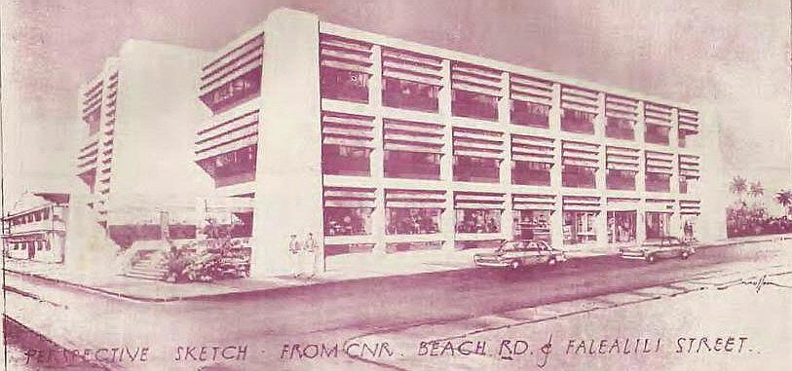

Faulalo Sagapotutele, “Fautuaga”. O Le Sulu Samoa, 1981, 13.
Congregational Christian Church of Samoa, General Assembly Minutes 25–29 May,5. 81FT11. Congregational Christian Church of Samoa, General Assembly Minutes 23–28 May,7. 82FT8.
“Taulaga mo le Ioane Viliamu (Fogafale Ono) E Tusa Ai Ma Tusaga Ta'i $2000 Aulotu I Vaiala, Pulega Vaimauga, Matagaluega Apia”.O Le Sulu Samoa,30 Aperila–15 Me 1981, 11–15
Tofilau Eti Alesana ed., “Preliminary Programme for Lands Development November 1982”. Apia: Development Committee, 1982 , 12.
Congregational Christian Church of Samoa, General Assembly Minutes 25–29 May, 7. 81FT23, 81FT24.
Congregational Christian Church of Samoa, The General Assembly of the Congregational Christian Church in Samoa. Minutes of the General Assembly 1989, 9.89FT31.
GaugauVa’afutiTavana, “Cultural Values Relating to Education in Western Samoa: A Conceptual Analysis of the Perspectives of Samoan Social Leaders”. PhD, Brigham Young University 1994, 42; “Ripoti O Le Iunivesite O Samoa”, 2.
Congregational Christian Church of Samoa, General Assembly Minutes 14–25 May, 28.
“Fono Komiti Aoga 9 Novema 1989”, 89KA153; Congregational Christian Church of Samoa, The General Assembly of the Congregational Christian Church in Samoa. Minutes of the General Assembly 1990.Apia: Malua Printing Press, 1990 ,
Leaula Amosa to Faatonusili O Aoga EFKS, 1989, 3 (CCCSA); “Fono Komiti Aoga. Ioane Viliamu. 7 Setema 1989”. Apia: Komiti Aoga, 1. 89KA122. Leaulu Amosa was elected principal of Leulumoega Fou College on the 7 September 1989.
Alec Thornton, Maria Kerslake and Tony Binns, “Alienation and Obligation: Religion and Social Change in Samoa”, 9.
MageleCrawley, ed., “Report of the Census of Population and Housing 1981”. Apia: Department of Statistics, 1981, 35; MageleCrawley, ed., “Report of the Census of Population and Housing 1991”. Apia: Department of Statistics, 1991. 29.

